Cloud Computing

MCA III SEMESTER

**02305 CLOUD COMPUTING (ELECTIVE-II)**

**UNIT- I** Cloud Computing Basics - Cloud Computing Overview, Applications, Intranets and the Cloud, First Movers in the Cloud. The Business Case for Going to the Cloud - Cloud Computing Services, Business Applications, Deleting Your Datacenter, Salesforce.com, Thomson Reuters.

**Organization and Cloud Computing** - When You Can Use Cloud Computing, Benefits, Limitations, Security Concerns, Regulatory Issues, Cloud Computing with the Titans - Google, EMC, NetApp, Microsoft, Amazon, Salesforce.com, IBM Partnerships.

**UNIT-II** Hardware and Infrastructure - Clients, Security, Network, Services. Accessing the Cloud - Platforms, Web Applications, Web APIs, Web Browsers. Cloud Storage - Overview, Cloud Storage Providers, Standards - Application, Client, Infrastructure, Service.

**Software as a Service** - Overview, Driving Forces, Company Offerings, Industries Software plus Services - Overview, Mobile Device Integration, Providers, Microsoft Online.

**UNIT-III** Developing Applications - Google, Microsoft, Intuit QuickBase, Cast Iron Cloud, Bungee Connect, Development, Troubleshooting, Application Management.

Local Clouds and Thin Clients - Virtualization in Your Organization, Server Solutions, Thin Clients, Case Study: McNeilus Steel.

**UNIT- IV** Migrating to the Cloud - Cloud Services for Individuals, Cloud Services Aimed at the Mid- Market, Enterprise-Class Cloud Offerings, Migration, Best Practices and the Future of Cloud Computing - Analyze Your Service, Best Practices, How Cloud ComputingMight Evolve.

#### Text Books:

1. Cloud Computing-A Practical Approach, Anthony T. Velte, Toby J. Velte, Robert Elsenpeter. McGrawHill.

#### Reference Books:

1. Cloud Computing, Theory and Practice, Dan C Marinescu, MKElsevier.
2. Cloud Computing, A Hands on approach, ArshadeepBahga, Vijay Madisetti,University Press

**CLOUD COMPUTING**

**UNIT- I** Cloud Computing Basics - Cloud Computing Overview, Applications, Intranets and the Cloud, First Movers in the Cloud. The Business Case for Going to the Cloud - Cloud Computing Services, Business Applications, Deleting Your Datacenter, Salesforce.com, Thomson Reuters.

**Organization and Cloud Computing** - When You Can Use Cloud Computing, Benefits, Limitations, Security Concerns, Regulatory Issues, Cloud Computing with the Titans - Google, EMC, NetApp, Microsoft, Amazon, Salesforce.com, IBM Partnerships.

**Cloud Computing – An Overview:**

Cloud computing is a computing paradigm, where a large pool of systems are connected in private or public networks, to provide dynamically scalable infrastructure for application, data and file storage. With the advent of this technology, the cost of computation, application hosting, content storage and delivery is reduced significantly.

Cloud computing is a practical approach to experience direct cost benefits and it has the potential to transform a data center from a capital-intensive set up to a variable priced environment.

The idea of cloud computing is based on a very fundamental principal of reusability of IT capabilities. The difference that cloud computing brings compared to traditional concepts of “grid computing”, “distributed computing”, “utility computing”, or “autonomic computing” is to broaden horizons across organizational boundaries.

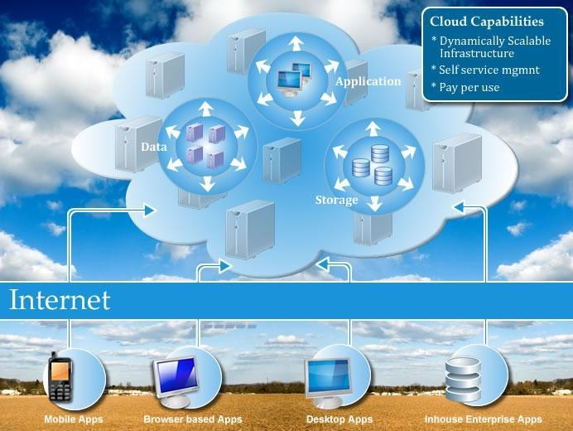

#### Cloud components

In a simple, topological sense, a cloud computing solution is made up of several elements :

* 1. Clients.
  2. Datacenter.
  3. Distributed servers.

A shown below, these components make up the three parts of a cloud computing solution.

Each element has a purpose and plays a specific role in delivering a functional cloud based application, so let’s take a closer look.



Client computers Distributed servers



Internet

Datacenters

Three components make up a cloud computing solution

#### Clients

Clients are, in a cloud computing architecture, the exact same things that they are in a plain, old, everyday local area networks (LAN). They are, typically the computers that just sit on your desk. But they might also be laptops, tablet computers, mobile phones , or PDAs- all big drivers for cloud computing because of their mobility.

Anyway, clients are the devices that the end users interact with to manage their information on the cloud. Clients generally fall into three categories :

* **Mobile** Mobile devices include PDAs(Personal Digital Assistance) or smartphones, like a Blackberry, Windows Mobile Smartphone, or an iPhone.
* **Thin** Clients are computers that do not have internal hard drives, but rather let the server do all the work, but then display the information.
* **Thick** This type of client is a regular computer, using a web browser like Firefox or Internet Explorer to connect to the cloud.

Thin clients are becoming an increasingly popular solution, because of their price and effect on the environment. Some benefits to using thin clients include

* **Lower hardware costs** Thin clients are cheaper than thick clients because they do not contain as much hardware. They also last longer before they need to be upgraded or become obsolete.
* **Lower IT costs** Thin clients are managed at the server and there are fewer points of failure.
* **Security** Since the processing takes place on the server and there is no hard drive, there’s less chance of malware invading the device. Also, since thin clients don’t work without a server, there’s less chance of them being physically stolen.
* **Data Security** Since data is stored on the server, there’s less chance for data to be lost if the client computer crashes or is stolen.
* **Less power consumption** Thin clients consume less power than thick clients. This means you’ll pay less to power them, and you’ll also pay less to air-condition the office.
* **Ease of repair or replacement** If a thin client dies, it’s easy to replace. The box is simply swapped out and the user’s desktop returns exactly as it was before the failure.
* **Less noice** Without a spinning hard drive, less heat is generated and quieter fans can be used on the thin client.

#### Datacenter

The datacenter is the collection of servers where the application to which you subscribe is housed. It could be a large room in the basement of your building or a room full of servers on the other side of the world that you access via the Internet.

A growing trend in the IT world is virtualizing servers. That is, software can be installed allowing multiple instances of virtual servers to be used. In this way, you can have half a dozen virtual servers running on one physical server.

#### Distributed Servers

But the servers don’t all have to be housed in the same location. Often, severs are in geographically disparate locations. But to you, the cloud subscriber, these servers act as if they’re humming away right next to each other.

This gives the service provider more flexibility in options and security. For instance, Amazon has their cloud solution in servers all over the world. If something were to happen at one site, causing a failure, the service would still be accessed through another site. Also, if the cloud needs more hardware, they need not throw more servers in the safe room- they can add them at another site and simply make it part of the cloud.

## Applications

Cloud computing applications, a way of viewing, manipulating, and sharing data. Like their desktop, many staple applications exist in cloud computing, but the difference is how you interact with those applications.

The most common are storage and database.

#### Storage

One of the uses for cloud computing is simple storage. The benefits are in line with the general benefits of cloud computing. If you lease storage space from a vendor, you are not responsible to buy equipment, pay to run it, and pay to cool it. But there are different options when it comes down to cloud storage.

#### Database

Databases are repositories for information with links within the information that help make the data searchable.

Distributed databases, like Amazon’s Simple DB, spread information among physically dispersed hardware. But to the client, the information seems to be located in one place.

The advantages of such a database include the following :

* **Improved Availability** If there is a fault in one database system, it will only affect one fragment of the information, not the entire database.
* **Improved performance** Data is located near the site with the greatest demand and the database systems are parallelized, which allows the load to be balanced among the servers.
* **Price** It is less expensive to create a network of smaller computers with the power of one large one.
* **Flexibility** Systems can be changed and modified without harm to the entire database.

#### Disadvantages :

* **Complexity** Database administrators have extra work to maintain the system.
* **Lobor costs** With that added complexity comes the need for more workers on the payroll.
* **Security** Database fragments must be secured and so must the sites housing the fragments.
* **Integrity** It may be difficult to maintain the integrity of the database if it is too complex or changes too quickly.
* **Standards** There are currently no standards to convert a centralized database into a cloud solution.

#### Database Services

Another “as a service” offering that is becoming prevalent in the world of cloud computing is Database as a Service (DaaS). The idea behind DaaS is to avoid the complexity and cost of running your own database.

DaaS offers these benefits :

* **Ease of Use** There are no servers to provision and no redundant systems to worry about. You don’t have to worry about buying, installing and maintaining hardware for the database.
* **Power** The database isn’t housed locally, but that doesn’t mean that it is not functional and effective. Depending on your vendor, you can get custom data validation to ensure accurate information.
* **Integration** The database can be integrated with your other services to provide more value and power.
* **Management** Because large databases benefit from constant pruning and optimization, typically there are expensive resources dedicated to this task. With some DaaS offerings, this management can be provided as part of the service for much less expense.

#### MS SQL

Microsoft’s premier offering SQL Server. They announced the cloud extension of that tool in the spring of 2008 by introducing Microsoft SQL Server Data Services(SSDS).

SSDS looks very similar to Amazon’s SimpleDB, with a straightforward, schema-free data storage, SOAP or REST APIs, and a pay-as-you-go payment system. Though it looks similar to simple DB it varies greatly.

Microsoft wants SSDS to work as a data hub, synchronizing data on multiple devices so they can be accessed offline.

There are three core concepts in SSDS :

* + **Authority** An authority is both a billing unit and a collection of containers.
  + **Container** A container is a collection of entities and is what you search within.
  + **Entity** An entity is a property bag of name and value pairs.

SSDS based on SQL Server, but it is not simple retooling of it. Microsoft built it with large-scale deployment in mind.

#### Oracle

In the fall of 2008 Oracle introduced three services to provide database services to cloud users. Customers can license

* Oracle Database 11g
* Oracle Fusion Middleware
* Oracle Enterprise Manager

The products are available for use on Amazon Web Services’ Elastic Compute Cloud (Amazon EC2). Developers can take advantage of the provisioning and automated software deployment to rapidly build applications using Oracle’s popular development tools such as Oracle Application Express, Oracle JDeveloper, Oracle Enterprise Pack for Eclipse and Oracle workshop for WebLogic.

Oracle also introduced a secure cloud-based backup solution.

The Oracle Secure Backup Cloud Module also enables encrypted data backups to help ensure complete privacy in the cloud environment.

## Intranets and the cloud

Intranets are customarily used within an organization and are not accessible publicly. That is , a webserver is maintained in-house and company information is maintained on it such that others within the organization can access. However, intranets are being maintained on the cloud.

To access the company’s private, in-house information, users are having to log on to the intranet by going to a secure public website.

A cloud intranet provides employees with secure access to all the tools and resources they need to work from anywhere, at any time, from any device. As our workforces become more mobile, cloud-based intranet software is providing enterprises with the technology to communicate, collaborate and drive productivity effectively.

#### Cloud components

There are two main components in client/server computing : ***servers*** and ***thin or light clients*** . The network map in fig. shows how they are deployed.

The servers house the applications your organization needs to run, and the thin clients- which do not have hard drives-display the results.

#### Hypervisor Applications

Applications like VMware or Microsoft’s Hyper-V allow you to virtualize your servers so that multiple virtual servers can run on one physical server. They also make it possible to install different operating systems on the same machine. For ex, you may need Windows Vista to run one application, while another application requires linux. Its easy to set up the server to run both operating systems

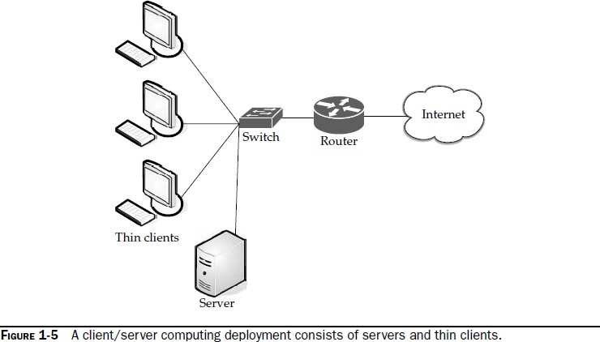

Thin clients use an application program to communicate with an application server. Most of the processing is done down on the server, and send back to the client. Some thin clients require an application program or web browser to communicate with the server. However, others require no add-on applications at all.

## First Movers in the Cloud:

Those are Amazon, Google, and Microsoft.

#### Amazon

It was one of the first companies to offer cloud services to the public, and they are very sophisticated. Amazon offers a number of cloud services, including

* **Elastic Compute Cloud (EC2)** offers virtual machines and extra CPU cycles for your organization.
* **Simple Storage Service (S3)** Allows you to store items up to 5GB in size in Amazon’s virtual storage service.
* **Simple Queue Service (SQS)** Allows your machines to talk to each other using this message-passing API.
* **Simple DB** A Web service for running queries on structured data in real time. This service with Amazon Simple Storage Service (Amazon S3) and Amazon Elastic Compute Cloud (Amazon EC2), providing the ability to store, process, and query data sets in the cloud.

#### Google

Google offers online documents and spreadsheets, and encourages developers to build

features for those and other online software, using its Google App Engine. Google reduced the web applications to a core set of features, and built a good framework for delivering them. Google also offers handy debugging features.

#### Microsoft

Microsoft’s cloud computing solution is called **Windows Azure**, an operating system that allows organizations to run Windows applications, store files and data using Microsoft’s datacenters. Its’ also offering its Azure Services Platform , which are services that allow developers to establish user identities, manage workflows, synchronize data, and perform other functions.

Key components of Azure Services Platform include

* + **Windows Azure** Provides service hosting and management and low-level scalable storage, computation, and networking.
  + **Microsoft SQL Services** Provides database services and reporting.
  + **Microsoft .NET Services** Provides service-based implementations of .NET framework concepts such as workflow.
  + **Live Services** Used to share, store, and synchronize documents, photos, and files across PCs, phones, PC applications, and websites.
  + **Microsoft SharePoint Services and Microsoft Dynamics CRM Services** used for business content, collaboration, and solution development in the cloud.

Microsoft plans the next version of office to offer a browser-based option so that users can read and edit documents online as well as offer the ability for users to collaborate using web, mobile and client versions of office.

## The Business Case for Going to the cloud

#### Cloud computing Services Infrastructure as a Service (IaaS)

In this scenario, you are using the cloud provider’s machines. Another term for this type of computing is Everything as a Service. That is , you are using a virtualized server and running software on it. One of the most prevalent is Amazon Elastic Compute Cloud (EC2). Another player in the field is GoGrid.

#### Amazon EC2 :

Amazon Elastic Compute Cloud is a web service that provides resizable computing capacity in the cloud. Amazon EC2’s simple web service interface allows businesses to obtain and configure capacity with minimal friction. It provides control of computing resources and lets organizations run on Amazon’s computing environment.

Amazon EC2 reduces the time required to obtain and boot new server instances to minutes, allowing quick scaling capacity, both up and down , as computing requirements change. Amazon EC2 changes the economics of computing by allowing you to pay only for capacity that you actually use.

When we launched Amazon EC2 over two years ago, the idea of accessing computing power over the web was still a novel idea. Today a diverse array of business drawn by the benefits of cloud computing- cost savings without giving up speed, reliability, flexibility, and performance- are running EC2 for all types of applications.

Amazon EC2 has given us the ability to easily spin up tailored computing environment that can quickly and cost-effectively process tremendous amounts of research data.

Now that Amazon EC2 runs Windows and SQL Server, greater flexibility in the kinds of applications we can build in the AWS cloud.

#### Windows and SQL Server Support for Amazon EC2 :

Customers can employ Amazon EC2 running Windows Server or SQL Server with all of the benefits of Amazon EC2. Windows with Amazon EC2 has been a common request of AWS

customers since the service launched. Amazon EC2 provides an environment for deploying ASP.NET websites, high-performance computing clusters, media transcoding solutions, and many other Windows-based applications.

Render Rocket delivers professional-level rendering power on-demand to 3-D production teams. They launch intensive 3-D rendering jobs for films and TV on Amazon EC2 to take advantage of Amazon’s massive compute power.

#### Amazon EC2 Service Level Agreement : (SLA)

With over two years of operation Amazon EC2 exited its beta into general availability and offers customers a Service Level Agreement (SLA). The Amazon EC2 SLA guarantees 99.95% availability of the service within a region over a trailing 365-day period, or customers are eligible to receive service credits back. The Amazon EC2 SLA is designed to give customers additional confidence that even the most demanding applications will run dependably in the AWS cloud.

#### Recent Features :

In 2009, AWS announced plans for several new features that make managing cloud-based applications easier. Thousands of customers employ the compute power of Amazon EC2 to build scalable and reliable solutions. AWS will deliver additional features that automate customer usage of Amazon EC2 for more cost-efficient consumption of computing power and provide greater visibility into the operational health of an application running in the AWS cloud.

These features include

* **Load balancing** Enables customers to balance incoming requests and distribute traffic across multiple Amazon EC2 compute instances.
* **Auto-scaling** Automatically grows and shrinks usage of Amazon EC2 compute capacity based on application requirements.
* **Monitoring** Enables customers to monitor operational metrics of Amazon EC2, providing even better visibility into usage of the AWS cloud.
* **Management Console** Provides a simple, point-and-click web interface that lets customers manage and access their AWS cloud resources.

#### GoGrid

GoGrid is a service provider of Windows and Linux cloud-based server hosting, and offers 32-bit and 64-bit editions of Windows Server 2008 within its cloud computing

infrastructure. Parent company ServePath is a Microsoft Gold Certified Partner, and launched Windows Server 2008 dedicated hosting in February of this year.

GoGrid becomes one of the first Infrastructure as a Service (IaaS) providers to offer Windows Server 2008 in the cloud. The Windows Server 2008 operating system from Microsoft offers increased server stability, manageability, and security over previous versions of Windows Server.

GoGrid enables system administrators to quickly and easily create, deploy, load-balance, and manage Windows and Linux cloud servers within minutes. GoGrid offers what it calls Control in the CloudTM with its web-based Graphical User Interface (GUI) that allows for point and click deployment of complex and flexible network infrastructures, which include load balancing and multiple web and database servers, all set up with icons through the GUI.

Initial Windows Server 2008 offerings on GoGrid include both 32-bit and 64-bit preconfigured templates. GoGrid users select the desired operating system and then choose preconfigured templates in order to minimize time to deploy. Preconfigurations include

* Windows Server 2008 Standard with Internet Infromation Services 7.0 (IIS 7)
* Windows Server 2008 Standard with IIS 7 and SQL Server 2005 Express Edition
* Windows Server 2008 Standard with IIS7, SQL Server 2005 Express Edition , and ASP.NET

Windows Server 2008 Standard includes Terminal Services Gateway, Remote Desktop Client for Terminal Services, Application Server, Active Directory Domain Services, DHCP Server, DNS Server, and SMTP.

#### Platform as a Service (PaaS)

Platform as a Service (PaaS) is a way to build applications and have them hosted by the cloud provider. It allows you to deploy applications without having to spend the money to buy the servers on which to house them. The companies are RightScale and Google. Their services are explained below.

#### RightScale

RightScale entered into a strategic product and partnership, broadening its cloud management platform to support emerging clouds from new vendors, including FlexiScale and GoGrid, while continuing its support for Amazon’s EC2. RightScale is also working with RackSpace to deploy

their applications on a supported cloud provider. They gain the capabilities of built-in redundancy, fault tolerance, and geographical distribution of resources.

Customers can leverage the RightScale cloud management platform to automatically deploy and manage their web applications. RigthScale’s automated system management, prepackaged and reusable components, leading service expertise, and best practices have been proven a best-of-breed, with customers deploying hundereds of thousands of instances on Amazon’s EC2.

Cloud Computing is a disruptive force in the business world because it provides pay-as- you-go, on-demand, virtually infinite compute and storage resources that can expand or contract as needed. Today’s announcement of RightScale’s partnerships with FlexiScale and GoGrid is an exciting ilndication of how mid-market and enterprise organizations can really take advantage of multicloud architectures.

FlexiScale is the only UK-based cloud computing provider and offers a unique infrastructure on demand with 99.99% SLA and many special features. For example, each customer gets their own virtual disk so that data lis segregated and they can do their own low- level encryption, while virtual network traffic is also segregated to deliver added security. It offers permanent on-demand storage and was the first cloud provider to support windows.

GoGrid offers hosted cloud computing infrastructure that enables system administrators, developers, and IT professionals or create, deploy, and control load-balanced cloud servers and complex hosted virtual server networks. GoGrid also delivers portal-controlled servers for windows 2003 and 2008 and multiple Linux operating systems, and supports application environments. GoGrid is a unique cloud computing with the availability of 32-bit and 64-bit editions of Windows Server 2008.

Rackspace Hosting provides IT systems and computing –as-service to more than 33,000 customers worldwide. Combining RightScale’s technologies with Rackspace’s focus in Financial Support will allow companies to focus more on their business and not spend a disproportionate amount of resources on IT demands.

#### Salesforce.com

Salesforce.com offers Force.com as its on-demand platform. Force.com features breakthrough Visualforce technology, which allows customers, developers, and ISVs to design any app, for any user , anywhere with the world’s first User Interface-as-a-Service. The Force.com platform

offers global infrastructure and services for database, logic, workflow, integration, user interface, and application exchange.

A capability of the Force.com platform, Visualforce provides a framework for creating user experiences, and enables the creation of new interface designs and user interactions to be built and delivered with no software or hardware infrastructure requirements. With Visualforce , developers hve control over the look and feel of their Force.com applications enabling wide flexibility in terms of application creation.

**On Demand** Force.com PaaS provides the building the blocks necessary to build business apps, whether they are simple or sophisticated , and automatically deploy them as a service to small teams or entire enterprise. The Force.com platform gives customers the power to run multiple applications within the same Salesforce instance, allowing all of a company’s Salesforce applications to share a common security model,data model, and user interface.

The multitenant Force.com platform encompasses a features set for the creation of business applications such as an on-demand operating system, the ability to create any database on demand, a workflow engine for managing collaboration between users, theApex Code programming language for building complex logic, the Froce.com Web Services API for programmatic access, mashups, and intergration with other application and data, and now Visualforce for a framework tobuild any user interface.

#### Delivery

As part of the Force.com platform, Visualforce gives customers the means to design application user interfaces for any experience on any screen. Using the logic and workflow intelligence provided by Apex Code, Visualforce offers the ability to meet the requirements of applications that feature different types of users on a variety of devices. Visualforce uses Internet technology , including HTML, AJAX, and Flex, for business applications.Visualforce includes the following features and capabilities :

* **Pages** This capability enables the design definition of an application’s user interface. This enables developers to create new pages using standard web technologies including HTML, AJAX, and Flex. Pages allows developers to create any user experience with standard web technologies that will be immediately familiar to any web developer. Visualforce automatically detects a user’s device, and gives them the ability to automatically deliver the right experience to the right device.
* **Components** This provides the ability to create new applications that automatically match the look and feel of Salesforce applications or customize and extend theSalesforce user interface to specific customer and user requirements. Customers can rapidly create a user experience by assembling existing user interface elements. Visualforce provides the means to reuse predefined standard Salesforce and custom-designed UI components.
* **Logic controllers** The controller enables customers to build any user interface behavior. Customers are able to use Visualforce to quickly create a new look and feel that leverages existing application functionality. Customers can define completely new UI interactions that benefit from Apex Code. The standard controller gives customers the ability to inherit and reuse any standard Salesforce UI behavior like new, edit and save.

**Software as a Service (SaaS) :** SaaS is simply the cloud vendor providing the given piece of software you want to use, on their servers. That is, unlike PaaS in which you developed your own application, SaaS provides the application for you.

The line between SaaS and PaaS gets a little blurry, but the delineation is whether the provider supplies the application (SaaS) or simply provides a mechanism to develop your own applications (PaaS). The gray area becomes even more marked by companies like Google or Salesforce that offer both types of services. For instance not only can you build an application with Salesforce, but you can also allow others to use the application you developed.

#### Google App Engine and Salesforce :

Google has partnered with Salesforce to make it easy for companies of all sizes to run their business in the cloud with Salesforce for Google Apps. The combination of the Google Apps suite for productivity applications and the Salesforce suite of Customer Relationship Management (CRM) applications enables business to effectively communicate and collaborate without any hardware or software to download, install, or maintain.

Google and Salesforce.com have always had similar models and philosophies about delivering innovations made possible by the Internet. Salesforce.com was a pioneer in Software- as-a-Service and a year ago we joined them in this mission to bring the benefits of cloud computing to businesses of all types. Together, we are making more applications and services available online so customers can focus on building their core business rather than the applications that support it.

Salesforce.com is thrilled to be offering Google Apps integrated witgh our Salesforce applications and Force.com Platform-as-a-Service to the millions of business es looking to manage their entire office in the cloud.

**Sales force for Google Apps:** It is a combination of essential applications for business productivity (email, calendaring, documents, spreadsheets, and presentations, instant messaging) and CRM (sales, marketing, service and support, partners) that enables an entirely new way for business professionals to communicate, collaborate and work together in real time over the web. Salesforce for Google Apps offers a complete way for businesses to harness the power of cloud computing without the cost and complexity of managing hardware or software infrastructure.

The following features are included in Salesforce for Google Apps :

* **Salesforce and Gmail** Business can now easily send, received, and store email communication, keeping a complete record of customer interactions for better sales execution and improved customer satisfaction.
* **Salesforce and Google Docs** Create, manage, and share online Google Documents, Google Spreadsheets, and Google Presentations within your sales organization, marketing group, or support team for instant collaboration.
* **Salesforce and Google Talk** Instantly communicate with collegues or customers from Salesforce and optionally attach Google Talk conversations to customer or prospect records stored in Salesforce.
* **Salesforce and Google Calendar** Expose sales tasks and marketing campaigns from Salesforce on Google Calendar. Built by Appirio, this application is one example of a new category of partner extensions to Salesforce for Google Apps.

#### Google Platform

Google offers a host of applications that businesses can use immediately, as well as a platform on which to make your own , business-specific apps.

Much of business’s data is stored on user desktops, laptops, or removable USB drives. Google promotes their SaaS offerings as a way to secure your sensitive data by taking USB and user disk drives out of the equation. As such, users can access their data from the office, a remote office, at home, or on the road.

Google operates on one of the largest networks of distributed datacenters, and they strive for data security. They say their controls , processes, and policies that protect your data undergo an SAS 70 Type II audit. Security fall under three main topics :

* + **People** Google employs a full-time information security team, which includesd experts in information, application, and network security. This team handles the company’s perimeter defense systems, security review processes, and customized security plans.
  + **Process** Each Google application is built with security in mind. Applications are constantly reviewed for security as part of their Secure Code development process. The application development environment is also restricted and monitored for an additional layer of security.

External security audits are also routinely conducted.

**Technology** Google Apps data is divided between multiple servers and disks, which makes it impossible to read, if someone were to breach alone server. Also , the way in which the Google servers are built makes it possible ot rapidly distribute updates and configuration changes.

## Business Applications

#### Operational Benefits

There are benefits to the way you operate. You can change business processes (for the better) by moving some applications and storage to the cloud. The following are some of the operational benefits:

* **Reduced cost** Since technology is paid incrementally, your organization saves money in the long run. Increased storage You can store more data on the cloud than on a private network.
* **Automation** Your IT staff no longer needs to worry that an application is up to date— that’s the provider’s job. And they know they have to keep it up to date or they’ll start losing customers.
* **Flexibility** You have more flexibility with a cloud solution. Applications can be tested and deployed with ease, and if it turns out that a given application isn’t getting the job done, you can switch to another.
* **Better mobility** Users can access the cloud from anywhere with an Internet connection. This is ideal for road warriors or telecommuters—or someone who needs to access the system after hours.
* **Better use of IT staff** IT staff no longer has to worry about server updates and other computing issues. They can focus on duties that matter, rather than being maintenance staff. **Economic Benefits**
* **People** We hate to suggest that anyone lose their job, but the honest-to-goodness truth is that by moving to the cloud, you’ll rely on fewer staffers.
* **Hardware** With the exception of very large enterprises or governments, major cloud suppliers can purchase hardware, networking equipment, bandwidth, and so forth, much cheaper than a “regular” business

.• **Pay as you go** Think of cloud computing like leasing a car. Instead of buying the car outright, you pay a smaller amount each month.

* **Time to market** One of the greatest benefits of the cloud is the ability to get apps up and running in a fraction of the time you would need in a conventional scenario.

#### Tips for Evaluating SaaS

Before employing a SaaS solution, there are factors to consider. You should evaluate not only the SaaS provider and its service, but also what your organization wants from SaaS. Be sure the following factors are present as you evaluate your SaaS provider:

* **Time to value** As we mentioned earlier, one of the great benefits of using cloud services is the ability to shorten the time it takes to get a new system or application up and running. Unlike traditional software that might require complex installation, configuration, administration, and maintenance, SaaS only requires a browser. This allows you to get up and running much more quickly than by using traditional software.
* **Trial period** Most SaaS providers offer a 30-day trial of their service. This usually doesn’t happen with traditional software—and certainly you wouldn’t move everyone en masse to the trial. However, you can try out the SaaS vendor’s offering and if it feels like a good fit, you can start making the move.
* **Low entry costs** Another appeal of SaaS is the low cost to get started using it. Rather than laying out an enormous amount of money, you can get started relatively inexpensively. Using an SaaS solution is much less expensive than rolling out a complex software deployment across your organization.
* **Service** In SaaS, the vendor serves the customer. That is, the vendor becomes your IT department—at least for the applications they’re hosting. This means that your own, in- house IT department doesn’t have to buy hardware, install and configure software, or maintain it. That’s all on your SaaS vendor. And if the vendor isn’t responsive to your needs, pack up your toys and move to a different service. It is in the vendor’s best interests to keep you and other customers happy.
* **Wiser investment** SaaS offers a less risky option than traditional software installed locally. Rather than spend a lot of money up front, your organization will pay for the software as it is used. Also, there is no long-term financial commitment. The monetary risk is greatly lessened in an SaaS environment.
* **Security** Earlier in this book we talked about the security concerns with going to the cloud. We mentioned those issues for the sake of completeness, but in reality it is in your vendor’s best interests to keep you as secure as possible. Most SaaS vendors understand that application data must be backed up often and that security is a top 80 P a r t I : G e t t i n g S t a r t e d concern. Your local IT department has a lot going on and might not be able to spend as much time as they would like on safety and security. Since the cloud vendor wants to keep customers safe and secure, they will have staff dedicated to ensuring that your data is safe.
* **Your voice** When’s the last time you made a suggestion for a change in Microsoft Word and Redmond listened? We’re not just picking on Microsoft here. The fact of the matter is that customers of traditionally installed software have very little ability to influence the development of new product features. But your SaaS vendor wants to keep you happy so that you will not jump ship for another provider. As such, they will listen to your wants and respond. Because you will have a closer relationship, you have a greater ability to influence the product and its features.
* **Reduced capital expense** Using an SaaS provider eliminates the need for buying hardware and software. This not only makes your CFO happy, but it makes it faster to get approval for a project when the need to buy hardware is taken out of the equation.
* **Meet short-term needs** Quite often organizations experience busy times, or they launch a new product, a new office opens, or something else occurs that requires more computational power. Rather than buy new hardware to deal with your capacity needs, an

SaaS provider can instantly expand and offer you more resources. And when you’re done, you scale back what you are using. The best part is that once you’re done paying for those additional resources, you go back to paying for what you need.

#### Staffing Benefits

There are a number of benefits the people in your organization will realize when you shift some applications to the cloud. For the most part their lives should be easier with the ease and convenience cloud computing offers. For the Consumer The consumer benefits from cloud computing in a number of ways, for example:

* **No software installation or maintenance** That means no more 1,000-page planning and implementation guides.
* **Shorter deployment time** It takes only a few minutes to spin up a new server, rather than the months it would normally take to plan, prepare, test, and deploy.
* **Worldwide availability** By using a cloud, your users can access data and applications from anywhere they have Internet access.
* **Service Level Agreement (SLA) adherence** If you have an SLA, then you’re guaranteed that level of service
* **Upgrades** The provider wants to keep you happy, so it’s in their best interests to ensure the application is constantly improved. With SaaS this can be in the guise of small changes that you don’t see that add up over time, rather than getting a monstrous patch that costs you time and money to implement.
* **Make life easier on your IT staff** SaaS offloads a lot of the maintenance duties onto your cloud provider so that your IT staff can focus on improving the day-today technical operations of your company, rather than being called to fix some piece of software that isn’t playing well with the others on the network.
* **More money** Your organization saves money by using a cloud vendor, both in operational costs and the IT budget. This is money that can be added to your bottom line or redistributed to other departments to boost productivity.

#### For the Provider

* + **Operating environment** The provider owns their domain. They aren’t just sending technicians to fix or customize software because it doesn’t fit on a client’s unique

(or antique) infrastructure. The provider has the control to optimize an infrastructure to their specific SaaS needs.

* **Predictable revenue stream** Because customers will be paying a subscription for their cloud use, it is easy to get a handle on forecasting revenues.
* **Study use** The provider is able to study how their SaaS is used and is then able to give customers more of what they want. This isn’t possible if software is housed on customers’ networks.
* **Small, regular upgrades** This isn’t just a benefit for customers, but the providers, as well. The provider’s development teams can focus on fixing bugs with incremental patch rollouts, rather than saving them for one, monstrous rollout.
* **Customer relationship management** Providers also must develop strong relationships with their customers. Since they are providing a subscription-based service, it is important to keep customers happy, rather than try to score the next big deal. While it is important to keep customers coming in, it is just as important to keep existing customers happy.

## Deleting Your Datacenter

When you move to the cloud, you won’t need to maintain some things on-site. But what and when you delete it is a complicated issue. Certainly, you can back up the data and file it away on some DVDs somewhere, but that’s just a snapshot in time of your organization. As you continue to use the cloud, your data will evolve and change.

#### What You Can Delete

Desktop applications are one of the areas perfect for a move to the cloud. Moving to the cloud allows companies to realize the benefits of economies of scale that come with managing several desktops. Those who specialize in desktop management are going to get the best economies of scale.

A key component in making desktops cloud capable and helping client virtualization go mainstream is the introduction of so-called bare metal hypervisors for clients. These hypervisors allow the desktop to run locally without network access to take advantage of the Pac’s computing power, rather than just relying on the server.

#### What You Should Keep

* **Steps**

You should also keep large files and things like media on-site. If you are storing more than you access online, you get a bigger bill from the vendor each month. Better to let those infrequently accessed files sit on a local drive than to pay the vendor bill each month.

For instance, all you need to do is call up a web browser and make adjustments to the amount of processing power, memory, and disk space each virtual server gets. You can tune your network to the precise configuration you need, without having to pop in new blades or add additional machines.

#### AppZero

AppZero provides a set of tools for creating Virtual Application Appliances (VAAs). This approach to provisioning and deploying applications on physical or virtual servers running anywhere is designed for the cloud environment and for movement of server applications and datacenter to cloud, hosting environment, or cloud to cloud.

## Salesforce.com

Salesforce.com offers SaaS with a host of different applications, many of which are created and shared by other Salesforce customers. Steve Fisher, senior vice president of AppExchange at Salesforce.com, talked about his company as well as the best way for companies considering a move to the cloud to get the most out of their move.

* Salesforce has the good fortune to have a broad variety of customers, existing in different industries and having different needs.
* There doesn’t seem to be one app that everyone uses or is more prevalent than others. Salesforce sees customers using different applications.
* A great advantage is that it drives the vendor to keep the customer happy.
* In a multitenant environment, the vendor can see what and how users are taking advantage of applications and can make changes based on their observations.
* “You don’t have to buy software. It’s so much easier than deploying conventional software.
* Another benefit is the ability to really get what an organization wants out of an application.

## Thomson Reuters

Thomson Reuters is a company that provides information to a wide range of clients— lawyers, accountants, scientists, reporters, and a host of others. For the most part, they have nothing in common but the need to get information. Providing that information is what Thomson Reuters is all about.

Thomson Reuters wanted to give its customers a better, more intelligent way to search for information than they were providing at the time. Their solution was to adopt a Microsoft Software-plus-Services solution. They integrated Microsoft Live Search with their own search engines and databases.

Thomson Web outlined its requirements for teaming with an existing web search engine provider:

* The company needed an engine that could return results in 200 milliseconds. This gave Thomson Reuters time to apply business logic to make the results more meaningful.
* The engine also needed to accept hundreds of thousands of search requests from a single IP address—theirs—without it being seen as a Denial of Service attack. The system works this way:

1. A customer accesses the Thomson Reuters information service, which can be a web application or a Windows-based application.
2. Once a search is initiated, that request is passed to the Thomson Reuters intranet to the Thomson Reuters Web Plus service layer.
3. The service layer begins two actions concurrently: It applies its custom business logic to the request, culling relevant information from it.
4. The service layer returns the information to the client.

#### Oraganization and cloud computing

When You Can Use Cloud Computing

Whether or not you should use cloud computing depends on a number of factors, including

* Cost/benefit ratio
* Speed of delivery
* How much capacity you will use
* Whether your data is regulated
* Your organization’s corporate and IT structure

#### Scenarios

There are three different major implementations of cloud computing

#### Cloud Scenarios :

There are three major implementations of cloud computing .How organizations are using cloud computing is quite different at a granular level, but the uses generally fall into one of these three solutions.

#### Compute Clouds

Compute Clouds allow access to highly scalable, inexpensive, on-demand computing resources that run the code that they’re given. Three examples of compute clouds are :

* + Amazon’s EC2
  + Google App Engine
  + Berkeley Open Infrastructure for Network Computing(BOINC)



Compute clouds allow you to access applications maintained on a provider’s equipment

clouds Computer are the most flexible in their offerings and can be used for sundry purposes; it simply depends on the application the user wants to access. These applications are good for any size organization, but large organizations might be at a disadvantage because these applications don’t offer the standard management, monitoring and governance capabilities that these organizations are used to.

#### Cloud Storage

One of the first cloud offerings was cloud storage and it remains a popular solution. Cloud Storage is a big world. There are already in excess of 100 vendors offering cloud storage. This is an ideal solution if you want to maintain files off-site.



Cloud storage allows you to store your data on a vendor’s equipment.

Security and cost are the top issues in this field. Currently, Amazon’s S3 is the top dog.

#### Cloud Applications

Cloud Applications differ from compute clouds in that they utilize software applications that rely on cloud infrastructure. Cloud applications are versions of SaaS and include such things as web applications that are delivered to users via a browser.



Cloud applications deliver applications that depend on the infrastructure of the internet itself.

Some cloud applications include :

* + Peer-to-peer computing
  + Web applications (MySpace or YouTube)
  + SaaS (Google Apps)
  + Software plus services (Microsoft Online Services)

#### Benefits :

1. **Scalability :** If you are anticipating a huge upswing in computing need, cloud computing can help you manage. Rather than having to buy, install, and configure new equipment, you can buy additional CPU cycles or storage from a third party.



Internet

As you require more capacity, the service provider Can make scalability much simpler than if you had to add the equipment on your own Premises.

1. **Simplicity :** Again, not having to buy and configure new equipment allows you and your IT staff to get right to your business. The cloud solution makes it possible to get your application

started immediately, and it costs a fraction of what it would cost to implement an on-site solutions.

1. **Knowledgeable Vendors :** Typically, when new technology becomes popular, there are plenty of vendors who pop up to offer their version of that technology.

Companies like Amazon, Google, Microsoft, IBM, and Yahoo! Have been good vendors because they have offered reliable service, plenty of capacity.

1. **Security :** There are plenty of security risks when using a cloud vendor, but reputable companies strive to keep you safe and secure.

#### Limitations :

1. **Sensitive Information :** The concern of storing sensitive information on the cloud, but it can’t be understated.

**Protect Data:** That doesn’t mean you can’t maintain your data on a cloud; you just need to be safe. The best way is to encrypt your data before you send it to a third party. Programs like PGP or open-source TrueCrypt can encrypt the file so that only those with a password can access it.

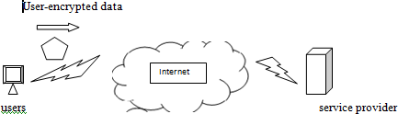

Encrypting your data before it is sent to the service provider ensures that if the provider’s security measures are breached, your data is still secure.

Encrypting your data before sending it out protects it. If someone does get your data, they need the proper credentials or all they get its gibberish.

#### Application Development :

Developing your own applications can certainly be a problem if you don’t know how to program, or if you don’t have programmers on staff. In such a case , you’ll have to hire a software company or be left to use whatever the applications the provider offers.

And it is n’t just applications that you might need some programming savvy to deploy. If you have a database on the cloud , you’ll need some sort of customized interface and some knowledge of Structured Query Language (SQL) to access and manage that data. This is a sort of

a minor concern, because chances are good that you have programmers on staff who can pound out what you need in no time.But there are benefits :The fact of the matter is that putting your database needs on a cloud can be very beneficial, in terms of scalability. At some point, servers are going to have issues if there are too many users trying to access them, and the inherent scalability of cloud-based resources can mitigate that risk.

It is oftern said that this generation of web services got its start form LAMP. LAMP is a stack of simple, powerful web technologies that power a lot of popular, smaller web sites.

LAMP stands for the following popular items :

* + **Linux** An open-source operating system
  + **Apache** An open-source web server
  + **MYSQL** An open-source Structured Query Language (SQL) relational database for web servers
  + **Perl** A programming language

LAMP is widely used because it is very simple. Because of its ease of use, you can get an application up and running very quickly. Scalability issues come from the number of threads and socket connections in the Apache web server. If the server is not properly tuned and a load increases, it can cause problems.

A larger scalability problem comes from MYSQL. Relational databases have a hard time growing beyond a certain capacity due to the way they represent information. Using data partitioning procedure, spilt the data into independent sets, and can scale indefinitely. But if you can’t split the data, then move to a distributed database, which sends to a cloud solution.

#### Security Concerns :

Security is a two-sided coin in the world of cloud computing. IDC conducted a survey of 244 IT executives about cloud services. The following figure shows, security led the pack of cloud concerns with 74.5%.

#### Privacy Concerns with a Third Party :

The first and most obvious concern is for privacy considerations.ie., if another party is housing all your data,how do you know that is safe and secure? As a starting point, assume that anything you put on the cloud can be accessed by anyone. There are also concerns because law enforcement has been better able to get at data maintained on a cloud, more so than they are from

an organization’s servers. If providers are doing their best to secure data, it can still be hacked and then sensitive information is at the mercy of whoever broke in.

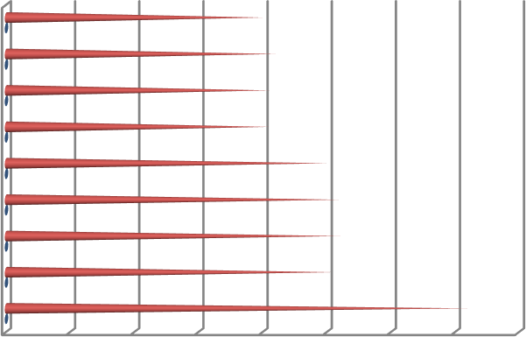

Not enough ability to customize Regulatory requirements prohibit cloud Bringing back in-house may be difficult Worried on-demand will cost more

Not enough ability to customize Hard to integrate with in-house IT

Availability

Performance

Security

0 10 20 30 40 50 60 70 80

IDC’s findings show that security concerns are the number one issue facing cloud computing.

The best plan of attack is to not perform mission-critical work or work that is highly sensitive on a cloud platform without extensive security controls managed by your organization.

#### Security Benefits :

This is not to suggest that data is unsecure on the cloud. Providers do endeavor to ensure security.But the very nature of the cloud lends it to needing some very strong security practices.

1. **Centralized Data** We’ve talked about the specter of data loss by being in one place.However, there are some good security traits that come with centralizing data. Just in practice, make your system more inherently secure.
2. **Reduced Data Los**s By maintaining data on the cloud, employing strong access control, and limiting esmployee downloading to only what they need to perform a task, cloud computing can limit the amount of information that could potentially be lost.
3. **Monitoring** If the data is maintained on a cloud, it is easier to monitor security than have to worry about the security of numerous severs and clients.
4. **Instant Swapover** If the data is compromised, while you are conducting investigation to find the culprits, you can instantly move the data to another machine.
5. **Logging** In the cloud, logging is improved. Logging is usually thought of late in the game, and issues develop with storage space. On a cloud, don’t need to guess how much storage will need and will likely maintain logs from the get-go, if for no other reason than to check your usage.
6. **Secure Builds** when you develop your own network, you had to buy third-party security software to get the level of protection you want. With a cloud solution, those tools can be bundled in and available to you and develop your system with whatever level of security you desire.
7. **Improved Software Security** Vendors are likely to develop more efficient security software. Since you’re charged for you CPU cycles. As such, the vendor doesn’t want to lose your business and is going to be more inclined to develop more efficient security software.
8. **Security Testing** SaaS providers don’t bill you for all of the security testing they do. It’s shared among the cloud users. The end result is that because you are in pool with others, you got realize lower costs for security testing.

#### Regulatory Issues :

In the case of cloud computing, however, regulation might be exactly what we need.

* 1. **No Existing Regulation :** Currently there is no existing regulation, but there should be. In sept 2008, the United States government took control of Washington Mutual. It was the greatest bank failure in American history to date. Look at company like Google ,for instance.

While comparing cloud service providers to banks might seem like an apples-to- oranges comparison, it underscores the need for regulation. While banks deal in money

,and cloud service providers deal in data, both are of immense value to consumers and organizations alike. The fact that there was some regulation in place prevented a run on the bank.

* 1. **Government to the Rescue :** Is it the government’s place to regulate cloud computing ? There are two schools of thought on the issue. First, if government can figure out a way to safeguard data-either from loss or left-any company facing such a loss would applaud the regulation. On the other hand, there are those who think the government should stay out of it and let competition and market forces guide cloud computing.

There are some of the other cloud computing concerns that were reported:

* + - Eight percent said they’d be very concerned if a vendor used their photos and other information in marketing campaigns.
    - Sixty-eight percent said they’d be very concerned if the vendor used their personal information to send them personalized ads.
    - Sixty-three percent said they’d be very concerned if service providers kept their data after the user deleted it.

There are also questions about whether government agencies will store their data on the cloud. Procurement regulations will have to change for government agencies to be keen on jumping on the cloud.

GSA (General Services Administration) is working with a vendor to develop an application that will calculate how much energy government agencies consume.

**Cloud Computing with Titans**

# Google

The cloud is certainly one of Google’s biggest business ventures, and they offer a couple of tools to help draw customers to their cloud.

Google App Engine

Google App Engine enables developers to build their web apps on the same infrastructure that powers Google’s own applications.

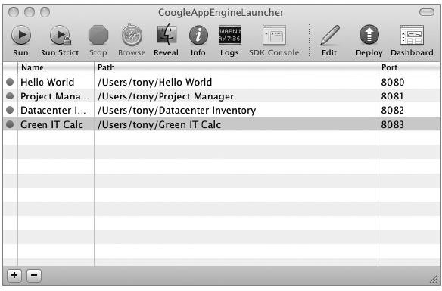

#### Features

Google App Engine, developers can accomplish the following tasks:

* **Write code once and deploy** Provisioning and configuring multiple machines for web serving and data storage can be expensive and time-consuming. Google App Engine makes it easier to deploy web applications by dynamically providing computing resources as they are needed. Developers write the code, and Google App Engine takes care of the rest.
* **Absorb spikes in traffic** When a web app surges in popularity, the sudden increase in traffic can be overwhelming for applications of all sizes, from startups to large companies that find themselves re-architecting their databases and entire systems several times a year. With automatic replication and load balancing, Google App Engine makes it easier to scale from one user to one million by taking advantage of Bigtable and other components of Google’s scalable infrastructure.
* **Easily integrate with other Google services** It’s unnecessary and inefficient for developers to write components like authentication and email from scratch for each new application. Developers using Google App Engine can make use of built-in components and Google’s broader library of APIs that provide plug-and-play functionality for simple but important

features. Cost Google enticed developers by offering the App Engine for free, when it launched, but after a few months slapped on some fees. In response to developer feedback, Google App Engine will provide new APIs. The image-manipulation API enables developers to scale, rotate, and crop images on the server.

#### Google Web Toolkit

With Google Web Toolkit, developers can develop and debug web applications in the familiar Java programming language, and then deploy them as highly optimized JavaScript. **EMC**

EMC Corporation is the world leader in products, services, and solutions for information storage and management that help organizations extract value from their information.

The system allows customers with vast storage needs to easily manage and expand storage systems without interfering with day-to-day operations. This system allows multiple datacenters to be run as if they were one, making their management much easier and more efficient.

Their other fields of expertise include

* **Archiving** Creating accessible online archives that offer a reduced operational cost by shrinking backup windows and making restores faster.
* **Backup and recovery** Different tools combine EMC’s recovery management offerings,

backup technologies, and management strategies to ensure that you have a solid backup and recovery practice.

* **Enterprise content management** Content-enabled solutions help mitigate risk without imposing overly complex technologies on your organization.
* **Intelligent information management** Using various technologies allows organizations to discover, store, and act on information in intelligent ways.
* **IT management** IT management is simplified and its cost reduced through automation, virtualization, and process efficiencies.
* **Replication** Data protection and remote replication technologies provide disaster recovery options.
* **Security** Organizations can deploy products with capabilities for access control, data

protection, and auditing.

* **Storage** Processes and technologies that help manage data and efficiently maintain it.
* **Virtualization** Products including VMware backup and other EMC virtualization tools improve the management and flexibility for virtual infrastructures.

VMware will play a key role in EMC’s strategy to help customers lower their costs and simplify their operations by deploying virtualization technologies across their heterogeneous IT infrastructure to create a single pool of available storage and computing resources.

**NetApp**

NetApp is an organization that creates storage and data management solutions for their customers. Their goal is to deliver cost efficiency and accelerate business breakthroughs.

NetApp was one of the first companies in the cloud, offering datacenter consolidation and storage services, as well as virtualization. Their products include a platform OS, storage

services, storage security, software management, and protection software.

Cisco and NetApp are working together to certify the combined solution, and the companies will also collaborate on customer support and marketing activities.

#### Microsoft

Microsoft offers a number of cloud services for organizations of any size—from enterprises.

#### Azure Services Platform

The cornerstone of Microsoft’s offerings is the Azure Services Platform. The Azure Services.

Platform is a cloud computing and services platform hosted in Microsoft datacenters.

The Azure Services Platform supplies a broad range of functionality to build applications to serve individuals or large enterprises, and everyone in between.

#### Windows Azure

Windows Azure is a cloud-based operating system that enables the development, hosting, and service management environment for the Azure Services Platform. Windows Azure

gives developers an on-demand compute and storage environment that they can use to host, scale, and manage web applications through Microsoft datacenters.

Windows Azure can be used to

* Add web service capabilities to existing applications
* Build and modify applications and then move them onto the Web
* Make, test, debug, and distribute web services efficiently and inexpensively
* Reduce the costs of IT management

#### SQL Services

Microsoft SQL Services extends SQL Server capabilities to the cloud as web-based services.

This allows the storage of structured, semistructured, and unstructured data.

#### .NET Services

Microsoft .NET Services are a set of Microsoft-hosted, developer-oriented services that provide the components required by many cloud-based and cloud-aware applications.

#### Live Services

Live Services is a development center and supplier of software development kits for Windows Live and Azure Services platforms.

#### Windows Live

Windows Live is an integrated set of online services that makes it easier and more fun for consumers to communicate and share with others.

#### SharePoint Services

Microsoft offers its SharePoint Services to aid collaboration efforts. SharePoint Services provides communities for team collaboration and makes it easy for users to work together on documents, tasks, contacts, events, and other information.

#### Microsoft Dynamics CRM

Microsoft Dynamics CRM Online is an on-demand customer relationship management service hosted and managed by Microsoft. The Internet service delivers a full suite of marketing, sales, and service capabilities through a web browser or directly into Microsoft Office and Outlook.

#### Amazon

Amazon may be the most widely known cloud vendor. They offer services on many different fronts, from storage to platform to databases.

#### Amazon Elastic Compute Cloud (Amazon EC2)

Amazon Elastic Compute Cloud (Amazon EC2) is a web service that offers resizable compute capacity in the cloud. Amazon EC2 provides a simple web interface that allows you to obtain and configure capacity with little difficulty. It allows you control of your computing resources. Amazon EC2 allows you to run Windows-based applications on Amazon’s cloud computing platform.

#### Amazon SimpleDB

For database services, Amazon offers its Amazon SimpleDB. It provides core database functions of data indexing and querying. For database services, Amazon offers its Amazon SimpleDB. It provides core database functions of data indexing and querying. This service works closely with Amazon Simple Storage Service (Amazon S3) and Amazon EC2. This provides the ability to store, process, and query data sets in the cloud.

#### Amazon Simple Storage Service (Amazon S3)

Amazon Simple Storage Service (Amazon S3) is Amazon’s storage solution for the Internet. It is designed to make web-scale computing easier for developers.

#### Amazon CloudFront

Amazon CloudFront is a web service for content delivery. It works in conjunction with other Amazon Web Services to give developers and businesses an easy way to distribute content to clients.

#### Amazon Simple Queue Service (Amazon SQS)

Amazon Simple Queue Service (Amazon SQS) offers a scalable, hosted queue for storing messages as they travel between computers. Amazon SQS allows an automated workflow to be created and works closely with Amazon EC2 and other Amazon Web Services.

#### Elastic Block Store

Amazon also launched its Amazon Elastic Block Store (Amazon EBS), a persistent storage feature for the Amazon EC2. With Amazon EBS, storage volumes can be programmatically created, attached to Amazon EC2 instances, and if even more durability is desired, can be backed with a snapshot to the Amazon Simple Storage Service (Amazon S3).

#### Salesforce.com

Salesforce.com made its name with the success of its flagship Salesforce.com automation application.

* **The Sales Cloud** The popular cloud computing sales application
* **The Service Cloud** The platform for customer service that lets companies tap into the power of customer conversations no matter where they take place
* **Your Cloud** Powerful capabilities to develop custom applications on its cloud computing platform, Force.com.

The company has made its platform available to other companies as a place to build and deploy their software services. Force.com offers

* A relational database
* User interface options
* Business logic
* Apex, an integrated development environment
* Workflow and approvals engine
* Programmable interface
* Automatic mobile device deployment
* Web services integration
* Reporting and analytics

#### Force.com

Force.com is Salesforce.com’s on-demand cloud computing platform—billed by Salesforce .com as the world’s first PaaS.

#### PaaS

Force.com delivers PaaS, a way to create and deploy business apps that allows companies and developers to focus on what their applications do, rather than the software and infrastructure to run them.

#### Visualforce

As part of the Force.com platform, Visualforce provides the ability to design application user interfaces for practically any experience on any screen. Visualforce uses HTML, AJAX, and Flex, for business applications

#### Salesforce.com CRM

Salesforce.com is a leader in cloud computing customer relationship management (CRM) applications. Its CRM offering consists of the Sales Cloud and the Service Cloud and can be broken down into five core applications:

**Sales** Easily the most popular cloud computing sales application, Salesforce.com says that CRM Sales is used by more than 1.1 million customers around the world.

**Marketing** With Salesforce.com CRM Marketing, marketers can put the latest web technologies to work building pipeline while collaborating seamlessly with their sales organization

**Service** The Service Cloud is the new platform for customer service. Companies can tap into the power of customer conversations no matter where they take place.

**Collaboration** Salesforce.com CRM can help an organization work more efficiently with customers, partners, and employees by allowing them to collaborate among themselves in the cloud. Some of the capabilities include

* Create and share content in real time using Google Apps and Salesforce.com
* Track and deliver presentations using Content Library
* Give your community a voice using Ideas and Facebook
* Tap into the collective wisdom of the sales team with Genius

**Analytics** Force.com offers real-time reporting, calculations, and dashboards so a business is better able to optimize performance, decision making, and resource allocation.

* **Custom Applications** Custom applications can be quickly created by leveraging one data model, one sharing model, and one user interface.

#### AppExchange

This allows for the development of applications serving a broad range of business requirements:

* Finance
* Electronic signatures
* Document management
* Project management
* Credit and collections
* Mobile workforce management
* Data cleansing
* Professional services management
* Human resources

#### IBM

IBM offers cloud computing services to help businesses of all sizes take advantage of thi increasingly attractive computing model.

Some of their features include

* **Industry-specific business consulting services for cloud computing** IBM Global Business Services uses an economic model for assessing the total cost of ownership

for building private clouds, and/or moving data and applications off-site in a public or hybrid cloud model.

* **Technology consulting, design, and implementation services** IBM Global Technology Services offers services to help clients install, configure, and deliver cloud computing inside the datacenter.
* **Cloud security** Spanning IBM Systems, Software, Services and IBM’s Research and X-Force arms, this effort is aimed at re-architecting and redesigning technologies and processes, to infuse security and shield against threats and vulnerabilities in the cloud.

**UNIT-II** Hardware and Infrastructure - Clients, Security, Network, Services. Accessing the Cloud - Platforms, Web Applications, Web APIs, Web Browsers. Cloud Storage - Overview, Cloud Storage Providers, Standards - Application, Client, Infrastructure, Service.

**Software as a Service** - Overview, Driving Forces, Company Offerings, Industries Software plus Services - Overview, Mobile Device Integration, Providers, Microsoft Online.

#### Clients

There are different types of clients that can link to the cloud, and each one offers a

different way for you to interact with your data and applications.

#### Mobile

Mobile clients run the gamut from laptops to PDAs and smartphones, like an iPhone or BlackBerry. Mobile clients, of course, have security and speed concerns.

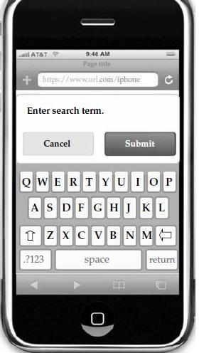

#### Thin

Thin clients, are client computers that have no hard drives, no DVD-ROM drives, and

simply display what’s on the server. There’s also a high level of security, because no data is stored on the thin client. All the data resides in your datacenter or on the cloud, so the risk of a physical breach is small.

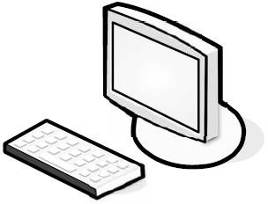

#### Thick

Thick clients are the clients you already use and are likely to use to connect

to applications in the cloud. You likely already have applications installed on your end users’ machines. These machines can certainly still connect to a virtualized server, and if we don’t want to spend any more money for clients, just use the machines that we already have.

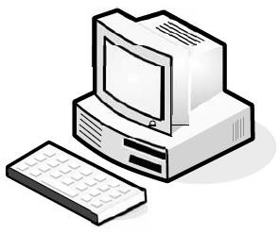

Thick clients are good choices if users need to maintain files on their own machines or run programs that don’t exist on the cloud. Security-wise, thick clients are more vulnerable to attack than thins. Since data is stored on the machine’s hard drive, if the machine is stolen then the data could be compromised.

#### Security

Security is the number one issue when it comes to cloud computing, and that only makes sense. Since a third party stores your data, on cloud.

#### Data Leakage

The biggest benefit is the centralization of data. Organizations have an issue with asset protection, in no small part because of data being stored in numerous places, like laptops

and the desktop.

Thick clients are apt to download files and maintain them on the hard drive, and there are plenty of laptops out there with non encrypted files. Using thin clients creates a better chance for centralized data storage. As such, there’s less chance for data leakage.

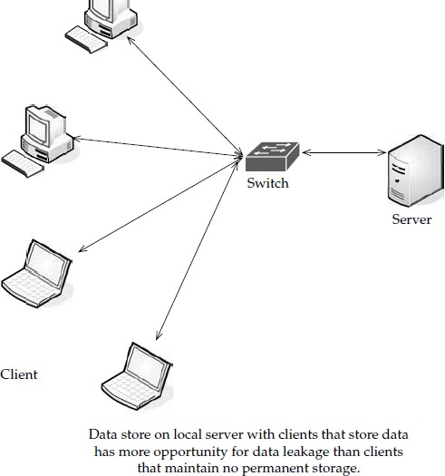

Centralization also provides the opportunity for better monitoring.

#### Logging

Logging is also improved. It’s something that, in-house, usually gets the short end of the stick. But in the virtualized world of cloud computing, providers can add as much memory

as they need to extend logging.

#### Forensics

If there is a breach, the cloud provider can respond to the incident with less downtime than if you had to investigate the breach locally. It is easy to build a forensic server online, and it costs almost nothing until it comes into use.

If there is a problem, the virtual machine can be cloned for easy offline analysis.

#### Development

They are actively developing products that can apply to virtual machines and the cloud.

Security vendors also have a unique opportunity in the cloud. Since it’s new ground,

there are new opportunities for the vendors who are open-minded enough to imagine them.

#### Auditing

As an IT professional, you already know the headache of securing your own local network. But when you send your data to the cloud, a whole new set of issues arise. This is largely because your data is being stored on someone else’s equipment.

#### Compliance

The same security issues that your organization deals with are the sorts of issues that SaaS providers face—securing the network, hardware issues, applications, and data. But compliance adds another level of headache. Regulations like Sarbanes-Oxley (SOX),

Gramm-Leach-Bliley (GLBA), and HIPAA, and industry standards like the Payment Card Industry Data Security Standard (PCI DSS) make things particularly challenging

Prior to SaaS, compliance could be managed by a few tasks:

* + Identify users and access privileges
  + Identify sensitive data
  + Identify where it’s located
  + Identify how it is encrypted
  + Document this for auditors and regulators

SaaS makes these steps even more complicated. If you store compliance-sensitive data with an SaaS provider, it is difficult to know where the data is being stored.

#### The PCI Appendix A

Requirement A.1 of Appendix A has four subprovisions that regulate how data is maintained by a service provider.

#### Requirement A.1.1—Unauthorized Exposure

The first subsection requires that each client of the provider only has access to their own

data.

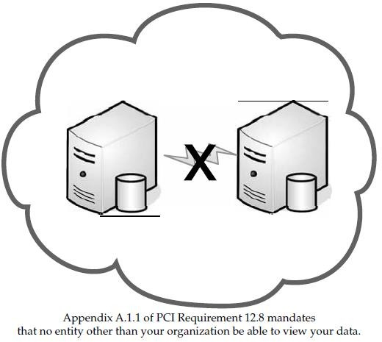

#### Appendix A.1.2—Credential Management

This section of Appendix A requires that access controls be held by the service provider and that the controls only allow the client to be able to access that data and to protect the data from others. Either the provider can maintain those controls or maintenance can be done by connecting to the client’s access management system. If the SaaS provider handles access controls, the authentication credentials are stored on the provider’s servers. While providers generally claim this method is safe and secure, use extra caution. If there is a breach at the provider, then not only could your data be compromised, but also your authentication credentials **Appendix A.1.3—Logging**

Logging and audit trails are covered by Appendix A.1.3. This is also mandated by Requirement 10 of PCI. Logs and audit trails are used for investigating

incidents.

#### Appendix A.1.4—Reporting

Service providers must “provide for timely forensic investigation” if there is a breach.

The SaaS provider’s logs are internal and most likely not accessible by clients, so monitoring is nearly impossible.

#### Web Application Breaches

Because service providers use so many web connections, they should be asked about the security of their web applications. This should include whether they follow Open Web Application Security Project (OWASP) guidelines for secure application development. This is similar to Requirement 6.5 of PCI, which requires compliance with OWASP coding procedures. **VPNs**

With applications being moved to the cloud, it makes it possible for each and every worker to be a telecommuter.

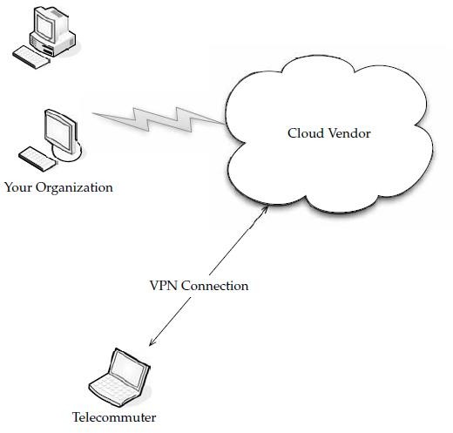

Also, there is certainly more to your datacenter than web applications. You have file storage, email, productivity applications, and anything else that doesn’t lend itself to being web-based.

**What SSL** Is An SSL VPN (Secure Sockets Layer virtual private network) is a VPN that can be used with a standard web browser. As compared to the traditional IPsec (Internet

Protocol Security) VPN, an SSL VPN does not require you to install specialized client software on end users’ computers.

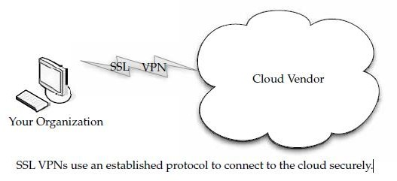

SSL is a protocol for managing the security of message transmission on the Internet. SSL is included as part of popular web browsers and most web server products. It employs a public and private key encryption system from RSA.

An SSL VPN cloud computing connection between your data center and the cloud provider secures your data without a lot of the Public Key Infrastructure (PKI) overhead

that comes from an IPsec-based VPN solution. Most SSL VPN gateways provide an on-demand client.

#### Better Security Practices

Requiring antivirus software to be running

* + Verifying that OS patches have been installed
  + Checking to see if malware or bots are running

#### Key Management

Remote services must also be cryptographically protected. You use an authorization infrastructure, like Kerberos, to ensure that you are properly authenticated.

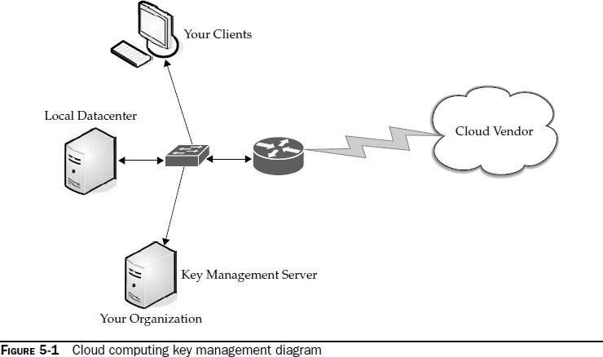

This process will make your data more secure, but it also requires a lot of keys. Consider the network diagram in Figure 5-1. Keys on the server include

* + Transport keys
  + Authentication keys
  + Authorization tokens
  + File encryption keys
  + Hardware storage keys
  + Revocation keys
  + Certificates

#### Network

In order for the cloud to deliver its best resources, there are differing levels of connectivity needed.

#### Basic Public Internet

The first option is the pipe most of us have coming into our office or homes. The public Internet is the most basic choice for cloud connectivity.

This is the type of access that you buy from an Internet service provider (ISP) and connect with via broadband or dial-up, based on your location.

This model has the following advantages:

* There’s a large audience. Anyone with Internet access can use this solution.
* It’s highly fault tolerant.
* Many provider options are available.
* Secure Sockets Layer (SSL)–based, Hypertext Transport Protocol Over Secure
* Sockets Layer (HTTPS), encrypted access provides confidentiality.
* It’s cost-effective.

It also has the following disadvantages:

* + Lack of end-to-end quality of service (QoS), thus making end-to-end service-level agreements (SLAs) difficult to reach.
  + Probability of poor response over high-latency connections. This is worsened by protocol inefficiencies in TCP, HTTP, and web services.
  + Downtime that might be out of your control (cable cuts, problems at the ISP, and so forth).

#### Optimized Internet Overlay

An optimized Internet overlay approach allows customers to access the cloud via the public Internet, but enhancement occurs on the provider’s cloud. Enhancements at these points of presence (POP) include

* + Optimized real-time routing. This helps avoid slowdowns, helping to make SLAs easier to attain.
  + An SSL session can be stopped so that protocols and payload can be optimized and re-encrypted.
  + Some of the application logic can reside on the POP. This allows for better scalability, fault tolerance, and response time, usually in excess of 80 percent.
  + Content that is frequently accessed can be delivered from local caches. Disadvantages of this method include
  + It is costlier than public Internet connectivity, sometimes as much as four times as much.
  + There is a strong vendor lock-in if the application is distributed into the carrier’s network.

#### Site-to-Site VPN

This setup allows confidentiality, guaranteed bandwidth, and SLAs for availability, latency, and packet loss. MPLS can also scale to meet changing bandwidth needs, and QoS can also be written into the SLAs.

#### Cloud Providers

Cloud providers that use services dispersed across the cloud need a robust connection method. Private tunnels make sure that bandwidth, latency, and loss aren’t as likely to affect performance. Plus, encryption and strong authentication offer another benefit.

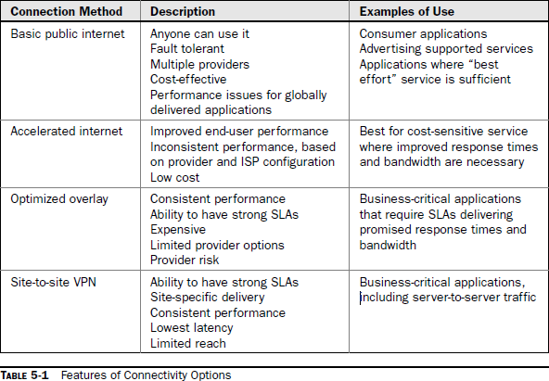Cloud providers that are growing might face big costs as network bandwidth charges increase. This traffic is from traffic both to and from clients as well as traffic among provider sites. Big providers, like Google, are able to sidestep these charges by building their own WANs with multiple peering points with major ISPs.

#### Cloud Consumers

Large companies can build their own scalable distributed IT infrastructure in which datacenters are connected with their own private fiber optic connections. This depends on distance, bandwidth requirements, and—of course—their budgets. This infrastructure starts to look like a cloud computing service.

Clients located at major sites normally access applications over the corporate WAN.

#### Pipe Size

Bandwidth is, simply put, the transmission speed or throughput of your connection to the Internet.

There are three factors that are simply out of your control when it comes to how much bandwidth you need:

* + The Internet bandwidth between your organization and the cloud
  + The round-trip time between your organization and the cloud
  + The response time of the cloud

#### Upstream/Downstream

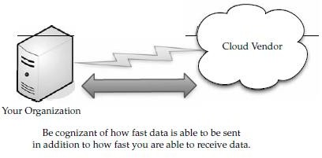Another factor to consider is whether it is okay for the transfers to be symmetric or asymmetric. If your connection with the cloud is symmetric, then that means you are sending and receiving data at the same rate. If your connection is asymmetric, then data is sent from your organization at a slower rate than you’re receiving it.

#### How Much Do We Need?

This can be a complex question, based on what you’ll be doing on the cloud. What you have to do is figure out how much data will be moving in and out of the cloud at any given time, and then decide how big of a pipe you need to move that data. Chances are good that you have a beefy enough Internet connection to make cloud computing viable.

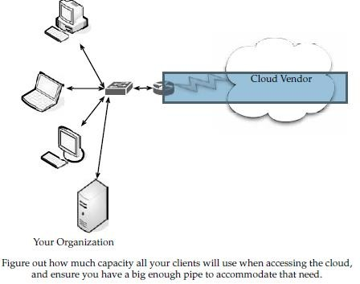

#### Redundancy

When formulating your cloud infrastructure, be sure to consider the issue of reliability and uptime and ask your service provider to configure your computing infrastructure for redundancy and failover.

In your LAN, redundancy used to mean that another server or two were added to the datacenter in case there was a problem. These days with virtualization, redundancy might mean a virtual server being cloned onto the same device, or all the virtual servers of one machine being cloned onto a second physical server.

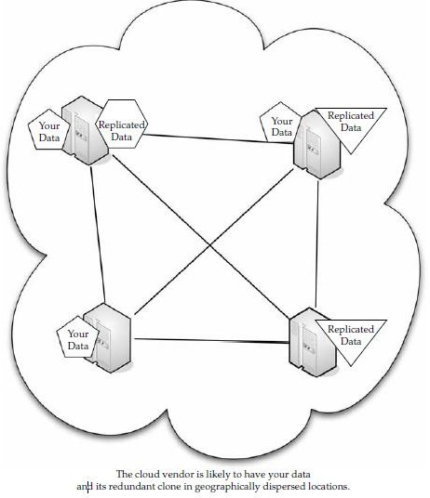

#### Services

There are different services you will need to run, depending on your cloud provider and what your organization does.

#### Identity

No matter where an application runs—in-house or on the cloud—it needs to know about its users. To accomplish this, the application asks for a digital identity—a set of bytes—to describe the user. Based on this information, the application can determine who the user is

and what he or she is allowed to do.

In-house applications rely on services like Active Directory to provide this information.

Clouds, however, have to use their own identity services. For instance, if you sign on to Amazon cloud services, you have to sign on using an Amazon-defined identity. Google’s

App Engine requires a Google account, and Windows uses Windows Live ID for use with Microsoft’s cloud applications Identity services need not be proprietary. OpenID is an open, decentralized, single signon standard that allows users to log in to many services using the same digital identity.

An OpenID is in the form of a uniform resource locator (URL) and does not rely on a central authority to authenticate a user’s identity. Since a specific type of authentication is not required, nonstandard forms of authentication may be used, including smart cards, biometric, or passwords. An OpenID registration is shown in Figure 5-2.

OpenID authentication is used by many organizations, including:

* + Google
  + IBM
  + Microsoft
  + Yahoo!

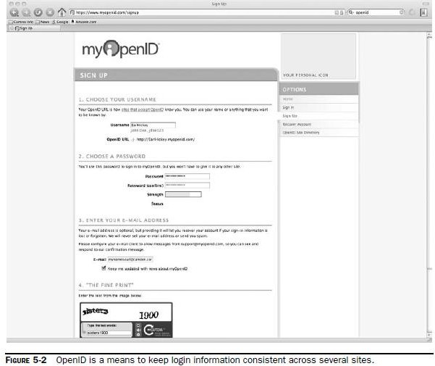

#### Integration

Integration is also on the cloud and technologies are being developed for that use, as

well. For example, Amazon’s Simple Queue Service (SQS) provides a way for applications to exchange messages via queues in the cloud.

SQS replicates messages across several queues, so an application reading from a queue may not see all messages from all queues on a given request.

Another example of cloud-based integration is BizTalk Services. Instead of using queuing, BizTalk Services utilizes a relay service in the cloud, allowing applications to communicate through firewalls.

Since cloud-based integration requires communicating through different organizations, the ability to tunnel through firewalls is an important problem to solve. **Mapping**

Maps are becoming more and more popular in web applications. For instance, hotel and restaurant web sites show their locations on their web sites and allow visitors to enter their addresses to get customized directions. But the guy who developed the web site likely didn’t have the time or money (not to

mention the interest) to make his own mapping database. Enough organizations want this functionality, however, so it is offered as a cloud application.

Such services as Google Maps and Microsoft’s Virtual Earth provide this cloud-based function, allowing developers to embed maps in web pages.

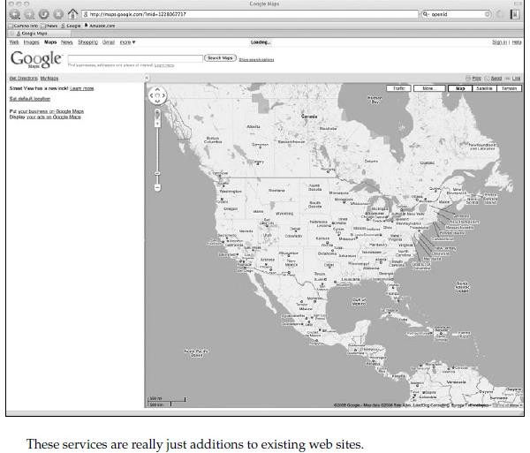

#### Payments

Another cloud service that you might want to plan for and configure your hardware appropriately for is payments. Depending on your organization, you may or may not want to accept online payments from customers.

#### Search

The ability to embed search options in a web site is certainly nothing new, but it is a rich feature that you might want to employ in your own web or application development.

Microsoft’s Live Search allows on-site and cloud applications to submit searches and then get the results back.

## Accessing the cloud

#### Platforms

A platform is how a cloud computing environment is delivered to you.

#### Web Application Framework

A web application framework is used to support the development of dynamic web sites, web applications, and web services. The point of a framework is to reduce the overhead

that comes with common activities in web development. For instance, frameworks provide libraries that are already written so the developer doesn’t have to reinvent the wheel every time a web site is developed.

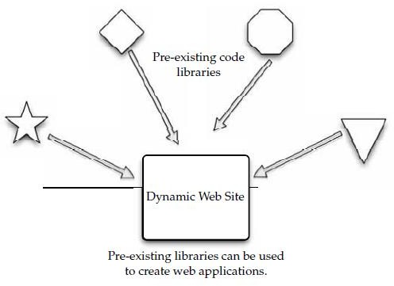

Early in the Web’s life, hypertext was mostly hand-coded Hypertext Markup Language

(HTML) that was published on Web servers. As the Web grew up, it became more dynamic with the

addition of the Common Gateway Interface (CGI). This allowed external applications to interface with web servers.

#### AJAX

Asynchronous JavaScript and XML (AJAX) is a group of web development techniques used for creating interactive web applications. By using AJAX, web applications can retrieve data from the server asynchronously.

#### Technologies

AJAX is a term that represents a wide range of web technologies that can be used to help web applications communicate with a server, but without interfering with the current state of that page. AJAX refers to these technologies:

* Extensible Hypertext Markup Language (XHTML) and Cascading Style Sheets
* (CSS) for presentation
* The Document Object Model for dynamic display of and interaction with data
* XML and Extensible Style Sheet Language Transformations (XSLT) for the
* interchange and manipulation of data, respectively
* The XMLHttpRequest object for asynchronous communication
* JavaScript to bring these technologies together

#### Pros and Cons

AJAX does some things right, but struggles with others. Among its advantages are the following capabilities:

Often, multiple pages on a web site contain the same information. If those pages were coded by hand, the same content would have to be written into each and everypage.

* + AJAX allows a web application to simply retrieve new information and adjust how the content is presented. This is very efficient and reduces the amount of bandwidth consumed and reduces load times.
  + Using asynchronous requests allows the client’s web browser to be more interactive and respond quickly to user inputs. The user may even perceive the application to be faster.
  + Connections to the server are reduced, because scripts and style sheets need only be
  + downloaded once. Disadvantages to AJAX include
  + Dynamically created web pages do not show up in the browser’s history engine, so clicking on the Back button would not re-create the last seen page.
  + It is difficult to bookmark a dynamically created web page.
  + If a browser does not support AJAX or if JavaScript is disabled, AJAX functionality cannot be used.
  + There is no standards body behind AJAX, so there is no widely adopted best practice to test AJAX applications

#### Python Django

Django is an open-source web application framework written in Python. Django was developed to ease the creation of database-driven web sites and uses reusability of components. Included in the core framework are

* + A lightweight, stand-alone web server for development and testing.
  + A caching framework, which can use any of several cache methods.
  + An internal dispatcher system that allows an application’s components to communicate using predefined signals.
  + An internationalization system that translates Django’s components into multiple languages.
  + A scheme for extending the capabilities of the template engine.

#### Web Hosting Service

A web hosting service that will allow you to store your data and applications. Some web hosting services include Amazon Elastic Compute Cloud and Mosso.

#### Amazon Elastic Compute Cloud

Amazon Elastic Compute Cloud (<http://aws.amazon.com/ec2)>is a web service that provides resizable compute capacity in the cloud. Amazon EC2’s web service interface allows you to obtain and configure capacity with minimal friction.

* It provides complete control of your computing resources and lets you run on Amazon’s computing environment.
* Amazon EC2 reduces the time required to obtain.
* EC2 uses Xen virtualization.
* One EC2 Compute Unit equals a 1.0–1.2GHz 2007 Opteron or 2007 Xeon processor.
* The service initially offered Sun Microsystems OpenSolaris and Solaris Express
* Community Edition.

#### Mosso

Mosso is the home of The Hosting Cloud and CloudFS, providing enterprise-grade hosting and storage services. Mosso provides an easily managed interface so that developers, designers, and IT managers can deploy reliable web applications quickly and easily as well

as a high-performance cloud-based storage service.

There are three components to Mosso’s offering:

* **Cloud Sites** Advertised as “the fastest way to put sites on the cloud”; runs Windows or Linux applications across hundreds of servers.
* **Cloud Files** Provides unlimited online storage for media (examples include backups, video files, user content), which is served out via Limelight Networks’

Content Delivery Network.

* **Cloud Servers** Able to deploy from one to hundreds of cloud servers instantly and creates advanced, high-availability architectures.

************************************************************************

#### Proprietary Methods

Individual companies offer their own, proprietary methods to connect to the cloud. Microsoft and Force.com are two examples of companies that have designed their own infrastructure for connecting to the cloud.

#### Azure

The Azure Services Platform is Microsoft’s cloud solution that spans from the cloud to the enterprise datacenter. Further, it delivers content across the PC, web, and phone.

* The platform combines cloud-based developer capabilities with storage, computational, and networking infrastructure services, all hosted on servers operating within Microsoft’s global datacenter network.
* This provides developers with the ability to deploy applications in the cloud or on- premises and enables experiences across a broad range of business and consumer scenarios.

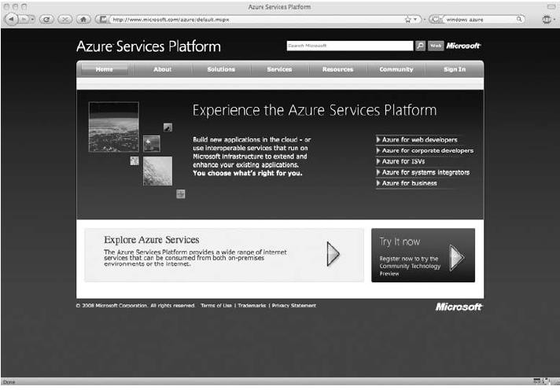

* The Azure Services Platform provides developers with the ability to create applications while taking advantage of their existing skills, tools, and technologies such as the Microsoft

.NET Framework and Visual Studio.

Key components of the Azure Services Platform include the following:

* Windows Azure for service hosting and management, low-level scalable storage, computation, and networking.
* Microsoft SQL Services for a wide range of database services and reporting.
* Microsoft .NET Services, which are service-based implementations of familiar .NET Framework concepts such as workflow and access control.
* Live Services for a consistent way for users to store, share, and synchronize documents, photos, files, and information across their PCs, phones, PC applications, and web sites.
* Microsoft SharePoint Services and Microsoft Dynamics CRM Services for business content, collaboration, and rapid solution development in the cloud.

**Force.com**

Force.com, a PaaS from Salesforce.com, is another way to create and deploy business applications. By replacing the complexity of software platforms with a complete, scalable service, Force.com provides developers a fast path to turn ideas into business impact.

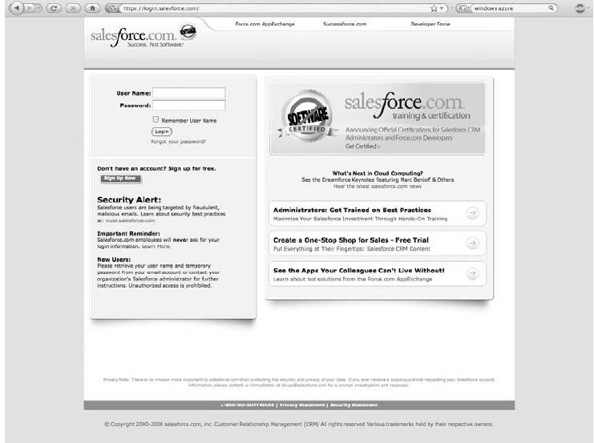

#### Force.com Features

* + Force.com PaaS provides the building blocks necessary to build any kind of business application, and automatically deploy them as a service to small teams or entire enterprises.
  + The Force.com platform gives customers the ability to run multiple applications within the same Salesforce.com instance, allowing all of a company’s Salesforce.com applications to share a common security model, data model, and user interface.
  + The multitenant Force.com platform encompasses a complete feature set for the creation of business applications such as an on-demand operating system, the ability to create any

#### Visualforce

database on demand, a workflow engine for managing collaboration between users, the Apex Code programming language for building complex logic, the Force.com Web Services API for programmatic access, mashups, and integration with other applications and data, and now Visualforce for a framework to build any user interface.

As part of the Force.com platform, Visualforce gives customers the ability to design application user interfaces for any experience on any screen.

Visualforce features and capabilities include:

* **Pages** Enables the design definition of an application’s user interface. This enables developers to create new pages using standard web technologies including HTML, AJAX, and Flex. Pages allows developers to create any user experience with standard web technologies.
* **Components** Provides the ability to create new applications that automatically match the look and feel of Salesforce applications or easily customize and extend the Salesforce user interface to specific customer and user requirements. Customers can create a user experience by assembling existing user interface elements.
* **Logic Controllers** Enables customers to build any user interface behavior. Customers can use Visualforce to quickly create a new look and feel that leverages existing application functionality. The standard controller gives customers the ability to inherit and reuse any standard Salesforce UI behavior like new, edit, and save.

#### Web Applications

You have tons of options when it comes to finding online applications. Your provider may have a stable of premade applications that you can use. Different companies offer different things.

Google Apps, launched as a free service in August 2006, is a suite of applications that includes

* Gmail webmail services
* Google Calendar shared calendaring
* Google Talk instant messaging and Voice Over IP
* Start Page for creating a customizable home page on a specific domain Google Apps also include
  + **Google Docs and Spreadsheets** With this addition, teams can collaborate on documents and spreadsheets without the need to email documents back and forth. Multiple employees can securely work on a document at the same time. All revisions are recorded for editing, and administrative controls allow organizations to define limits on document sharing.
  + **Gmail for mobile devices on BlackBerry** Gmail for mobile devices provides the same Gmail experience—such as search, conversation view, and synchronization with desktop version—on BlackBerry handheld devices for users of Google Apps. Gmail for mobile devices joins a list of other mobile options for Google Apps and BlackBerry users that already includes a Google Talk client and a variety of calendar sync tools.
  + **Application-level control** Allows administrators to adapt services to business policies, such as sharing of calendars or documents outside of the company.

#### Web APIs

**API**

To use APIs when building your apps. There are a number of different APIs.

An application programming interface (API) is a set of programming instructions and

standards for accessing a web-based program. Software companies release their APIs to the public so that other software developers can design products that are powered by its service.

For example, Amazon released its own API so that web site developers could more easily access information maintained at the Amazon web site.

APIs allow one program to speak with another. They are not user interfaces.

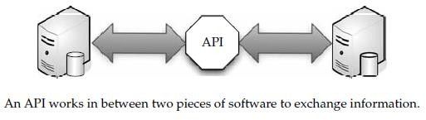

An API is similar to Software as a Service (SaaS), because software developers don’t have to start from scratch every time they write a program.

#### How APIs Work

An API is (as the acronym says) an interface that defines the way in which two things will communicate. With APIs, the calls back and forth are managed by web services. Web services are a collection of standards including XML, the programming language that

allows applications to communicate over the Internet.

XML isn’t the only standard that makes APIs work. Other standards include

* **SOAP (Simple Object Access Protocol)** SOAP encodes XML messages so that they can be received and understood by any operating system over any type of

network protocol.

* **UDDI (Universal Description, Discovery, and Integration)** UDDI is an XMLbased directory that allows businesses to list themselves, find each other, and collaborate using web services.
* **WSDL (Web Services Description Language)** WSDL is the SOAP of UDDI. WSDL is the XML-based language that businesses use to describe their services in the UDDI. **API Creators**

**Google Gadgets** Google Gadgets are a desktop search application that enables users to search their email, files, web history, and chats.

The Google Gadgets API is composed of three languages:

* **XML** This is the language you use to write gadget specifications. A gadget is just

an XML file, placed on the Web somewhere where Google can find it. The XML file contains the instructions on how to process and render the gadget. The XML file can contain all the data, or it can have reference URLs where the data can be found.

* **HTML** HTML is the markup language used to format the pages on the web. It is generally responsible for the static portions of your web pages. HTL and XML look similar, but HTML is used to format web documents, whereas XML is used to describe structured data.
* **JavaScript** JavaScript is the scripting language you can use to add dynamic behavior to your gadgets.

The application operates locally on the user’s computer, where it provides the following capabilities:

* **System-wide search** Users can search across their email and a wide range of files

and information such as email in Microsoft Outlook and Outlook Express; files in Microsoft Word, Microsoft Excel, Microsoft PowerPoint, and text; web site history in Internet Explorer; and instant message chats in AOL Instant Messenger.

**High search speed** Google.com can search billions of web pages in a fraction of a second. Google Desktop Search is built with the same technology, and it can search a single hard drive in even less time.

* **Easy access to desktop results via Google.com** Google Desktop Search enables

users to search both their computer and the Web simultaneously. When users search through Google.com (either from the home page or the Google Toolbar), Google Desktop Search runs the same search in parallel on the user’s computer. If Google desktop Search finds relevant results, those results are added to the Google.com search results page. This means that users don’t need to decide before they search whether to search the Web or their computer.

* **Dynamic results** Unlike traditional computer search software that updates once a day, Google Desktop Search updates continuously for most file types. When a user downloads a new email in Outlook, for example, it can be found within seconds using Google Desktop Search.

#### Google Data APIs

The Google Data APIs provide a simple standard protocol for reading and writing data on the Web.

The Google Data APIs include

* Google Apps APIs
* Google Base Data API
* Blogger Data API
* Google Book Search Data API
* Google Calendar Data API
* Google Code Search Data API
* Google Contacts Data API
* Google Documents List Data API
* Google Finance Portfolio Data API
* Google Health Data API
* Google Notebook Data API
* Picasa Web Albums Data API
* Google Spreadsheets Data API
* Webmaster Tools Data

**Partnership** Salesforce.com partnered with Google, making it easier for developers to create applications for cloud computing.

#### GoGrid

GoGrid’s API is a web service that allows developers to control their interaction with GoGrid’s

cloud hosting infrastructure. Typical uses for the API include

* Auto-scaling network servers
* Listing assigned public and private IP addresses
* Deleting servers
* Listing billing details

The GoGrid API supports these languages:

* Java
* PHP
* Python
* Ruby

#### Apex

The Apex Web Services API is one of the world’s most widely used enterprise web services, handling more than 50 percent of Salesforce.com’s 3.7 billion service transactions.

The Apex Web Services API makes it possible to access and manage complex data relationships—such as a set of information about an account, all the products they have bought, and all of their contacts—in a single request.

#### Development Platform

Apex is a development platform for building Software as a Service (SaaS) applications on top of Salesforce.com’s customer relationship management (CRM) functionality.

The Apex platforms consist of three tools:

* **Apex Builder** An on-demand component allowing easy drag-and-drop customization with a limited set of features.
* **Apex API** A method of retrieving raw data from Salesforce.com’s servers. The API

is used by programs that are external to Salesforce.com, like Java applications that need access to information on a client’s Salesforce.com account.

* **Apex Code** A programming language that is executed on Salesforce.com’s servers. The Apex Code offers flexibility in developing by using the Apex API while reducing the number of calls between the client and server.

#### Web Browsers

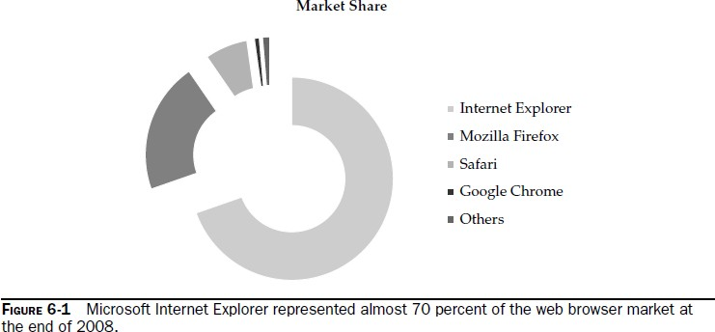

**Internet Explorer**

Windows Internet Explorer 8 for Windows Vista, XP, and Windows 7 is the latest version of the popular web browser.

#### IE 8 Features

Internet Explorer 8 delivered a new look and enhanced capabilities that made everyday tasks—such as searching, browsing multiple sites, and printing—simple and fast.

Internet Explorer 8 has been designed to include three rendering modes:

* + One that reflects Microsoft’s implementation of current web standards
  + A second reflecting Microsoft’s implementation of web standards at the time of the release of Internet Explorer 7 in 2006
  + A third based on rendering methods dating back to the early Web.

#### Firefox

In June 2008 Mozilla released Firefox 3, a major update to its popular, free, open-source web browser. Firefox 3 is the culmination of three years of efforts from thousands of developers,

security experts, localization and support communities, and testers from around the globe.

* **User Experience** The enhancements to Firefox 3 include the new Firefox 3 smart location bar, affectionately known as the “Awesome Bar.” It learns as people use it, adapting to user preferences and offering better-fitting matches over time.
* **Firefox Performance** Firefox 3 is built on top of the Gecko 1.9 platform, resulting in a safer, easier-to-use, and more personal product.
* **Security** Firefox 3 raises the bar for security. The new malware and phishing protection helps protect from viruses, worms, trojans, and spyware to keep people safe on the Web.
* **Customization** Firefox 3 lets users customize their browser with more than 5,000 add- ons. Firefox add-ons allow users to manage tasks like participating in online auctions, uploading digital photos, seeing the weather forecasts, and listening to music, all from the convenience of the browser.

#### Safari

Apple claims that Safari 3.1 is the world’s fastest web browser for Mac and Windows

PCs, loading web pages 1.9 times faster than Internet Explorer 7 and 1.7 times faster than Firefox 2. Safari also runs JavaScript up to six times faster than other browsers, and is the first browser to support the latest innovative web standards needed to deliver the next generation

of highly interactive Web 2.0 experiences. Safari 3.1 is available as a free download at [www.apple.com/safari](http://www.apple.com/safari) for both Mac OS X and Windows.

* **Safari Performance** Safari features an intuitive browsing experience with drag-and-drop bookmarks, easy-toorganize tabs, an integrated Find capability that shows the number of matches in a page, and a built-in RSS reader to quickly scan the latest news and information.
* **System Requirements** Safari 3.1 for Mac OS X requires Mac OS X Leopard or Mac OS X Tiger version 10.4.11 and a minimum of 256MB of memory and is designed to run on any Intel-based Mac or a Mac with a PowerPC G5, G4, or G3 processor and built-in FireWire.

#### Chrome

Chrome is Google’s foray into the open-source browser market. In the early days of the Internet, web pages were frequently little more than text. But today the Web has evolved

into a powerful platform that enables users to collaborate with friends and colleagues

through email and other web applications, edit documents, watch videos, listen to music, manage finances, and much more.

#### Chrome Features

* + A combined search and address bar quickly takes users where they want to go.
  + When users open a new tab in Google Chrome, they’ll see a page that includes snapshots of their most-visited sites, recent searches, and bookmarks, making it easier to navigate the Web.
  + Each browser tab operates as a separate process; by isolating tabs, if one tab crashes or misbehaves, others remain stable and responsive, and users can continue working without having to restart Google Chrome.

#### Open Source

The intent is that Google will help make future browsers better by contributing the underlying technology in Google Chrome to the market, while continuing to develop additional features.

#### Chrome Cloud

There’s a lot of buzz around Chrome being a great tool for cloud computing. Major API components to Gears include

* A database module that can store data locally
* A WorkerPool module that provides parallel execution of JavaScript code
* A LocalServer module that caches and serves application resources (like HTML, JavaScript, images, and so on)
* A Desktop module that lets web applications interact more naturally with the desktop
* A Geolocation module that lets web applications detect the geographical location of their users.

#### Cloud Storage

Cloud storage has a number of advantages over traditional data storage. If you store your data on a cloud, you can get at it from any location that has Internet access.

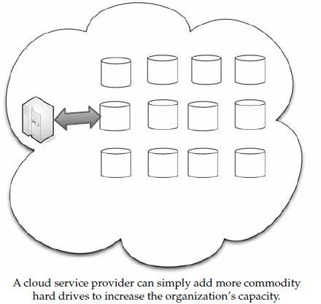

cloud storage systems utilize dozens or hundreds of data servers. Because servers require maintenance or repair, it is necessary to store the saved data on multiple machines, providing redundancy. Without that redundancy, cloud storage systems couldn’t assure clients that they could access their information at any given time.

**Storage as a Service**

The term Storage as a Service (another Software as a Service, or SaaS, acronym) means that a third-party provider rents space on their storage to end users who lack the budget or capital budget to pay for it on their own. It is also ideal when technical personnel are not available

or have inadequate knowledge to implement and maintain that storage infrastructure. Storage service providers are nothing new, but given the complexity of current backup, replication, and disaster recovery needs, the service has become popular, especially among small and medium-sized businesses.

The biggest advantage to SaaS is cost savings. Storage is rented from the provider using

a cost-per-gigabyte-stored or cost-per-data-transferred model.

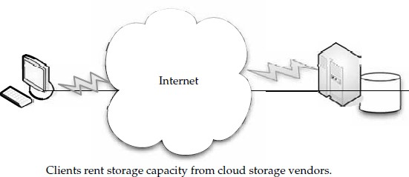

#### Providers

There are hundreds of cloud storage providers on the Web, and more seem to be added each day.

* Google Docs (shown in Figure 7-1) allows users to upload documents, spreadsheets,

and presentations to Google’s data servers. Those files can then be edited using a Google application.

* Web email providers like Gmail, Hotmail, and Yahoo! Mail store email messages on their own servers. Users can access their email from computers and other devices connected to the Internet.
* Flickr and Picasa host millions of digital photographs. Users can create their own online photo albums.
* YouTube hosts millions of user-uploaded video files.
* Hostmonster and GoDaddy store files and data for many client web sites.
* Facebook and MySpace are social networking sites and allow members to post
* Pictures and other content. That content is stored on the company’s servers.
* MediaMax and Strongspace offer storage space for any kind of digital data.

### Security

To secure data, most systems use a combination of techniques:

* **Encryption** A complex algorithm is used to encode information. To decode the encrypted files, a user needs the encryption key.
* **Authentication processes** This requires a user to create a name and password.
* **Authorization practices** The client lists the people who are authorized to access information stored on the cloud system.

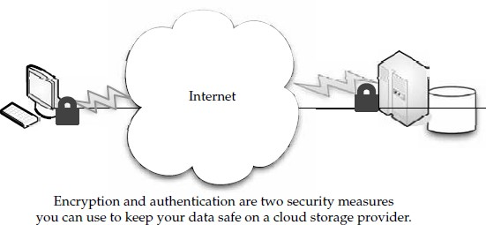

#### Reliability

Most cloud storage providers try to address the reliability concern through redundancy, but the possibility still exists that the system could crash and leave clients with no way to access their saved data.

Reputation is important to cloud storage providers.

#### Advantages

* Cloud storage is becoming an increasingly attractive solution for organizations.
* Cloud storage providers balance server loads and move data among various datacenters.
* some products are agent-based, and the application automatically transfers information to the cloud via FTP. But others employ a web front end, and the user has to select local files on their computer to transmit.
* Amazon S3 is the best-known storage solution, but other vendors might be better for large enterprises.

#### Cautions

Large enterprises might have difficulty with vendors like Google or Amazon, because they are forced to rewrite solutions for their applications and there is a lack of portability.

A vendor like 3tera, however, supports applications developed in LAMP, Solaris, Java, or

Windows.NET.

The biggest deal-breakers when it comes to cloud storage seem to be price and reliability. This is where you have to vet your vendor to ensure you’re getting a good deal with quality service. One mistake on your vendor’s part could mean irretrievable data.

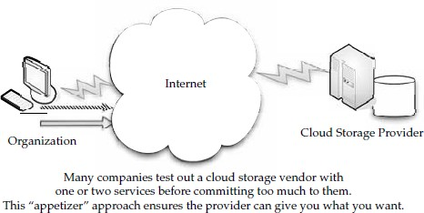

#### Outages

Legal issues are also important.

Further, organizations have to be cognizant of the inherent danger of storing their data on the Internet. Amazon S3, for example, dealt with a massive outage in February 2008. The result was numerous client applications going offline. Amazon reports that they have responded to the problem, adding capacity to the authentication system blamed for the problem. They also note that no data was lost, because they store multiple copies of every object in several locations.

#### Theft

You should also keep in mind that your data could be stolen or viewed by those who are not authorized to see it. Whenever your data is let out of your own datacenter, you risk trouble from a security point of view.

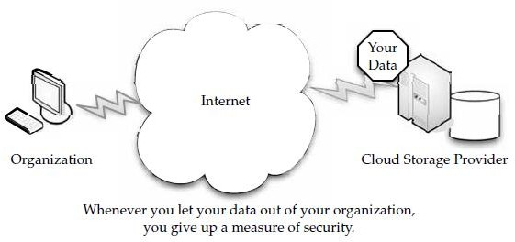

#### Cloud Storage Providers

some of the big players in the game have to offer, and you can use it as a starting guide to determine if their services match your needs. Amazon and Nirvanix are the current industry top dogs.

#### Amazon Simple Storage Service (S3)

The best-known cloud storage service is Amazon’s Simple Storage Service (S3), which launched in 2006. Amazon S3 is designed to make web-scale computing easier for developers. Amazon S3 provides a simple web services interface that can be used to store and retrieve any amount of data, at any time, from anywhere on the Web. It gives any developer access to the same highly scalable data storage infrastructure that Amazon uses to run its own global network of web sites. The service aims to maximize benefits of scale and to pass those benefits on to developers.

Amazon S3 is intentionally built with a minimal feature set that includes the following functionality:

* Write, read, and delete objects containing from 1 byte to 5 gigabytes of data each. The number of objects that can be stored is unlimited.
* Each object is stored and retrieved via a unique developer-assigned key.
* Objects can be made private or public, and rights can be assigned to specific users.
* Uses standards-based REST and SOAP interfaces designed to work with any Internet-development toolkit.

#### Design Requirements

Amazon built S3 to fulfill the following design requirements:

* **Scalable** Amazon S3 can scale in terms of storage, request rate, and users to support an unlimited

number of web-scale applications.

* **Reliable** Store data durably, with 99.99 percent availability. Amazon says it does not allow any downtime.
* **Fast** Amazon S3 was designed to be fast enough to support high-performance applications. Server-side latency must be insignificant relative to Internet latency.
* **Inexpensive** Amazon S3 is built from inexpensive commodity hardware components.
* **Simple** Building highly scalable, reliable, fast, and inexpensive storage is difficult.

#### Design Principles

Amazon used the following principles of distributed system design to meet Amazon S3 requirements:

* **Decentralization** It uses fully decentralized techniques to remove scaling bottlenecks and single points of failure.
* **Autonomy** The system is designed such that individual components can make decisions based on local information.
* **Local responsibility** Each individual component is responsible for achieving its consistency; this is never the burden of its peers.
* **Controlled concurrency** Operations are designed such that no or limited concurrency control is required.
* **Failure toleration** The system considers the failure of components to be a normal mode of operation and continues operation with no or minimal interruption.
* **Controlled parallelism** Abstractions used in the system are of such granularity that parallelism can be used to improve performance and robustness of recovery or the introduction of new nodes.
* **Small, well-understood building blocks** Do not try to provide a single service that does everything for everyone, but instead build small components that can be used as building blocks for other services.
* **Symmetry** Nodes in the system are identical in terms of functionality, and require no or minimal node-specific configuration to function.
* **Simplicity** The system should be made as simple as possible, but no simpler.

**How S3 Works**

Amazon keeps its lips pretty tight about how S3 works, but according to Amazon, S3’s design aims to provide scalability, high availability, and low latency at commodity costs. S3 stores arbitrary objects at up to 5GB in size, and each is accompanied by up to 2KB of metadata. Objects are organized by *buckets*. Each bucket is owned by an AWS account and the buckets are identified by a unique, user-assigned key.

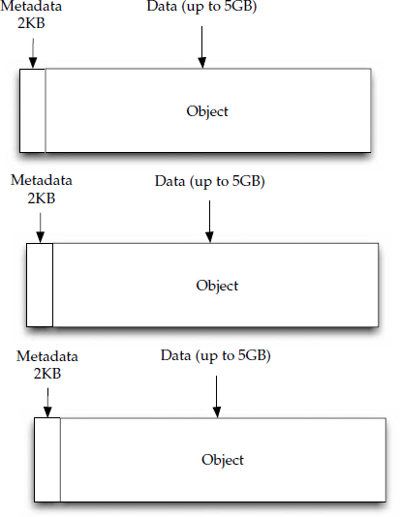

Buckets and objects are created, listed, and retrieved using either a REST-style or SOAP interface. Objects can also be retrieved using the HTTP GET interface or via BitTorrent. An access control list restricts who can access the data in each bucket.

#### Nirvanix

Nirvanix uses custom-developed software and file system technologies running on Intel storage servers at six locations on both coasts of the United States. They continue to grow, and expect to add dozens more server locations.

#### SDN Features

* Nirvanix Storage Delivery Network (SDN) turns a standard 1U server into an infinitecapacity network attached storage (NAS) file accessible by popular applications and immediately integrates into an organization’s existing archive and backup processes.
* Nirvanix has built a global cluster of storage nodes collectively referred to as the Storage Delivery Network (SDN), powered by the Nirvanix Internet Media File System (IMFS).
* The SDN intelligently stores, delivers, and processes storage requests in the best network location, providing the best user experience in the marketplace.
* The Nirvanix CloudNAS for Linux mounts the Nirvanix Storage Delivery Network as a virtual drive that can be accessed via NFS, CIFS, or FTP.
* Additionally, storage administrators get access to the robust Nirvanix SDN functionality such as automated policy-based file replication.

#### Benefits of CloudNAS

The benefits of cloud network attached storage (CloudNAS) include

* + Cost savings of 80–90 percent over managing traditional storage solutions
  + Elimination of large capital expenditures while enabling 100 percent storage utilization
  + Encrypted offsite storage that integrates into existing archive and backup processes
  + Built-in data disaster recovery and automated data replication on up to three geographically dispersed storage nodes for a 100 percent SLA
  + Immediate availability to data in seconds, versus hours or days on offline tape &&&&&&&&&&&&&&&&&&&&&&&&&&&&&&&&&&&&&&&&&&

#### Google Bigtable Datastore

In cloud computing, it’s important to have a database that is capable of handling numerous users on an on-demand basis.

Bigtable was developed with very high speed, flexibility, and extremely high scalability in mind. A Bigtable database can be petabytes in size and span thousands of distributed servers.

Bigtable is available to developers as part of the Google App Engine, their cloud computing platform.

#### How Bigtable Works

Bigtable is a complex offering that is not easy to understand. If you have trouble sleeping, they offer a very technical explanation Google describes Bigtable as a fast and extremely scalable DBMS. This allows Bigtable to scale across thousands of commodity servers that can collectively store petabytes of data. Each table in Bigtable is a multidimensional sparse map. That is, the table is made up of rows and columns, and each cell has a timestamp. Multiple versions of a cell can exist, each with a different timestamp. With this stamping, you can select certain versions of a web page, or delete cells that are older than a given date and time.

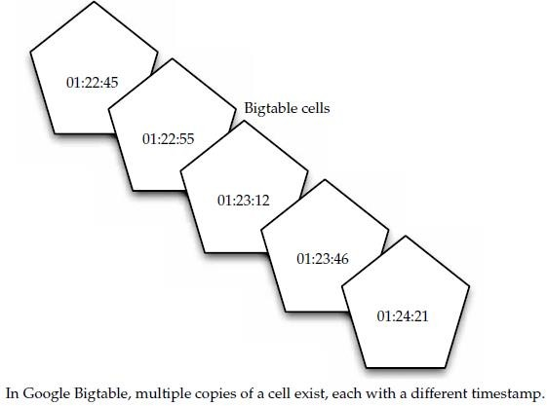

This architecture also allows for load balancing. If one table is getting a lot of queries,

it can remove other tablets or move the busy table to another machine that is not as busy. When a machine fills up, it compresses some tablets using a Google-proprietary technique. Bigtable tablet locations are stored in cells, and looking them up is a three-tiered system.

#### Issues

While Bigtable is a robust tool, developers have been cautious about using it.

### MobileMe

MobileMe is Apple’s solution that delivers push email, push contacts, and push calendars from the MobileMe service in the cloud to native applications on iPhone, iPod touch, Macs,

and PCs. MobileMe also provides a suite of ad-free web applications that deliver a desktoplike experience through any modern browser.

#### MobileMe Features

MobileMe web applications provide a desktop-like experience that allows users to drag and drop, click and drag, and even use keyboard shortcuts. MobileMe provides anywhere access to Mail, Contacts, and Calendar, with a unified interface that allows users to switch

between applications with a single click, and Gallery makes it easy to share photos on the Web in stunning quality. Gallery users can upload, rearrange, rotate, and title photos from any browser; post photos directly from an iPhone; allow visitors to download print-quality images; and contribute photos to an album. MobileMe iDisk lets users store and manage files online with drag-and-drop filing and makes it easy to share documents too large to email by automatically sending an email with a link for downloading the file. MobileMe includes 20GB of online storage that can be used for email, contacts, calendar, photos, movies, and documents.

#### Live Mesh

Live Mesh is Microsoft’s “software-plus-services” platform and experience that enables PCs and other devices to be aware of each other through the Internet, enabling individuals and organizations to manage, access, and share their files and applications seamlessly on the

Web and across their world of devices. Live Mesh has the following components:

* A platform that defines and models a user’s digital relationships among devices, data, applications, and people—made available to developers through an open data model and protocols.
* A cloud service providing an implementation of the platform hosted in Microsoft datacenters.
* Software, a client implementation of the platform that enables local applications to run offline and interact seamlessly with the cloud.
* A platform experience that exposes the key benefits of the platform for bringing

together a user’s devices, files and applications, and social graph, with news feeds across all of these.

Microsoft promises an open data model, and developers will be able to help Live Mesh grow through the development of additional applications and services.

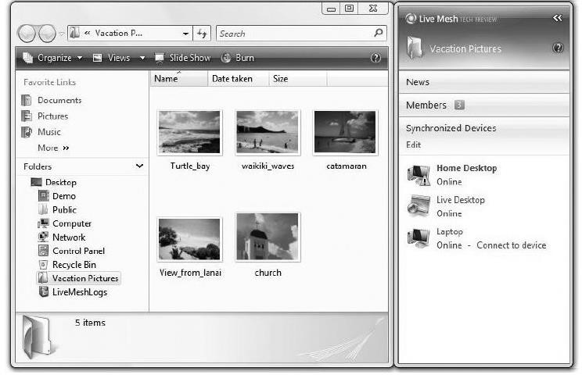

The Live Mesh software, called Mesh Operating Environment (MOE), is available for

* Windows XP
* Windows Vista
* Windows Mobile
* Mac OS X

## Cloud Standards Application

A cloud application is the software architecture that the cloud uses to eliminate the need to install and run on the client computer.

#### Communication

Computers need a common way to speak with one another. Think of it like talking on the telephone to someone who doesn’t speak English and you don’t speak their language. There’s no way to achieve a common understanding.

#### HTTP

To get a web page from your cloud provider, you’ll likely be using the Hypertext

Transfer Protocol (HTTP) as the computing mechanism to transfer data between the cloud and your organization. HTTP is a stateless protocol. This is beneficial because hosts do not need to retain information about users between requests, but this forces web developers to use alternative methods for maintaining users’ states.

GET/HTTP/1.0

Host: [www.velte.com](http://www.velte.com/) The server responds with HTTP/1.0 200 OK

Content-Type: text/html

<head>

<title>Thank you for visiting Velte Publishing. </title>

#### XMPP

The Extensible Messaging and Presence Protocol (XMPP) is being talked about as the

next big thing for cloud computing. The problem is that current cloud services—including SOAP and other HTTP-based protocols—are all one-way information exchanges.

XMPP allows for two-way communication and eliminates polling.

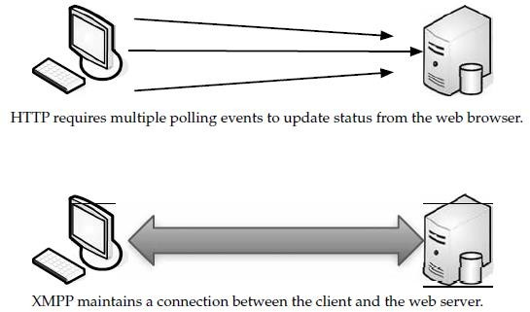

XMPP was developed for instant messaging and presence, and it is widely used in those circles. It includes the following features:

* XMPP allows for easy two-way communication, eliminating the need for polling.
* It is XML-based and easily extensible, which makes it ideal for cloud services.
* It is efficient and able to scale to millions of concurrent users on a single service.

#### Security

Widely used Secure Sockets Layer (SSL) for encryption, and one means of authentication, OpenID.

#### SSL

SSL is the standard security technology for establishing an encrypted link between a web

server and browser. This ensures that data passed between the browser and the web server stays private. To create an SSL connection on a web server requires an SSL certificate. When your cloud provider starts an SSL session, they are prompted to complete a number of questions about the identity of their company and web site. The cloud provider’s computers then generate two cryptographic keys—a public key and a private key.

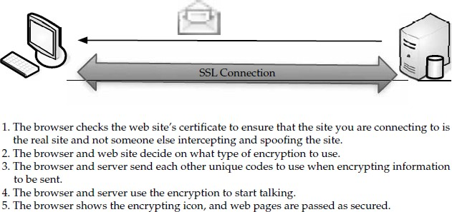

When a browser tries to connect securely to the cloud, it will retrieve the site’s SSL certificate and check that it has not expired and that it is being used by the web site for which it was issued.

#### OpenID

OpenID is an open-source solution for the problem of needing a unique username and password for access to different web sites, thus making your life simpler. This allows you to choose the OpenID provider that best meets your need and that you trust. OpenID is a lightweight way to authenticate users, using the same technology that is used to identify web sites. Anyone can be an OpenID user or provider for free.

## Client

When your clients connect to the cloud, they need to run certain software on their machines, and most often it’ll be a web browser, or a similarly equipped application.

* + **HTML** HTML is under constant revision to improve its usability and functionality. W3C is the organization that is charged with designing and maintaining the language. When you click on a link in a web page, you are accessing HTML code in the form of a hyperlink, which then takes you to another page.
    - **How HTML Works** HTML is a series of short codes typed into a text file by the author or created by web page design software. These short codes are called *tags*.

The text is then saved as an HTML file and viewed through a browser, like Internet Explorer or Mozilla Firefox.

* + - **Tags** Tags are what separate normal text from HTML code. You’ve likely seen them as the words between <angle brackets>.

<b>This text will appear in bold.</b> But this text won't.

* + - **Cascading Style Sheets in HTML** Cascading Style Sheets (CSS) are used to control how pages are presented, and make pages more accessible.
  + **Dynamic HTML** Dynamic HTML (DHTML) is not a new specification of HTML, but rather a different way of looking at and controlling the standard HTML codes and commands.

There are four parts to DHTML:

* Document Object Model (DOM)
* Scripts
* Cascading Style Sheets (CSS)
* XHTML
  + - **DOM** The Document Object Model (DOM) is what allows you to access your web page and make changes with DHTML.
    - **Scripts** The most common scripting languages in DHTML are JavaScript and ActiveX.
    - **Cascading Style Sheets in DHTML** CSS is used in DHTML to control the look and feel of the web page. Style sheets list the colors and fonts of text, the background colors and images, and the placement of objects on the page.
  + **XHTML** DHTML web pages are actually written in XHTML or HTML 4.x. DHTML is also used to build the elements for the CSS and the DOM to work on.

#### DHTML Features

DHTML has four main features:

* Changing the tags and properties
* Real-time positioning
* Dynamic fonts
* Data binding
* **JavaScript** Basic HTML does only basic stuff. It’s when you use JavaScript to write functions that are embedded in the HTML pages and interact with the DOM that you start adding pizzazz and specific user entered data that adds functionality to your web pages.

Here are some examples of the uses of JavaScript:

* + Opening or popping up new windows, and having control of the size and attributes of the window (whether to include menus, toolbars, and so on).
  + Validating web form input values to ensure that they will be accepted before submitting them to the server.
  + Changing images as the cursor rolls over them.

JavaScript is a scripting language used for client-side web development. The following is a sample JavaScript program:

<!DOCTYPE HTML PUBLIC "-//W3C//DTD HTML 4.01//EN"

"[http://www.w3.org/TR/html4/strict.dtd"](http://www.w3.org/TR/html4/strict.dtd)>

<html>

<head><title>simple page</title></head>

<body>

<script type="text/javascript"> document.write('Hello World!');

</script>

<noscript>

<p>Your browser either does not support JavaScript, or you have JavaScript turned off.</p>

</noscript>

</body>

</html>

## $$$$$$$$$$$$$$$$$$$$$$$$$$$$$$$$$$$$$$$$$$$$$$$$$$$$$$$$$$$$$$$$$$ Infrastructure

Infrastructure is a way to deliver virtualization to your cloud computing solution.

#### Virtualization

Virtualization is somewhat different, and major players worked together to develop a standard.

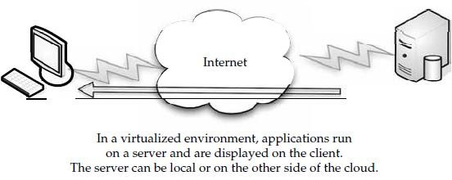

VMware, AMD, BEA Systems, BMC Software, Broadcom, Cisco, Computer Associates International, Dell, Emulex, HP, IBM, Intel, Mellanox, Novell, QLogic, and Red Hat all worked together to advance open virtualization standards.

These initiatives are intended to benefit end users by

* **Expanding virtualization solutions** The availability of open-standard virtualization interfaces and the collaborative nature of VMware Community Source are intended to accelerate the availability of new virtualization solutions.
  + **Expanded interoperability and supportability** Standard interfaces for hypervisors are expected to enable interoperability for customers with heterogeneous virtualized environments.
  + **Accelerated availability of new virtualization-aware technologies** Vendors across the technology

stack can optimize existing technologies and introduce new technologies for running in virtual environments.

#### Open Hypervisor Standards

Hypervisors are the foundational component of virtual infrastructure and enable computer system partitioning. An open-standard hypervisor framework can benefit customers by enabling innovation across an ecosystem of interoperable virtualization vendors and solutions.

As an initial step, VMware contributed an existing framework of interfaces, called Virtual Machine Hypervisor Interfaces (VMHI), based on its virtualization products to facilitate the development of these standards in an industry-neutral manner.

Cross-platform frameworks that govern the standardized operation and management of stand-alone virtual machine environments as well as highly dynamic, data center-scale deployment of virtualized systems

* + Cooperative virtualization APIs between hypervisors and guest operating systems
  + Virtual machine formats that enable virtual machine migration and recovery across platforms.

#### Community Source

The Community Source program provides industry partners with an opportunity to access VMware ESX Server source code under a royalty-free license. Partners can contribute shared code or create binary modules to spur and extend interoperable and integrated virtualization solutions. For customers, the VMware Community Source program is expected to yield a richer and broader set of partner solutions that are well integrated with VMware virtual infrastructure products.

#### OVF

As the result of VMware and its industry partners’ efforts, a standard has already been developed called the Open Virtualization Format (OVF). OVF describes how virtual appliances can be packaged in a vendor-neutral format to be run on any hypervisor. It is a platform-independent, extensible, and open specification for the packaging and distribution of virtual appliances composed of one or more virtual machines. OVF gives customers and developers the choice to select any hypervisor based on price, preference, or functionality, and it prevents vendor lock-in.

As part of their efforts to work with other vendors, VMware developed a standard with these features:

* Optimized for distribution
  + Enables the portability and distribution of virtual appliances
  + Supports industry-standard content verification and integrity checking
  + Provides a basic scheme for the management of software licensing
* A simple, automated user experience
  + Enables a robust and user-friendly approach to streamlining the installation process
  + Validates the entire package and confidently determines whether each virtual machine should be installed
  + Verifies compatibility with the local virtual hardware
* Portable virtual machine packaging
  + Enables platform-specific enhancements to be captured
  + Supports the full range of virtual hard disk formats used for virtual machine today, and is extensible to deal with future formats that are developed
  + Captures virtual machine properties concisely and accurately
* Vendor and platform independent
  + Does not rely on the use of a specific host platform, virtualization platform, or guest operating system
* Extensible
  + Designed to be extended as the industry moves forward with virtual appliance technology
* Localizable
  + Supports user-visible descriptions in multiple locales
  + Supports localization of the interactive processes during installation of an appliance
  + Allows a single packaged appliance to serve multiple market opportunities.

))))))))))))))))))))))))))))))))))))))))))))))))))))))))))))))))))))))))))))))))))))))))))))))))))

#### Web Services

A *web service*, as defined by the World Wide Web Consortium (W3C), “is a software system designed to support interoperable machine-to-machine interaction over a network” that may be accessed by other cloud computing components. Web services describe how data is transferred from the cloud to the client.

#### REST

Representational state transfer (REST) is a way of getting information content from a web site by reading a designated web page that contains an XML file that describes and includes the desired content.

For instance, REST could be used by your cloud provider to provide updated subscription information.

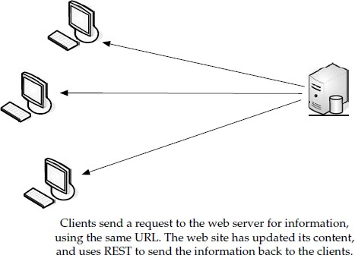

REST exploits existing technology and protocols of the Web including HTTP and XML. REST uses the same publishing approach that many sites use with RDF Site Summary (RSS). RSS uses the Resource Description Framework (RDF), which is a standard way to describe a web site.

REST offers the following benefits:

It gives better response time and reduced server load due to its support for the Caching of representations.

* + Server scalability is improved by reducing the need to maintain session state.
  + A single browser can access any application and any resource, so less client-side software needs to be written.
  + A separate resource discovery mechanism is not needed, due to the use of hyperlinks in representations.
  + Better long-term compatibility and evolvability characteristics exist than in RPC. This is due to:
  + The ability of documents, like HTML, to evolve with both forward- and backward- compatibility.
  + Resources can add support for new content types as they are defined, without

eliminating support for older content types.

#### SOAP

Simple Object Access Protocol (SOAP) is a way for a program running in one kind of operating system (such as Windows Vista) to communicate with a program in the same or another kind of an operating system (such as Linux) by using HTTP and XML as the tools to exchange information.

SOAP describes exactly how to encode an HTTP header and an XML file so that a program on one computer can call a program in another computer and pass it information. It also explains how a called program can return a response.

One of the advantages of SOAP is that program calls are more likely to get through firewalls that normally screen out requests for those applications.

POST /InStock HTTP/1.1 Host: [www.example.org](http://www.example.org/)

Content-Type: application/soap+xml; charset=utf-8 Content-Length: nnn

<?xml version="1.0"?>

<soap:Envelope xmlns:soap="<http://www.w3.org/2001/12/soap-envelope>"

soap:encodingStyle="[http://www.w3.org/2001/12/soap-encoding"](http://www.w3.org/2001/12/soap-encoding)>

<soap:Body xmlns:m="[http://www.example.org/stock"](http://www.example.org/stock)>

<m:GetStockPrice>

<m:StockName>IBM</m:StockName>

</m:GetStockPrice>

</soap:Body>

</soap:Envelope>

******************************************************

#### Software as a Serivce

In SaaS, an application is hosted by a service provider and then accessed via the World Wide Web by a client.

#### Overview

SaaS (Software as a Service) is an application hosted on a remote server and accessed through the Internet.

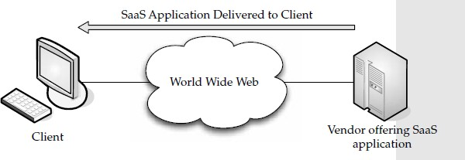

An easy way to think of SaaS is the web-based email service offered by such companies as Microsoft (Hotmail), Google (Gmail), and Yahoo! (Yahoo Mail). Each mail service meets the basic criteria: the vendor (Microsoft, Yahoo, and so on) hosts all of the programs and data in a central location, providing end users with access to the data and software, which is accessed across the World Wide Web.

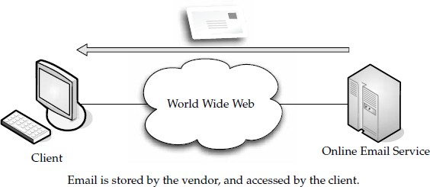

SaaS can be divided into two major categories:

* **Line of business services** These are business solutions offered to companies and enterprises. They are sold via a subscription service. Applications covered under this category include business processes, like supply-chain management applications, customer relations applications, and similar business-oriented tools.
* **Customer-oriented services** These services are offered to the general public on a subscription basis. More often than not, however, they are offered for free and supported by advertising. Examples in this category include the aforementioned web mail services, online gaming, and consumer banking, among others.

#### Advantages

There are definite advantages to your organization pursuing SaaS, for example:

* + There’s a faster time to value and improved productivity, when compared to the long n implementation cycles and failure rate of enterprise software.
  + There are lower software licensing costs.
  + SaaS offerings feature the biggest cost savings over installed software by eliminating the need for enterprises to install and maintain hardware, pay labor costs, and maintain the applications.
  + SaaS can be used to avoid the custom development cycles to get applications to the organization quickly.
  + SaaS vendors typically have very meticulous security audits.

SaaS, on the other hand, has no licensing. Rather than buying the application, you pay for it through the use of a subscription.

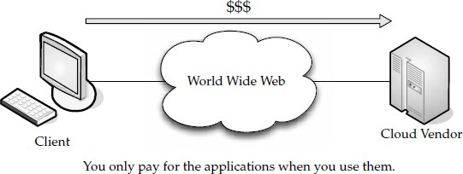

#### Vendor Advantages

The advantages flow both ways. Not only does the end user benefit, but so does the vendor. Vendors also benefit more as more subscribers come online. They have a huge investment in physical space, hardware, technology staff, and process development. The more these resources are used to capacity, the more the provider can clear as margin.

#### Limitations

* Technical obstacles to SaaS have included an effective, multitenant architecture. This has become less and less of a problem due to virtualization, but designing an application to efficiently deliver it to thousands of customers via the Internet is hard work.
* Another problem is that software companies are being asked to become service companies, and the two don’t necessarily mesh well. They tend to have a corporate culture that is dominated by engineering innovation and a license-sales mindset.
* Not only does the vendor face challenges, but so does the customer. While some applications are ideal for SaaS, others are not good to use employing an SaaS model. For example, Business Intelligence (BI) is tough to translate to a traditional SaaS approach.

#### Driving Forces

* **Popularity**

SaaS has become big buzz in the already buzzy issue of cloud computing. SaaS is becoming trendy, thanks to a number of factors. But there are solid reasons—other than hype—that make it so popular.

#### Software Vendors Love it

A couple of years ago, there were plenty of vendors who had nothing nice to say about SaaS.

#### Enterprises Love it

SaaS can be deployed both internally and externally. External use is especially appealing to IT professionals, because it takes work off their shoulders.

#### Plenty of SaaS Platforms

There are many SaaS platforms out there, and they grow each month. For example, Oracle is developing its own SaaS platform while Microsoft is working to make their own applications SaaS-ready**.**

Another reason SaaS platforms will continue to grow is because of the interest in Green IT and the efforts to move toward virtualized infrastructure.

#### Virtualization Benefits

Virtualization makes it easy to move to an SaaS system. One of the main reasons is that it is easier for independent software vendors (ISVs) to adopt SaaS is the growth of virtualization. The growing popularity of some SaaS vendors using Amazon’s EC2 cloud platform and the overall popularity of virtualized platforms.

#### SaaS and SOA

A service-oriented architecture (SOA) is one in which IT supports the business processes that cover current and emerging requirements to run the business end-to-end. This ranges from electronic data interchange (EDI) to online auctions.

SOA unifies business processes by structuring large applications as a collection of smaller modules known as “services.” SOA presents a design framework for realizing rapid and low-cost system development and improving total system quality.

SaaS and SOA are quite similar; what they have in common is that they use a services

model.

#### Company Offerings

There are dozens of companies offering SaaS.

Intuit QuickBooks has been around for years as a conventional application for tracking business accounting.

#### QuickBooks Overview

QuickBooks Online features include

* + The ability to access financial data anytime and from anywhere. QuickBooks Online is accessible to users 24 hours a day, seven days a week.
  + Automated online banking. Download bank and credit card transactions automatically every night, so it’s easy to keep data up to date.
  + Reliable automatic data backup. Financial data is automatically backed up every day and is stored on Intuit’s firewall-protected servers, which are monitored to keep critical

business information safe and secure. QuickBooks Online also supports 128-bit Secure Sockets Layer (SSL) encryption.

* + No software to buy, install, or maintain and no network required. The software is hosted online, so small business users never have to worry about installing new software or upgrades. QuickBooks Online remembers customer, product, and vendor information, so users don’t have to re-enter data.
  + Easy accounts receivable and accounts payable. Invoice customers and track customer payments. Create an invoice with the click of a button. Apply specific credits to invoices or apply a single-customer payment to multiple jobs or invoices. Receive bills and enter them into QuickBooks Online with the expected due date.
  + Write and print checks. Enter information in the onscreen check form and print checks.

#### iPhone and BlackBerry Capabilities

Additionally, Intuit Inc. offers both iPhone and BlackBerry integration with QuickBooks Online, the leading web-based small business accounting software. iPhone and BlackBerry applications help QuickBooks Online users get an up-to-date view of their finances by

* + Checking current bank and credit card balances
  + Tracking who owes them money and whom they owe
  + Finding vendor and customer contact info with addresses via Google Maps
  + Running balance sheet and profit and loss reports

#### Google

Google’s SaaS offerings include Google Apps and Google Apps Premier Edition.

Google Apps Premier Edition has the following unique features:

* **Per-user storage of 10GBs** Offers about 100 times the storage of the average corporate mailbox.
* **APIs for business integration** APIs for data migration, user provisioning, single sign-on, and mail gateways enable businesses to further customize the service for unique environments.
* **Uptime of 99.9 percent** Service level agreements for high availability of Gmail, with Google monitoring and crediting customers if service levels are not met.
* **Advertising optional** Advertising is turned off by default, but businesses can choose to include Google’s relevant target-based ads if desired.
* **Low fee** Simple annual fee of $50 per user account per year makes it practical to offer these

applications to select users in the organization. Google Apps now include

**Google Docs and Spreadsheets** Teams can collaborate on documents and spreadsheets without the need to email documents back and forth. Multiple employees can securely work on a document at the same time. All revisions are recorded for editing, and administrative controls allow organizations to define limits on document sharing.

* **Gmail for mobile devices on BlackBerry** Gmail for mobile devices provides the same Gmail experience—such as search, conversation view, and synchronization with desktop version—on BlackBerry handheld devices for users of Google Apps. Gmail for mobile devices joins a list of other mobile options for Google Apps and BlackBerry users that already includes a Google Talk client and a variety of calendar sync tools.
* **Application-level control** Allows administrators to adapt services to business policies, such as sharing of calendars or documents outside of the company.

**Microsoft**

Microsoft offers SaaS in a number of forms. One that is particularly appealing to small businesses is Microsoft Office Live Small Business.

Microsoft Office Live Small Business offers features including Store Manager, an e- commerce tool to help small businesses easily sell products on their own web site and on eBay; and E-mail Marketing beta, to make sending email newsletters and promotions simple and affordable.

Small businesses that sign up will receive a set of tools and features for free, including

* + Web hosting
  + Rich site-design capabilities
  + Numerous productivity applications
  + Contact management software for performing basic customer relationship management (CRM)
  + Custom domain name registration with 100 business email accounts (custom domains are free for the first year).
  + This release is also compatible with the Firefox 2.0 web browser, making the service accessible on both Macs and PCs.

The following features are available in Microsoft Office Live Small Business:

* Store Manager is a hosted e-commerce service that enables users to easily sell products on their own web site and on eBay.
* Custom domain name and business email is available to all customers for free for

one year. Private domain name registration is included to help customers protect their contact information from spammers. Business email now includes 100 company- branded accounts, each with 5GB of storage.

* Web design capabilities, including the ability to customize the entire page, as well as the header, footer, navigation, page layouts, and more.
* Support for Firefox 2.0 means Office Live Small Business tools and features are now compatible with Macs.
* A simplified sign-up process allows small business owners to get started quickly. Users do not have to choose a domain name at sign-up or enter their credit card information.
* Domain flexibility allows businesses to obtain their domain name through any provider and redirect it to Office Live Small Business. In addition, customers may purchase additional domain names.
* Synchronization with Microsoft Office Outlook provides customers with access to vital business information such as their Office Live Small Business email, contacts, and calendars, both online and offline.
* E-mail Marketing beta enables users to stay connected to current customers and introduce themselves to new ones by sending regular email newsletters, promotions,
* Contact Manager is the foundation of customer marketing. The improved user interface enables customers to find and add contacts more efficiently.
  + The adManager search marketing tool is now easier to use and allows users to advertise across multiple sites and search engines.

#### IBM

Big Blue—IBM—offers its own SaaS solution under the name “Blue Cloud.” Blue Cloud

is a series of cloud computing offerings that will allow corporate datacenters to operate more like the Internet by enabling computing across a distributed, globally accessible fabric of resources, rather than on local machines or remote server farms.

* Blue Cloud is based on open-standards and open-source software supported by IBM software, systems technology, and services.
* IBM’s Blue Cloud development is supported by more than 200 IBM Internet-scale researchers worldwide and targets clients who want to explore the extreme scale of cloud computing infrastructures.
* Blue Cloud will help our customers quickly establish a cloud computing environment to test and prototype Web 2.0 applications within their enterprise environment.
* IBM developed Blue Cloud to help clients take advantage of cloud computing, including the ability of cloud applications to integrate with their existing IT infrastructure via SOA based web services.
* Blue Cloud will particularly focus on the breakthroughs required in IT management simplification to ensure security, privacy, and reliability, as well as high utilization and efficiency.

#### Software Plus Services Overview

In a nutshell, Software plus Services takes the notion of Software as a Service (SaaS) to complement packaged software.

Here are some of the ways in which it can help your organization:

* **User experience** Browsers have limitations as to just how rich the user experience can be.
* **Working offline** By connecting occasionally and synching data, you get a good solution for road warriors and telecommuters who don’t have the same bandwidth or can’t always be connected.
* **Privacy worries** No matter how you use the cloud, privacy is a major concern. With Software plus Services, you can keep the most sensitive data housed on-site, while less sensitive data can be moved to the cloud.
* **Marketing** Software plus Services gives vendors a chance to keep their names in front of clients. Since it’s so easy to move from vendor to vendor, providing a partsoftware/ part- Internet solution makes it easier to sell your product to a client.
* **Power** More efficiency is realized by running software locally and synching to the cloud as needed.
* 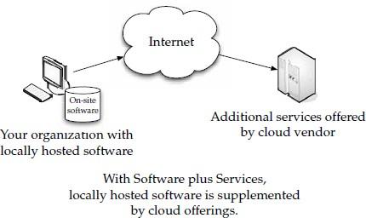**Flexibility** Vendors can offer software in different sizes and shapes—whether onsite or hosted. This gives customers an opportunity to have the right-sized solution.

#### Vendors

* **Microsoft** Microsoft offers Dynamics CRM, Microsoft Outlook, Windows Azure, and Azure Services Platform. Windows Azure is a collection of cloud-based services, including Live Framework, .NET Services, SQL Services, CRM Services, SharePoint Services, and Windows Azure Foundation Services for compute, storage, and management.
* **Adobe** Adobe Integrated Runtime (AIR) brings Flash, ActionScript, and MXML/Flex to the PC. Using AIR,vendors can build desktop applications that access the cloud.
* **Salesforce.com** Salesforce.com’s AppExchange is a set of APIs that vendors can use to create desktop applications to access salesforce data and run on the desktop of an end user.
* **Apple** Apple offers a number of cloud-enabled features for its iPhone/iPod touch. Not only does it come with an integrated Safari web browser, but they also offer a software developer’s kit (SDK) that allows software to be created for the iPhone/ iPod touch. Vendors

can build their own applications, and on-the-go users can access cloud offerings with those applications.

* + **Google** Google’s mobile platform is called “Android” and helps vendors build software for mobile phones. Google also offers its Google Apps and the Google Chrome browser, which also installs Google Gears software on the desktop. This allows offline and online solutions.
  + **WeatherBug** An API from api.weatherbug.com (an example of its use is shown on an iPod touch in Figure 10-1) is a set of APIs that vendors can use to create applications that utilize current weather data.
  + **DiCentral’s DiIntegrator EDI Solution** DiIntegrator is an application enabling users to perform supply chain functions related to electronic data interchange (EDI) and order fulfillment. Trading partners are connected within DiCentral’s infrastructure.

#### Mobile Device Integration

A key component of Software plus Services is the ability to work in the cloud from a mobile device. There are a number of free applications that you can use on the cloud. Take, for instance, Google’s free apps. Your needs might be more proprietary, however. Rather than using Microsoft Live or Google Docs to collaborate on documents, maybe your company needs a special application in service vehicles.

#### Google Android

A broad alliance of leading technology and wireless companies joined forces to develop Android, an open and comprehensive platform for mobile devices. Google Inc., T-Mobile, HTC, Qualcomm, Motorola, and others collaborated on the development of Android through the Open Handset Alliance, a multinational alliance of technology and mobile industry leaders.

* This alliance shares a common goal of fostering innovation on mobile devices and giving consumers a chance to experience performance improvements over existing mobile platforms.
* By providing developers with a new level of openness that enables them to work more collaboratively, Android accelerates the pace at which new mobile services are made available to consumers.
* The Android platform is available under one of the most progressive, developerfriendly open-source licenses, which gives mobile operators and device manufacturers significant freedom and flexibility to design products.
* Android holds the promise of benefits for consumers, developers, and manufacturers of mobile services and devices. Handset manufacturers and wireless operators will be free to customize Android in order to bring to market innovative new products faster and at a much lower cost.
* Consumers worldwide will have access to less expensive mobile devices that feature more compelling services, rich Internet applications, and easierto-use interfaces.

#### Providers

But while Software plus Services is a good match for mobile users, telecommuters, and others on the go, there is still value for deskbound users. Applications can be developed by your organization or your vendor, depending on what your vendor offers or what you need.

Here are some development solutions are:

#### Adobe AIR

Adobe Systems offers its Adobe Integrated Runtime (AIR), formerly code-named Apollo. Adobe AIR is a cross-operating-system application runtime that allows developers to use HTML/CSS, AJAX, Adobe Flash, and Adobe Flex to extend rich Internet applications (RIAs) to the desktop. New features in Adobe AIR include an embedded local database, PDF support, enhanced capabilities for JavaScript developers, and deeper integration with Adobe Flex.

#### RIA

Adobe AIR, along with Adobe Flex, are cornerstones of Adobe’s RIA platform, which enables developers and designers to create and deliver rich, dynamic, branded content and applications across all major operating systems. Key elements of Adobe AIR are open source, including the WebKit HTML engine, the ActionScript Virtual Machine (Tamarin project), and SQLite local database functionality. Additionally, Adobe also offers Adobe Flex as open source. By embracing open-source technologies and offering prerelease versions of software, Adobe enables developers worldwide to participate in the growth of the industry’s most advanced platform for building cross-operating-system RIAs.

#### Tools

The embedded, cross-platform, open-source SQLite local database was one of the most requested features from the Apollo release. It requires no extra setup while providing large data capacity and full text search, enabling web developers who traditionally rely on a database for storage to easily build desktop applications without changing existing techniques. Additionally, a tool is now available on Adobe Labs for Dreamweaver CS3 that enables Dreamweaver projects to be delivered as Adobe AIR applications.

#### Apple iPhone SDK

For its popular iPhone and iPod touch devices, Apple offers its iPhone Software Development Kit (SDK) as well as enterprise features such as support for Microsoft Exchange ActiveSync to provide secure, over-the-air push email, contacts, and calendars as well as remote wipe, and the addition of Cisco IPsec VPN for encrypted access to private corporate networks.

The iPhone SDK provides developers with a rich set of application programming interfaces (APIs) and tools to create applications for iPhone and iPod touch.

With the iPhone SDK, third-party developers are able to build native applications for the iPhone with a rich set of APIs, including programming interfaces for Core OS, Core

Services, Media, and Cocoa Touch technologies.

#### Leverage

Apple has licensed Exchange ActiveSync from Microsoft and is building it right into the iPhone. The iPhone software supports Cisco IPsec VPN to ensure the highest level of IP- based encryption available for transmission of sensitive corporate data, as well as the ability to authenticate using digital certificates or password-based, multifactor authentication. The iPhone software provides a configuration utility that allows IT administrators to easily and quickly set up many iPhones, including password policies, VPN setting, installing certificates, email server settings, and more.

#### App Store

The iPhone software contains the App Store, an application that lets users browse, search, purchase, and wirelessly download third-party applications directly onto their iPhone or iPod touch. The App Store enables developers to reach every iPhone and iPod touch user. Apple handles all credit card, web hosting, infrastructure, and DRM costs associated with offering applications on the App Store. Thirdparty iPhone and iPod touch applications must be approved by Apple and will be available exclusively through the App Store.

#### Microsoft Online

Microsoft’s Software plus Services offering allow a functional way to serve your organization, but it also provides a means to function on the cloud in a way that you are probably already used to with your in-house computers.

#### Hybrid Model

Microsoft is moving toward a hybrid strategy of Software plus Services, the goal of which is to empower customers and partners with richer applications, more choices, and greater opportunity through a combination of on-premise software, partner-hosted software, and Microsoft-hosted software. As part of this strategy, Microsoft expanded its Microsoft Online Services—which includes Exchange Online and SharePoint Online—to organizations of all sizes.

#### Partnership

Working closely with partners of all types—whether it’s systems integrators, hosters, web designers, advertisers and publishers, system builders, retailers, independent software vendors and finally value-added resellers and distributors.

#### Exchange Online and SharePoint Online

Exchange Online and SharePoint Online are two examples of how partners can extend their reach, grow their revenues, and increase the number to sales in a Microsoft-hosted scenario.

The extension of these services to small and mid-sized businesses is appealing to partners in the managed services space because they see it as an opportunity to deliver additional services and customer value on top of Microsoft-hosted Exchange Online or SharePoint Online. Microsoft Online Services opens the door for partners to deliver reliable business services such as desktop and mobile email, calendaring and contacts, instant messaging, audio and video conferencing, and shared workspaces—all of which will help

increase their revenue stream and grow their businesses.

Microsoft Online Services helps partners to deliver greater value to customers and grow their own businesses profitably.

#### Microsoft Dynamics CRM 4.0

Microsoft Dynamics CRM 4.0, released in December of 2007, also provides a key aspect of Microsoft’s Software plus Services strategy. The unique advantages of the new Microsoft Dynamics CRM 4.0, which can be delivered on-premise or on-demand as a

hosted solution, make Microsoft Dynamics CRM an option for solution providers who want to rapidly offer a solution that meets customer needs and maximizes their potential to grow their own business through additional services.

#### Flexibility

Microsoft’s Software plus Services strategy includes the best of on-premise software combined with the best of hosted services, bridging this continuum to allow for a range of superior options in customer choice and business opportunities for partners.

#### Partnership

As part of its Software plus Services strategy, Microsoft has partnered with a number of other organizations to deliver their products and services. In 2008 the Microsoft Worldwide Partner Conference started with the announcement of a new pricing and partner model for Microsoft Online Services, a key component of its Software plus Services initiative.

#### Business Model

To help partners get the guidance for discovery, enrollment, and activation of the two suites, a program called Quickstart for Microsoft Online Services was announced.

#### Resources

Building on the success of its Early Access program involving 200 partners, and the general availability of Microsoft Dynamics CRM Online, Microsoft offers a program expansion and readiness tool:

* The Microsoft Partner Program will provide discounts to qualified partners in the

U.S. and Canada for use of Microsoft Dynamics CRM Online in their own organizations. The discounted price is US$19 per user per month.

* The Microsoft Dynamics CRM ISV SaaS Readiness tool extends Microsoft’s Innovate On program, helping ISVs evolve their on-premise solutions into on- demand services.

#### Opportunities

Microsoft also offers a spectrum of new partner opportunities: across the fast-growing unified communications platform; the range of opportunities for Microsoft Windows and small businesses; a new Mobile Readiness program to help partners take advantage of the burgeoning mobility space; and new licensing and financing programs to help partners

improve their customers’ purchasing experience with more flexible, predictable, and manageable options.

#### Unified Communications

Microsoft has also seen broad adoption of its unified communications platform and products, including Microsoft Office Communications Server 2007, Microsoft Office Communicator 2007, and Microsoft Exchange Server 2007. Microsoft Office Communications Server alone has experienced triple-digit business growth over the past couple of years.

#### Mobility Opportunities

Microsoft’s Mobile Communications Business offers its Mobile Readiness Program, which will address resellers with four components:

* The Get Mobile Ready initiative offers Microsoft consulting to small and midsize resellers.
* The Try and Buy initiative deploys Microsoft mobility solutions within resellers to create SMB mobility experts around the globe and help partners showcase the technology in action.
* The Microsoft Partner Program Mobility Competency is a full-scale resource to train and certify resellers that are ready to take the next step in mobility.
* Microsoft distributors worldwide offer solutions to help resellers provide their SMB customers with a ready-made package of mobility offerings at a competitive price.

#### Active Directory

Active Directory is a Microsoft directory service, and it is used to provision, store, and manage users, groups, passwords, and contacts, among other objects.

To make a replica of your on-site Active Directory environment with the Microsoft Online environment, follow these steps:

1. Create a Microsoft Online Service Domain name. Use the same name as your on-site company (like compuglobalmegaware.com).
2. Verify the Microsoft Online Service Domain name. This proves that you have ownership and allows a Microsoft Online Services administrator to create new users for this domain. It also provides a means to add SMTP addresses for existing users.
3. Set this domain name as default. As new users are created, their accounts and email address will use this domain.
4. Modify the on-site Active Directory User object’s MAIL attribute with an emai address that was previously created and verified
5. Run the Microsoft Online Services Directory Synchronization Tool. This replicates all mail and mailbox-enabled users and groups into the Microsoft Online Company.

**UNIT-III** Developing Applications - Google, Microsoft, Intuit QuickBase, Cast Iron Cloud, Bungee Connect, Development, Troubleshooting, Application Management.

Local Clouds and Thin Clients - Virtualization in Your Organization, Server Solutions, Thin Clients, Case Study: McNeilus Steel.

#### Google

If you want to get an app on the cloud, the Google App Engine is the perfect tool to use

to make this dream become reality. In essence, you write a bit of code in Python, tweak some HTML code, and then you’ve got your app built, and it only takes a few minutes. Best of all, you don’t have to worry about buying servers, load balancers, or DNS tables—Google handles all the heavy lifting for you.

Having knowledge of Python certainly helps, but it isn’t a deal-breaker, because Python is a lot like other scripting languages. A seasoned programmer should be able to pick it up with some ease.

Java is very prevalent on the cloud. It is a very robust scripting tool and one that programmers know well. But its complexity is probably hurting it more than helping.

App Engine is akin to a data store. It won’t do the complex things that Oracle will allow. The database is integrated well with Python, but only allows basic search and store functions that you would need to tuck away users’ information. Data objects are set up in Python, and then you use the save method and all the data disappears into the cloud where instances of the app can find it. Google App Engine isn’t perfect. The documentation mentions web services and Asynchronous JavaScript and XML (AJAX), but there isn’t much support for them.

* **Payment** Google is charging when applications exceed certain limits.
* **Force.com and Google** Salesforce.com struck up a strategic alliance with Google with the availability of Force.com for Google App Engine. Force.com for Google App Engine is a set of tools and services to enable developer success with application development in the cloud. The offering brings together Force.com and Google App Engine, enabling the creation of entirely new web and business applications. Force.com for Google App Engine builds on the relationship between Salesforce.com and Google, spanning philanthropy, business applications, social networks, and cloud

computing.

Force.com for Google App Engine provides a set of tools and services meant to foster the creation of new kinds of web and business applications built and delivered entirely in the cloud. Instead of managing and maintaining their own client/server infrastructure, developers can use cloud computing infrastructure from Google and Salesforce.com to build, run, and deliver new applications on the Web.

Similarly, Force.com provides developers a complete environment to quickly build business applications that run on Salesforce.com’s trusted global infrastructure.

Force.com for Google App Engine provides:

* A means to leverage Python in a scalable cloud environment and interact directly with database, workflow, and logic capabilities in Force.com.
* Force.com for Google App Engine enables the creation of Python libraries that, when placed on Google App Engine, allow App Engine apps to read and write to Force.com using the Force.com API.
* App Engine developers get access to Force.com services and capabilities including mobile, analytics, security and sharing models, user authentication, Multilanguage and currency support, and more.

Force.com for App Engine includes

* Getting started guide
* Python library documentation
* Examples showing Python code accessing Force.com
* Testing harness for the provided library
* Wiki FAQ page on developer.force.com with best practices and latest tips and tricks

#### Google Gears

Another development tool that Google offers is Google Gears, an open-source technology for creating offline web applications.

#### Microsoft

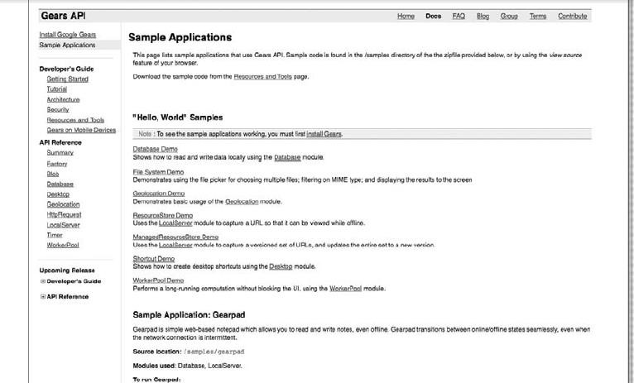

Google Gears builds on the Web’s existing programming model by introducing new JavaScript APIs for sophisticated data storage, application caching, and multithreading features. With these APIs, developers can bring offline capabilities to even their most complex web applications. Google Gears works with all major browsers on all major platforms: Windows, Mac, and Linux.

#### Microsoft

Microsoft’s Azure Services Platform is a tool provided for developers who want to write applications that are going to run partially or entirely in a remote datacenter.

The Azure Services Platform (Azure) is an Internet-scale cloud services platform hosted in Microsoft datacenters, which provides an operating system and a set of developer services that can be used individually or together. Azure can be used to build new applications to run from the cloud or to enhance existing applications with cloud-based capabilities, and it forms the foundation of all Microsoft’s cloud offerings. Its open architecture gives developers the choice to build web applications, applications running on connected devices, PCs, servers, or hybrid solutions offering the best of online and onpremises.

Azure allows developers to quickly create applications running in the cloud by using their existing skills with the Microsoft Visual Studio development environment and the Microsoft

.NET Framework.

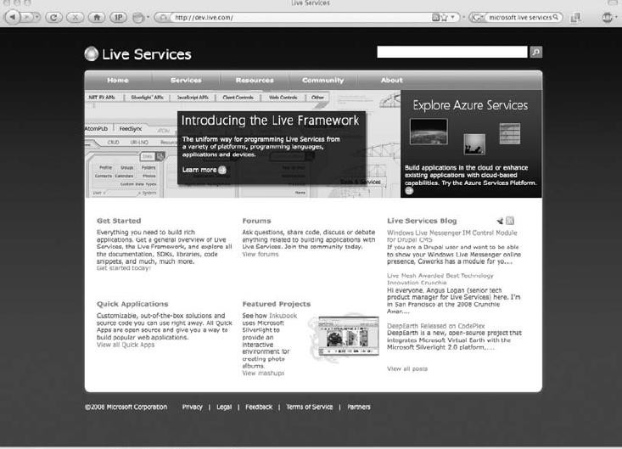

**Microsoft’s Azure offers a number of applications that you can use right away**

Infrastructure management is automated with a platform that is designed for high availability and dynamic scaling to match usage needs with the option of a pay-as-you-go pricing model. Azure provides an open, standards-based, and interoperable environment with support for multiple Internet protocols, including HTTP, REST, SOAP, and XML.

Microsoft also offers cloud applications ready for consumption by customers such as Windows Live, Microsoft Dynamics, and other Microsoft Online Services for business such as Microsoft Exchange Online and SharePoint Online. The Azure Services Platform lets developers provide their own unique customer offerings by offering the foundational components of compute, storage, and building block services to author and compose applications in the cloud.

#### Live Services

Live Services is a set of building blocks within the Azure Services Platform that is used to handle user data and application resources. Live Services provides developers with a way to build social applications and experiences across a range of digital devices that can connect with one of the largest audiences on the Web.



* **Microsoft SQL Services** enhances the capabilities of Microsoft SQL Server into the cloud as a web-based, distributed relational database. It provides web services that enable relational queries, search, and data synchronization with mobile users, remote offices, and business partners. It can store and retrieve structured, semistructured, and unstructured data.
* **Microsoft .NET Services** is a tool for developing loosely coupled cloud-based applications. .NET Services includes access control to help secure applications, a service bus for communicating across applications and services, and hosted workflow execution.
* **Microsoft SharePoint Services and Dynamics CRM Services** are used to allow developers to collaborate and build strong customer relationships.
* **Design** Azure is designed in several layers
  + **Layer Zero** Layer Zero is Microsoft’s Global Foundational Service. GFS is akin to the hardware abstraction layer (HAL) in Windows. It is the most basic level of the software that interfaces directly with the servers.
  + **Layer One** Layer One is the base Azure operating system. It used to be code- named “Red Dog,” and was designed by a team of operating system experts at Microsoft. Red Dog is the technology that networks and manages the Windows Server 2008 machines that form the Microsofthosted cloud.

Red Dog is made up of four pillars:

* + - Storage (a file system)
    - The fabric controller, which is a management system for deploying and provisioning
    - Virtualized computation/VM
    - Development environment, which allows developers to emulate Red Dog on their desktops.

#### Layer Two

Layer Two provides the building blocks that run on Azure. These services are the aforementioned Live Mesh platform.

#### Layer Three

At Layer Three exist the Azure-hosted applications. Some of the applications developed by Microsoft include SharePoint Online, Exchange Online, Dynamics CRM, and Online. Third parties will create other applications.

# Intuit QuickBase

Using QuickBase, program members will be able to easily build new on-demand business applications from scratch or customize one of 200 available templates and resell them to their clients.

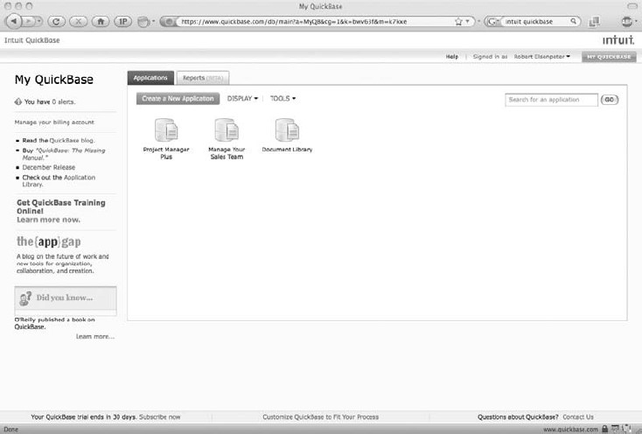

SaaS implementations do not require highly technical people, although they may require consultants with data integration skills. To help members succeed, the program provides training, partner relationship management, and lead-generation tools to help them locate potential customers and maximize the power of QuickBase. QuickBase Business Consultants also receive a free version of QuickBooks Online to help them better manage and grow their own businesses. **Cast Iron Cloud**

Cast Iron Systems introduced its development platform, the Cast Iron Cloud. Cast Iron offers the choice of a completely cloud-based integration service or an on-premise integration appliance as an organization’s application ecosystem evolves. Any organization, regardless of size or resources, can connect SaaS solutions with other on-demand and onpremise applications, immediately boosting productivity.

As SaaS usage expands from departmental silos into the extended enterprise, integration of data and applications is even more critical to productivity and success. Cast Iron and its partners can deliver the most widely used solution for connecting SaaS and enterprise

applications through the simplicity and speed of Integration as a Service (IaaS). The Cast Iron Cloud leverages the company’s delivery of completed integration projects quickly and also eliminates the need for customers to invest in integration infrastructure or deep middleware expertise.

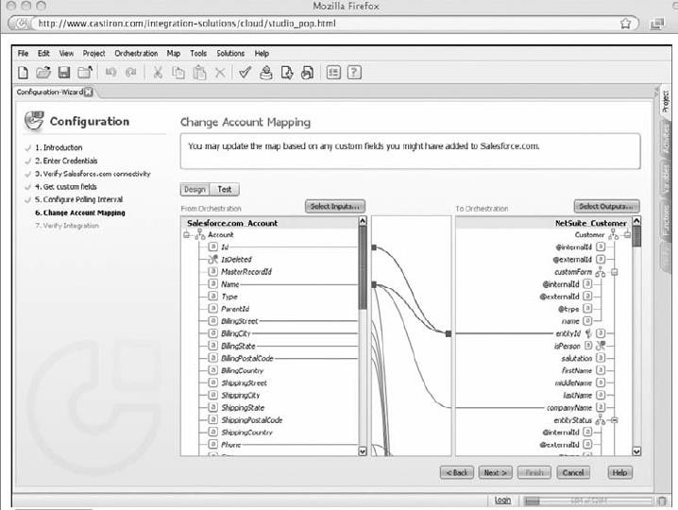

Cast Iron is transforming the integration experience using the Cast Iron Cloud. The company is introducing a cloud-based library of preconfigured Template Integration Processes (TIPs) for the most common SaaS business processes. Cast Iron has created these templates based on its experience with thousands of customer integrations. For example, if customers need to integrate two SaaS applications, they simply search Cast Iron’s cloudbased library of TIPs, choose the TIP that matches their scenario, and deploy it to the Cast Iron Cloud. Cast Iron is

providing a self-guided wizard similar to the simple wizard-based experience in popular products like Intuit TurboTax.

#### Bungee Connect

Bungee Labs offers its Bungee Connect web application development and hosting platform. Developers use Bungee Connect to build desktop-like web applications that leverage multiple web services and databases, and then deploy them on Bungee’s multitenant grid infrastructure.

Bungee Connect provides development, testing, deployment, and hosting in a single, on- demand platform.

Bungee Connect includes the following features:

* A single, on-demand environment for developing, testing, deploying, and hosting
* Interaction delivered entirely via browser with no download or plug-in for developers or end users
* Delivery of highly interactive user experience without compromising accessibility and security
* Automated integration of web services (SOAP/REST) and databases (MySQL/ PostgreSQL)
* Built-in team collaboration and testing
* Built-in scalability, reliability, and security
* Deep instrumentation of end-user application utilization for analytics
* Utility pricing model based on end-user application use

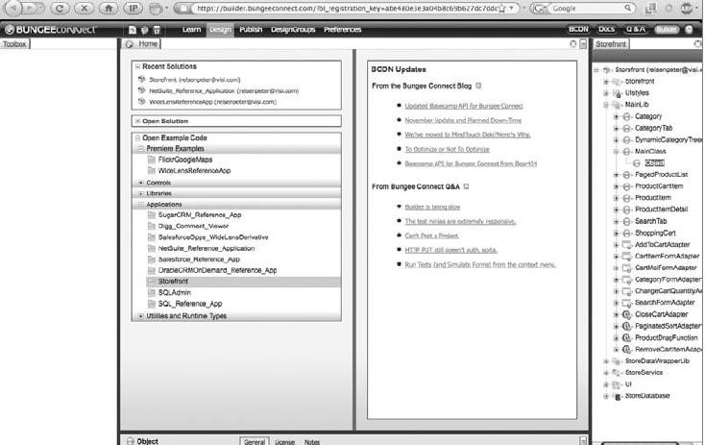

Development, team collaboration, and test deployment hosting on Bungee Connect are free of charge. Developers pay only when their applications are actually used by end users.

#### Development

The development steps with three different, popular platforms: the Google App Engine, Salesforce.com, and Microsoft Azure.

**Google App Engine** Google uses Python.

#### Environment

The SDK is available for Windows, Mac OS X, and Linux environments that also have Python 2.5. The SDK includes a web server application that simulates the App Engine environment. It also includes a local version of datastore, Google Accounts, and the ability to get URLs and send email from your computer using the App Engine APIs.

Download and install the App Engine SDK. For this demonstration, you will use two commands from the SDK:

* **dev_appserver.py** The development web server
* **appcfg.py** Used to upload your app to App Engine

#### The App

App Engine applications communicate with the web server using the CGI standard. When the server receives a request for your application, it runs the app with the request data in environment variables and on the input stream. When it responds, the app writes the response to the output stream and includes HTTP content.

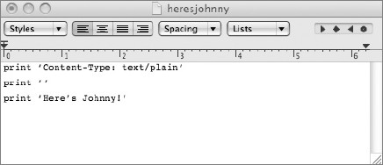

Here’s what the code is doing, line by line:

* The application identifier is heresjohnny. When the application is registered with App Engine, you select a

unique identifier, so this will change. It can be named whatever you want at this stage.

* Since this is the first version of this code, this is number 1. Use this field to keep track of different versions of

your app’s code.

* This code runs in the Python runtime environment, version 1.
* Every request to a URL whose path matches the regular expression /.* will be handled by the heresjohnny.py

script.

#### Script Testing

Start the web server with the following command : google_appengine/dev_appserver.py heresjohnny/

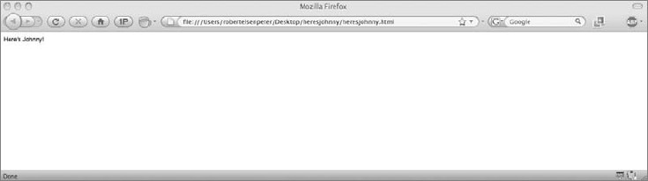

Now that the web server is running, it is listening for requests on port 8080 http://localhost:8080/

#### Uploading the App

After creating and managing your app and registering it on Google, the next step is to upload the application using a command-line tool included in the SDK called appcfg.py.

#### Tegistration

the next step is to register the application ID for your application. This is shown in Figure 11-3.

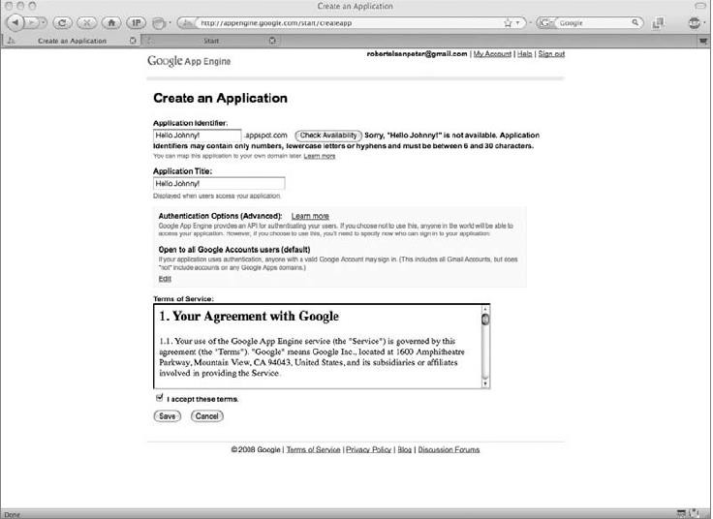



**Send It In** To upload your finished application to Google App Engine, run the following command:

appcfg.py update heresjohnny/

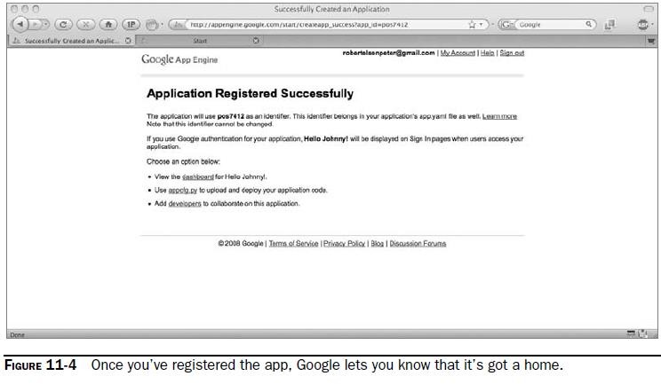

Enter your Google username and password at the prompts. Now you can see your application on App Engine and all you need to do is open up a web browser and enter

[**http://application-id.appspot.com**](http://application-id.appspot.com/). **Troubleshooting**

Troubleshooting on the cloud is a different animal than in a traditional IT environment. Conventional troubleshooting tools and processes were developed around the hub-andspoke concept, with remote applications being the spokes to the centralized datacenter being the hub. But applications delivered from an off-site provider’s datacenter defy traditional monitoring and require a different way to troubleshoot.

At your organization, you have local visibility and control of applications. That control is much more limited with SaaS applications. In particular, it is difficult to distinguish SaaS traffic from other Internet usage going in and coming out of remote locations. IT staff do not have the local ability to determine whether the service is running or if them client has connectivity to the

hosted application. Deep packet inspection (DPI) can deliver this granularity, but this technology is expensive to deploy throughout the enterprise.

For instance, there could be a legitimate issue with Amazon, for which you need to invoke the service level agreement (SLA). On the other hand, the problem could simply be the result of contention for the Internet.

To troubleshoot SaaS problems, you must be able to understand the perspective of the application and the end user, and to see all the variations inside and outside the infrastructure. That visibility is not available with traditional management tools and technology, but new tools are available.

By using this tracking information, profiles are created for all applications and for the networked application experiences of each end user that allow IT to detect unusualbehavior and figure out the root cause of the performance problems.

#### Application Management

When you do decide to manage your cloud application, you can use a product like Kaavo’s (www.kaavo.com) cloud application management software: Infrastructure and Middleware on Demand (IMOD).

IMOD is the first solution with an application-focused approach to IT infrastructure management through public and private clouds.

IMOD enables users to manage infrastructure as a unified system and provides the following benefits:

* + **Application and service–centric n-tier configuration** IMOD automatically brings online one or multiserver systems for running applications.
  + **Business continuity** An interface to schedule automatic data backups ensures business continuity.
* **Security and access control** IMOD provides a point-and-click interface to secure data in the clouds through the National Security Association’s recommended AES 256-bit data encryption. It allows users to easily and securely connect to servers, transfer data to and from internal datacenters, and configure custom firewall rules

on cloud servers.

* + **Effective monitoring and alerts** Users can monitor resources used by their applications and set up alerts to proactively manage application service levels.

#### Local Clouds and Thin Clients

The cloud computing model doesn’t always mean your clients have to traverse the Internet to get at content. A local cloud—also known as *presentation virtualization*— skips the service provider component, and allows you to manage all the content yourself in your own datacenter.

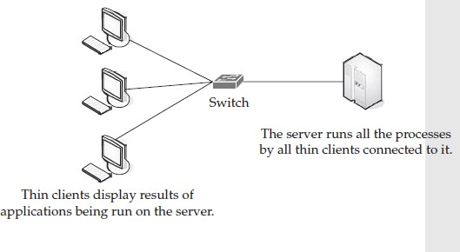

#### Virtualization in Your Organization

There are pros and cons to going virtual.

* **Server virtualization** This is a method of partitioning a physical server computer into multiple servers so that each has the appearance and capabilities of running on its own dedicated machine. An example of this is VMware or Hyper-V).
* **Application virtualization** This is a method that describes software technologies that separate them from the underlying operating system on which they are executed. A fully virtualized application is not installed in the traditional sense, although it still executes as though it were. The application is tricked at run time to believe that it is directly interfacing with the original OS and the resources it manages.
* **Presentation virtualization** This method isolates processing from the graphics and I/O, which makes it possible to run an application in one location (the server) but be controlled in another (the thin client). In this method, a virtual session is created and the applications

project their interfaces onto the thin clients. It can either run a single application or present an entire desktop.

#### Why Virtualize?

Virtualization can help companies maximize the value of IT investments, decreasing the server hardware footprint, energy consumption, and cost and complexity of managing IT systems while increasing the flexibility of the overall environment.

#### Cost

Depending on your solution, you can have a cost-free datacenter. You do have to shell out the money for the physical server itself, but there are options for free virtualization software and free operating systems.

Microsoft’s Virtual Server and VMware Server are free to download and install.

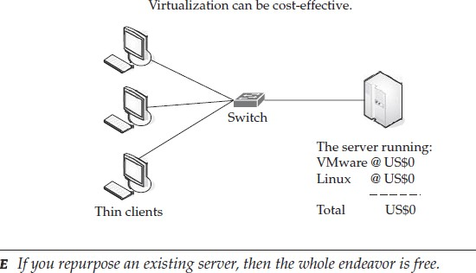

#### Administration

Having all your servers in one place reduces your administrative burden. According to VMware, you can reduce your administrative burden from 1:10 to 1:30.

The following factors ease your administrative burdens:

* + A centralized console allows quicker access to servers.
  + CDs and DVDs can be quickly mounted using ISO files.
  + New servers can be quickly deployed.
  + New virtual servers can be deployed more inexpensively than physical servers.
  + RAM can be quickly allocated for disk drives.
  + Virtual servers can be moved from one server to another.

#### Fast Development

Because every virtual guest server is just a file on a disk, it’s easy to copy (or clone) a system to create a new one. To copy an existing server, just copy the entire directory of the current virtual server.

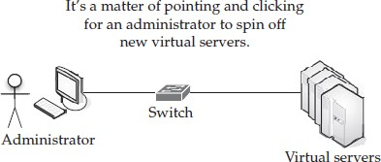

Virtualization software allows you to make clones of your work environment for these endeavors.

#### Reduced Infrastructure Costs

If you reduce the number of physical servers you use, then you save money on hardware, cooling, and electricity. You also reduce the number of network ports, console video ports, mouse ports, and rack space.

Some of the savings you realize include

* + Increased hardware utilization by as much as 70 percent
  + Decreased hardware and software capital costs by as much as 40 percent
  + Decreased operating costs by as much as 70 percent

#### How to Virtualize

The best way to implement a virtualization solution is to start by making sure you fully understand the issues surrounding virtualization.

#### Assessment

The first step is to conduct an environmental assessment of your organization to determine each department’s server processing needs.

* CPU
* Memory
* Adapters
* File and system capacity
* Total used and unallocated disk space

Along with this assessment, you should also identify peaks in

* + CPU
  + Memory
  + Adapter usage
  + Read
  + Write
  + Wait cycles

Discover also data that has not been accessed over extended periods of time.

#### Analyze

Take a good hard look at your current server environment. Identify and consolidate processing-compatible applications to a single server, or you can virtualize your existing multiserver datacenter to share processing capabilities from a common pool. Identify your mission-critical servers.

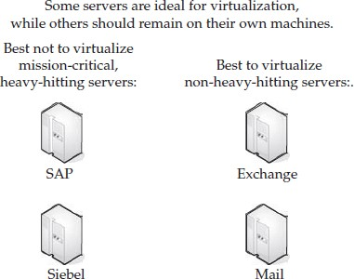

#### Save Your Money

Tap into your existing hardware pool and reduce the number of servers you think you need, simply to increase on-demand processing capacity. If you virtualize the servers you have, you can save money.

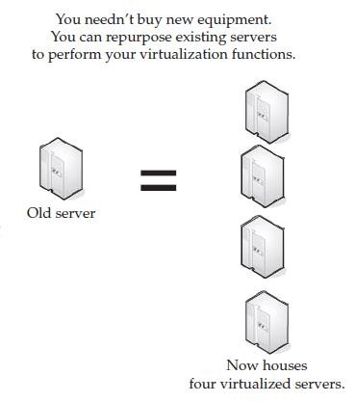

#### Concerns

Server applications that require access to hardware like PCI cards and USB devices are difficult to virtualize. Also server virtualization doesn’t typically play well with proprietary hardware.

#### Security

When it comes to security, the same risks that exist for a physical server exist for a virtualized server. There is a misconception that virtual servers are somehow immune to these problems. Virtual machines need to have the same networking concerns dealt with and the same virus concerns addressed as a physical machine. You also need to protect against spyware and malware.

#### Server Solutions

There are two (major) components of a virtualized environment—clients and servers. In a virtualized environment the server does everything. Virtualization products: Microsoft Server 2008 Hyper-V, VMware, and VMware ESX.

#### Microsoft Hyper-V

Microsoft Server 2008 Hyper-V (Hyper-V) is a hypervisor-based virtualization technology that is a feature of select versions of Windows Server 2008. Microsoft’s strategy and investments in virtualization—which span from the desktop to the datacenter—help IT professionals and developers implement Microsoft’s Dynamic IT initiative, whereby they can build systems with the flexibility and intelligence to automatically adjust to changing business conditions by aligning computing resources with strategic objectives.

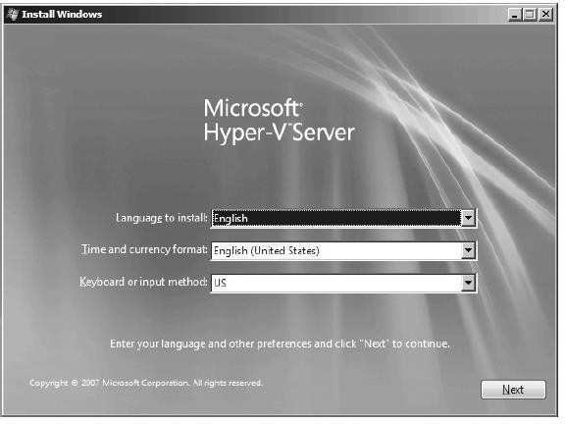

Hyper-V offers customers a scalable and high-performance virtualization platform that plugs into customers’ existing IT infrastructures and enables them to consolidate some of the most demanding workloads. In addition, the Microsoft System Center product family gives customers a single set of integrated tools to manage physical and virtual resources, helping customers create a more agile and dynamic datacenter.

#### VMware

VMware offers its VMware Server, a free entry-level hosted virtualization product for Linux and Windows servers. The product is available for download at [www.vmware.com/](http://www.vmware.com/) products/server/.

#### Features

VMware Server, the successor to VMware GSX Server, enables users to quickly provision new server capacity by partitioning a physical server into multiple virtual machines, bringing the powerful benefits of virtualization to every server.

VMware Server is feature-packed with the following market-leading capabilities:

* + Support for any standard x86 hardware
  + Support for a wide variety of Linux and Windows host operating systems, including 64-bit operating systems
  + Support for a wide variety of Linux, NetWare, Solaris x86, and Windows guest operating systems, including 64-bit operating systems
  + Support for Virtual SMP, enabling a single virtual machine to span multiple physical processors
  + Quick and easy, wizard-driven installation similar to any desktop software
  + Quick and easy virtual machine creation with a virtual machine wizard
  + Virtual machine monitoring and management with an intuitive, user-friendly.

VMware Server supports 64-bit virtual machines and Intel Virtualization Technology, a set of Intel hardware platform enhancements specifically designed to enhance virtualization solutions.

#### VMware Infrastructure

VMware is the biggest name in virtualization, and they offer VMware Infrastructure, which includes the latest version of VMware ESX Server 3.5 and VirtualCenter 2.5. VMware Infrastructure will allow VMware customers to streamline the management of IT environments through greater levels of automation, increase overall infrastructure availability, and boost performance for mission-critical workloads.

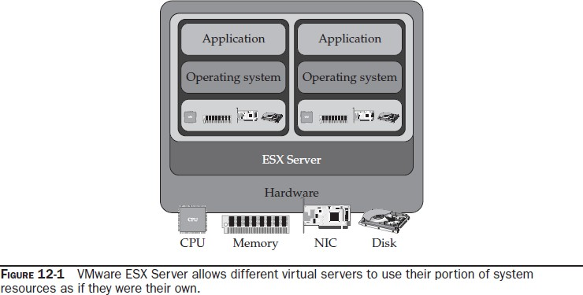

VMware Infrastructure is VMware’s third-generation, production-ready virtualization suite. The new features in VMware Infrastructure are targeted at a broad range of customers and IT environments—from midsize and small businesses to branch offices and corporate datacenters within global 100 corporations—and extend the value of all three layers of the virtualization suite.

#### Features

Virtualization platform enhancements help deliver new levels of performance, scalability, and compatibility for running the most demanding workloads in virtual machines:

* + Expanded storage and networking choices such as support for SATA local storage and 10 Gig Ethernet as well as enablement of Infiniband devices expand storage and networking choices for virtual infrastructure.
  + Support for TCP Segment Offload and Jumbo frames reduces the CPU overhead associated with processing network I/O.
  + Support for hardware-nested page tables such as in-processor assists for memory virtualization.
  + Support for paravirtualized Linux guest operating systems enables higher levels of performance through virtualization-aware operating systems.
  + Support for virtual machines with 64GB of RAM and physical machines with up to 128GB of memory.

Virtual infrastructure capabilities help deliver increased infrastructure availability and resilience:

* VMware Storage VMotion enables live migration of virtual machine disks from one data storage system to another with no disruption or downtime. VMware VMotion has become an indispensable tool for many infrastructure administrators to dynamically balance their server workloads and eliminate planned downtime for server maintenance.
* VMware Update Manager automates patch and update management for VMware ESX Server hosts and virtual machines. Update Manager addresses one of the most significant pain points for every IT department: tracking patch levels and manually applying the latest security/bug fixes.
* VMware Distributed Power Management is an experimental feature that reduces power consumption in the datacenter through intelligent workload balancing.
* VMware Guided Consolidation, a feature of VMware VirtualCenter, enables companies to get started with server consolidation in a step-by-step tutorial fashion.

#### Products

* VMware Infrastructure is available for purchase in the following editions: VMware ESX Server 3i, providing single-server partitioning, is delivered embedded as firmware in server systems or as a stand-alone purchase for hard drive installation.
* VMware Infrastructure 3 Foundation (previously called “Starter”) includes VMware ESX Server, VMware ESX Server 3i, VMware Consolidated Backup, and the new VMware Update Manager.
* VMware Infrastructure 3 Standard is designed to bring higher levels of resiliency to IT environments at greater value.
* VMware Infrastructure 3 Enterprise contains the entire array of virtual infrastructure capabilities for resource management, workload mobility, and high availability.
* VMware VMotion, Storage VMotion, and DRS with DPM are available for standalone purchase with VMware Infrastructure 3 Foundation and Standard.

#### Thin Clients

Desktop and mobile thin clients are solid-state devices that connect over a network to a centralized server where all processing and storage takes place, providing reduced maintenance costs and minimal application updates, as well as higher levels of security and energy efficiency.

#### Sun

Sun’s thin client solution is called Sun Ray, and it is an extremely popular product. Contributing to the demand for it is further market demand for Sun Virtual Desktop Infrastructure (VDI) Software 2.0. Sun Ray machines are able to display Solaris, Windows, or Linux desktops on the same device.

Sun offers a comprehensive desktop to data center virtualization product portfolio and set of virtualization service offerings to help customers deploy new services faster, maximize the utilization of system resources, and more easily monitor and manage virtualized environments. Sun’s virtualization products helps to provide unified software management tools and virtualization capabilities across operating systems ,servers, storage,desktop and processors.

#### Hewlett Packard

It is certainly well known technology company, and their products extended into the world of thin clients. In fact HP is the leading manufacturer of thin clients.

#### Dell

Another well known player in the world of client development is Dell, and they two offer a thin client. But they are also thoughting environmental responsibility with a new line of PCs. Their most recent additions are a line of OptiPlex commercial desktops, flexible computing solutions, and service offerings designed to reduce costs throughout the desktop life cycle.

* **ImageDirect** Allows customers to securely create, load, and manage custom images onto the Dell desktop systems they purchase; it is fully integrated into Dell’s production systems so images are applied during the manufacturing process.
* **Application Packaging** Allows IT departments to efficiently manage, deploy

,install, and uninstall applications; can significantly reduce portfolio management and application support costs.

* + **Desktop Manager** Automates asset management, software distribution and upgrades, patches, and antivirus and malware updates.
  + **Software Inventory and Usage** Automates applications monitoring and inventories and tracking software usage.
  + **Back-up and Restore** Automates desktop data backup to a secure, off-site datacenter using single instancing and data compression.
  + **Email Management Services** Automates email backup and archiving to help prevent downtime, at a fraction of the cost of typical on-premise solutions.
  + **Crisis Management and Alerting** Utilizes automation to provide continuous communication, reaching thousands of employees in minutes and keeping them updated during a crisis or disaster.
  + **Dell Asset Recovery and Recycling Services** Recycle systems; recover residual value for customers; dispose of older assets in an environmentally responsible manner

#### Case Study: McNeilus Steel

Different companies chose virtualization for different reasons. For a steel distributor in Dodge Center, Minnesota, McNeilus Steel, the main reason for a 2006 change was reliability.

#### Benefits

Before deciding on virtualization, McNeilus considered eight-way servers.

* The problem with that solution was that every server had just one backup. By using blade servers, if the system fails, it is instantly switched over to a new blade. Workers don’t notice that anything has changed, and Boeck gets a message to notify him of the failure. All he has to do is swap over a new blade. This is a huge benefit over the past where it could sometimes take an entire day of system downtime to repair a failed network.
* Additionally, if he wants to spin off a server for a specific resource, VMware will tell him how many resources it will require.
* Reliability was their key issue, but McNeilus faced other problems that virtualization helped with.
* You’ll run out of RAM before you run out of processor,” observed Boeck.
* Making the sell
* Another benefit is in administration. Now that everything is centralized, it can be managed from one location, rather than scattered around the organization or at remote sites.
* In terms of hardware, McNeilus switched from Hewlett Packard servers to an IBM 4700 Fiber SAN with Expansion Bay, IBM Blade Center Chassis with HS20 and HS21 IBM Blade Server, and Cisco C9020 Fiber Switches. On the software side, they are using VMware ESX Servers, which include high availability and VMotion options
* Patch management has also been simplified with VMware’s snapshot feature. Now, when a new patch is issued, Boeck can test the patch to ensure it works.

**UNIT- IV** Migrating to the Cloud - Cloud Services for Individuals, Cloud Services Aimed at the Mid- Market, Enterprise-Class Cloud Offerings, Migration, Best Practices and the Future of Cloud Computing - Analyze Your Service, Best Practices, How Cloud ComputingMight Evolve.

#### Cloud Services for Individuals

The most basic—and the easiest—way to move to the cloud is at an individual or small business level.

some of the most popular cloud applications out there.

**Apple Mobile Me** [(http://www.me.com/](http://www.me.com/))) This service synchronizes emails, photos, and contacts among multiple devices. Your computer, laptop, and mobile devices can remain in sync as long as they have access to Apple’s cloud servers.

* **Google Docs** [(http://docs.goo](http://docs.google.com/))g[le.com/)](http://docs.google.com/)) Providing an intuitive interface, Google Docs provides applications that you normally associate with the desktop—a word processor, spreadsheet, and presentation designer. Documents can be saved to the cloud or locally.

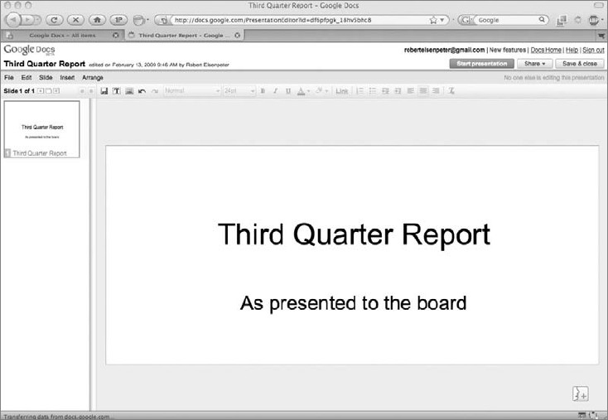

* **Adobe Acrobat** [(http://www.a](http://www.acrobat.com/))c[robat.com/)](http://www.acrobat.com/)) Known for its free PDF reader (among other tools), Adobe provides its own online word processor and cloud storage space for your documents. It also includes collaboration tools and an online PDF converter.
  + **Jooce** [(http://www.joo](http://www.jooce.com/))c[e.com/)](http://www.jooce.com/)) Jooce is a Flash-based desktop environment, mostly for users of Internet cafés. Dragging a file onto the desktop uploads it to the cloud, giving you access to your files from any Internet-connected computer.
  + **Evernote** [(http://www.](http://www.evernote.com/))e[vernote.com/)](http://www.evernote.com/)) Evernote allows you to save photos, screenshots, or files to their servers in the cloud.

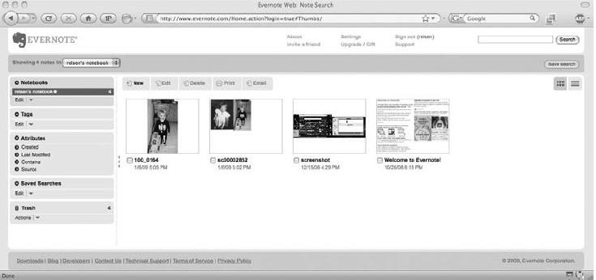

* **Microsoft Live Search** (<http://www.live.com/)> Microsoft’s mobile phone search engine uses heavy cloud processing to bring detailed searches to handheld devices.
* **Twitterfone** [(http://ww](http://www.twitterfone.com/))w[.twitterfone.com/)](http://www.twitterfone.com/)) Twitterfone uses speech recognition in the cloud to transcribe voice messages into “tweets” on the Twitter social network.
* **Blist/Socrata** [(http://www.socratablist.com/](http://www.socratablist.com/))) Blist, now called Socrata, is a database with an eye-catching interface, how-to videos, and a drag-and-drop design. After it’s been created, the database can be shared with other users of the site.
* **Adobe Photoshop Express** [(http://www.photoshop.com/](http://www.photoshop.com/express))e[xpress)](http://www.photoshop.com/express)) This is another editor by the creators of the powerful Photoshop application. You can store your photos on the

cloud and edit them with the same tools that you would use with a desktop version of Photoshop. Once your photo editing is done, you can add yourphotos to the site’s gallery.

#### Skytap Solution

Skytap offers a virtual lab in the cloud. And to help you move your efforts from your local environment, they offer an API to help mount a solid migration.

#### Skytap Virtual Lab

Cloud-based virtualization solution company Skytap (formerly known as illumita) offers Skytap Virtual Lab, a virtual lab automation solution available as an on-demand service over the Web.

It enables application development and test teams to provision lab infrastructure on demand (including servers, software, networking, and storage) and utilize a powerful virtual lab management application to automate the setup, testing, and tear-down of complex, multitiered environments. It also gives distributed teams the capability to collaborate and rapidly resolve software defects using a virtual lab and virtual project environment.

Skytap’s customers include Independent Software Vendors (ISVs), Systems Integrators (SIs), and test outsourcing firms, mid-size companies, and departments within global enterprises that want the benefits that Skytap’s virtual lab service provides Customers using Skytap are able to access the following:

* **Virtual infrastructure on-demand** Virtually unlimited hardware, software, and storage available from any location and any browser. Skytap Virtual Lab scales up and down with software project demands and requires no upfront investment.
* **Automated setup and tear-down of environments** A web-based virtual lab automation application that eliminates manual setup and tear-down tasks and enables the rapid provisioning and replication of multimachine production environments for development and testing.
* **Skytap Library** A prepopulated software library that includes major operating

systems, databases, and applications in multiple languages that dramatically reduces media installation tasks and enables construction of lab environments by dragging and dropping preconfigured virtual machines.

* **Collaboration in a virtual environment** The capability to instantly collaborate on software issues and defects in a virtualized environment. Entire multimachine lab environments can be suspended and shared with distributed, global team members.

#### Skytap Migration API

The Skytap API enables customers to blend Skytap’s cloud-based Virtual Lab platform with their existing on-site IT infrastructure. Rather than using cloud resources in a silo, Skytap’s Web Services API and one-click VPN functionality allows organizations to create a “hybrid” IT model whereby cloud resources can be used as an extension of existing on-site IT environments.. Skytap allows companies to run their existing applications, virtual machines, and systems unchanged on industrystandard platforms. Skytap cloud infrastructure supports the leading hypervisors, including VMware and Citrix Xen, and support is planned for Microsoft Hyper-V, and operating systems, such as Microsoft Windows, Linux, and Solaris.

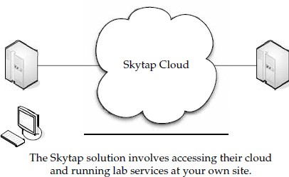

The API and advanced networking features that are now in Skytap Virtual Lab include

* A REST-based Web Service interface that enables cloud resources to be controlled programmatically
* Public/static IP addresses to provide seamless access to Skytap environments
* One-click VPN for easy connection back to the onsite IT environments
* Automated upload of existing virtual machines and software to run in Skytap Virtual Lab

#### Cloud Services Aimed at the Mid-Market Force.com

The Force.com Migration Tool is more of a roll-up-your-sleeves-because-you’re-going- toget- your-hands-dirty thing, compared to being able to point and click your way through a

GUI. The Force.com Migration Tool is an Ant library that lets you migrate metadata (code and settings) from your organization to Force.com’s cloud.

The Force.com platform holds your application as metadata on the platform, and you can access this metadata. That is how the Force.com IDE works—it uses the metadata to get your code, your packages, your triggers, and edit them locally.

The Force.com Migration Tool is especially useful in these scenarios:

* **Development projects** When you need to populate a test environment with large amounts of setup changes. If you were to make these changes using a web interface, it would take a large amount of time.
* **Multistage release processes** Most development processes run in iterative cycles of building, testing, and staging before they are released to a production environment. Scripted retrieval and deployment of your components makes this process easier and cleaner.
* **Repetitive deployment using the same parameters** You can retrieve all your organization’s metadata, make changes as needed, and deploy that metadata.

#### Force.com Apps

The following are some of the (currently) most popular apps on Force.com:

**Appirio Calendar Sync for Salesforce.com and Google Apps** With Appirio Calendar Sync, it is easy to automatically keep your Salesforce Calendar in sync with your Google Calendar. You can share customer-related events across company boundaries through an easy-to-use online calendar.

**Gmail to Salesforce.com browser button for Firefox** Browser buttons can easily be added to your browser’s toolbar. When using Gmail, simply click the Gmail to Salesforce.com browser button to send the email and automatically copy it as an activity on related lead and contact records inside Salesforce.com.

**Lead and opportunity management dashboards** Install lead-tracking and opportunity management dashboards instantly within your Salesforce.com account. There is no configuration to be done, just a simple download.

**Appirio CRM Dashboards for Salesforce.com & Google Apps** Appirio CRM Dashboards for Salesforce.com & Google Apps allows you to put Salesforce data into graphs and tables on your Google Start Page, Google Document, or Google Site.

**Sales Activity Dashboard** This Dashboard is important to sales professionals who want to have visibility of the types of Activity their sales teams are engaging in on Opportunities.

**VerticalResponse for AppExchange** VerticalResponse for AppExchange provides self-service email and direct mail solutions.

**Appirio Search for Salesforce.com & Google Apps** Appirio Search for Salesforce .com & Google Apps allows you to find and add Google Docs to any Salesforce object as you work.

**Salesforce.com for Google AdWords** Salesforce.com for Google AdWords allows online marketers to track the effectiveness of Google advertising campaigns and web site lead- generation activity.

**Astadia Report Collaboration for Google Spreadsheets** Astadia Report Collaboration for Google Spreadsheets allows a Salesforce subscriber to export any reportable information in Salesforce to Google Spreadsheets for further analysis and share the report with both Salesforce and non-Salesforce users.

**Conga Merge** Create content-rich output from Word/Excel templates or PDF forms. Custom quotes, proposals, account plans, and more from any custom object and related lists—as little as one click to print, attachment, or email.

# Enterprise-Class Cloud Offerings

Moving to the cloud gets more complex as your organization grows in size. Enterprise- class organizations should follow the same sorts of guidelines as the mid-market group—that is, try out new things, figure out what to move, and then move over time—but their scope is entirely different.

#### MS Exchange

A cornerstone of most enterprises is the Microsoft Exchange service for email. Microsoft now offers Exchange Online and Microsoft SharePoint Online for businesses of all sizes. These subscription services offer businesses a new way to purchase, deploy, and manage the industry- leading email and calendaring solution, and the industry-leading solution for portals and collaboration.

To help businesses plan, deploy, and operate the services, Microsoft released Microsoft Solution Accelerators for Microsoft Online Services. These include automated tools and guidance, such as the Microsoft Assessment and Planning Toolkit, the Infrastructure Planning and Design Guide, and the Microsoft Operations Framework Companion Guide.

Microsoft also has other online services in the pipeline. In addition to Office Communications Online, Microsoft is planning to offer a Microsoft Online Services solution that will provide IT management and security capabilities for businesses, enabling IT managers to secure and manage desktops using a web-based subscription service. These online services will be based on components from existing systems management, identity, and security offerings, and will complement Microsoft’s onpremise solutions, as customers begin to adopt cloud-based computing to address specific needs.

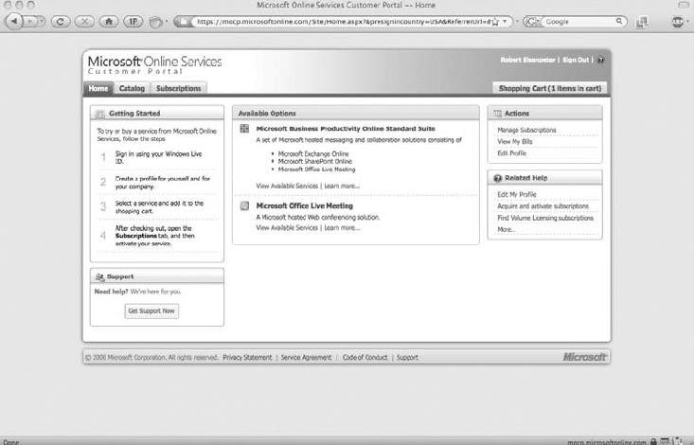

#### VMotion

The main tool for migrations in VMware’s arsenal is VMotion. VMware says that VMotion leverages the complete virtualization of servers, storage, and networking to move an entire running virtual machine instantaneously from one server to another. The entire state of a virtual machine is encapsulated by a set of files stored on shared storage, and VMware’s vStorage VMFS cluster file system allows both the source and the target VMware ESX server to access these virtual machine files concurrently.

#### Features

VMotion offers these capabilities:

* Perform migrations with no downtime, undetectable by your users.
* Optimize virtual machines in resource pools.
* Perform hardware maintenance without downtime and disrupting operations.
* Move virtual machines from poorly performing or failing physical servers onto new machines.
* Multiple concurrent migrations can optimize a virtual IT environment.
* A migration wizard can provide real-time availability information to identify the optimal placement of a virtual machine.
* Migrate any virtual machine running any operating system across hardware supported by VMware ESX, including Fibre Channel SAN, NAS, and iSCSI SAN.
* Prioritize live migrations to ensure that mission-critical virtual machines maintain access to the resources they need.
* Schedule migrations to happen at predefined times, and without an administrator’s presence.
* Maintain an audit trail with a detailed record of migrations.

#### VMware vCenter Converter

VMware offers its vCenter Converter to migrate physical servers to virtual servers. The application can be run on a number of different types of hardware and supports most versions of Microsoft Windows operating systems.

With this enterprise-class migration tool, you can

* Quickly convert local and remote physical machines into virtual machines with no downtime.
* Simultaneously convert multiple servers with a centralized management console and conversion wizard.
* Convert other virtual machine formats (like Microsoft Virtual PC and Microsoft Virtual Server) or back up images of physical machines to VMware virtual machines.
* Restore VMware Consolidated Backup (VCB) images onto running virtual machines.
* Clone and back up physical machines to virtual machines, as part of a disaster recovery plan. Among its features, VMware Converter includes these attributes:
* The ability to perform simultaneous conversions, enabling large-scale virtualization projects.
* Quiescing and snapshotting of the guest OS on the source machine before migrating. This ensures the data is migrated reliably.
* Hot cloning allows for non-disruptive conversions.
* Sector-based copying to enhance cloning and conversion speed.
* Use of a centralized management console that allows users to queue up and monitor multiple simultaneous remote locations, as well as local conversions.
* Wizards minimize the number of steps in a conversion.
* The ability to clone both local and remote servers allows conversions in remote locations. VMware vCenter Converter can import virtual machines created in
* Workstation 5.x and Workstation 4.x
* VMware Player 1.x
* VMware ESX 3.x
* ESX Server 2.5.x (if the virtual machine is managed by VirtualCenter 2.x)
* GSX Server 3.x
* VMware Server 1.x
* VirtualCenter 2.x
* Microsoft Virtual PC version 7 and later
* Any version of Microsoft Virtual Server There are two versions of VMware Converter:
  + **VMware vCenter Converter Starter** A free download (located [http://www.vmware.com/download/converter/),](http://www.vmware.com/download/converter/)) used for single conversions.
  + **VMware vCenter Converter Enterprise** An enterprise-class product for managing and automating large-scale conversions.

**Hyper-V Live Migration**

Microsoft Server 2008 Hyper-V makes migration a very clean affair, although it is used for moving virtual servers around to different machines.

Migration is accomplished through Live Migration, a tool part of Windows Server 2008 R2. Live migration utilizes the integrated hypervisor technology and high-availability features of the server operating system so that customers can move running applications between servers to accommodate changing, dynamic computing needs across a datacenter. In addition to other features, the next version of Microsoft Hyper-V Server will have live migration capabilities.

Microsoft’s virtual products include

* Microsoft Hyper-V Server 2008, a hypervisor-based server virtualization product, that is available at no cost via the Web. Microsoft Hyper-V Server 2008 provides an optimized

virtualization solution that allows customers to consolidate Windows or Linux workloads onto a single physical server. Hyper-V Server 2008 allows customers to leverage their existing patching, provisioning, management and support tools, processes and skills.

* System Center Virtual Machine Manager 2008 enables customers to configure and deploy new virtual machines and centrally manage their virtualized infrastructure, whether running on Windows Server 2008 Hyper-V, Microsoft Virtual Server 2005 R2, Microsoft Hyper-V Server 2008, or VMware Virtual Infrastructure 3. System Center Virtual Machine Manager is part of the System Center suite of products, which provides centralized, enterprise-class management of physical and virtual resources across desktops and datacenters.
* Microsoft Application Virtualization 4.5 gives desktop users a boost in fully harnessing the power of Windows Vista by streaming resource-heavy applications to the desktop. This helps eliminate potential software conflicts driving desktop stability and performance, while simultaneously enabling IT managers to centrally control key applications and their use. Application Virtualization 4.5 is included as part of Microsoft Desktop Optimization Pack 2008 R2.

# Migration

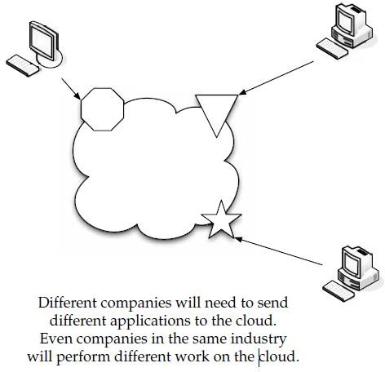

#### Which Applications Do You Need?

Deciding what you should migrate to the cloud really comes down to figuring out what you want out of the cloud. That is, are you looking to store data on someone else’s servers? If that’s the case, it’s simply a matter of deciding which data you want to send (and pay for) and what data doesn’t need to be sent.

* If you are using the cloud for SaaS or PaaS, you have to look at which applications are most appropriate for maintenance on the cloud.
* When you do decide to move to the cloud, make sure the applications you are going to use don’t consume too many network resources.
* If the application you want to use on the cloud demands high performance and low latency, make sure that the provider you’ve elected to go with can deliver on your needs.

#### Sending Your Existing Data to the Cloud

There are all sorts of data that you can send to the cloud. You can store specific files, you can run applications online. Symantec’s solution and what one of their customers gets out of sending their data to the Symantec cloud.

* Symantec Online Backup is used to protect business records while reducing the time and money spent managing backups.
* With Symantec’s Software-as-a-Service (SaaS) online backup application, small and mid-sized businesses can ensure their data is protected against catastrophic loss while remaining easily recoverable.
* Symantec Online Backup provides businesses with backup and recovery for PCs and servers over the Internet.
* Businesses using Symantec Online Backup eliminate the need to purchase and manage on-site hardware and receive increased protection from theft and disasters.
* Data is automatically stored off-site in multiple geographically distributed datacenters and can be restored to any location using a supported web browser.
* The service is hosted in the cloud by Symantec, eliminating the need for businesses to devote resources to managing patches and upgrades.

An independent study finds that small and medium businesses (SMB) rate backup as their second-highest computing priority, after defense against viruses and other malware, and ahead of issues such as reducing costs and deploying new computers.

#### Use the Wave Approach

The best way to migrate your data to the cloud is by following the same steps you would when rolling out a new operating system to your organization. Use the wave approach and release your data in waves. At first, you’re testing the waters. You’re finding out if the solution was what you expected. You’re finding out if your vendor is the right one to work with.

Start with small data that is of low importance. Then, as you add more data, send more important stuff.

Now, if you start with the data of least importance, you aren’t going to see the performance that you will when more important data moves to the cloud.

When you use a phased-in approach, it gives you a chance to see how the data fits on the cloud. Rather than throw everything over at once, you get a chance to see how things are going.

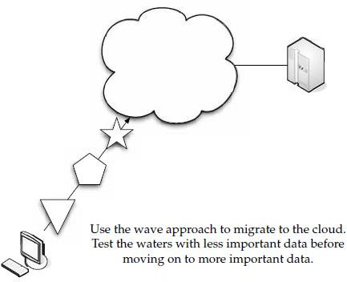If it turns out things aren’t going well, you can take corrective action to fix it, or just pull the plug and walk away.

#### Best Practices and the Future of Cloud Computing Analyze Your Service

**Establishing a Baseline and Metrics**

There’s some research you should do before signing on with a vendor, and that you should regularly perform once subscribed. There are a number of variables that you should use as a baseline, and then check back with frequently. Here are some variables to check:

* **Connection speed** The speed at which you connect to the vendor’s cloud.
* **Datastore delete time** How long it takes to delete the datastore.
* **Datastore read time** How long it takes to read data.
* **Deployment latency** The amount of latency between when an application is posted and ready to use.
* **Lag time** How slow the system is.

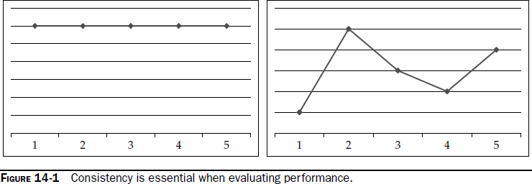

The first stat—connection speed—has nothing to do with your cloud vendor. It’s your ISP’s issue. What you are looking for is consistency. You don’t want to see huge spikes in performance over time. A graph of your connection speed should look like the one on the left of Figure 14-1, not the one on the right. There is no shortage of tools you can use to check your speed.

#### Tools

Here is a rundown of some tools you can use to check your cloud performance.

#### Hyperic HQ

Hyperic Inc offers its Hyperic HQ 4.0, the latest version of its systems monitoring and management application. The release addresses the needs of businesses embracing Amazon

cloud services to create scalable IT deployment strategies. Hyperic HQ enables the modern enterprises to monitor their Amazon Web Services securely alongside internal infrastructure. It is also the first enterprise-class monitoring and management software offered for deployment,and payment directly through Amazon Web Services.

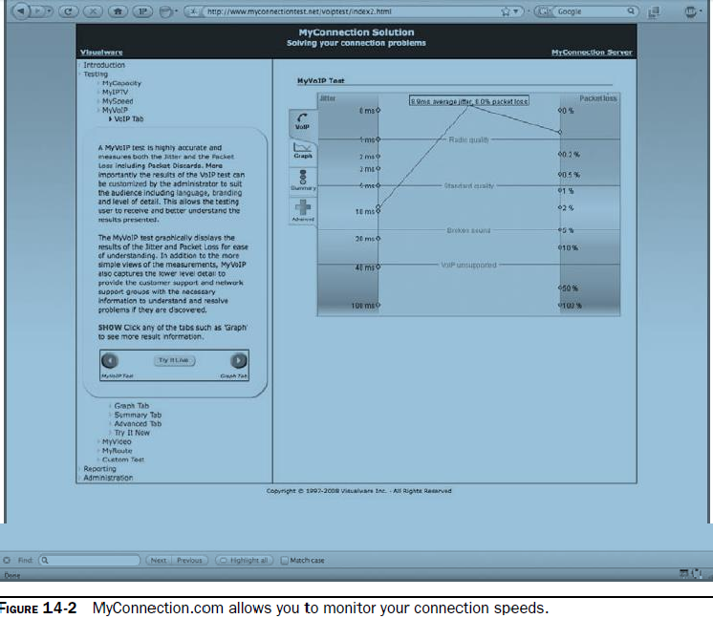

Hyperic HQ is poised to grow as cloud computing continues its development.

Hyperic HQ 4.0 was designed to address next-generation monitoring and management to help enterprises adopt cloud computing strategies, by better equipping operations teams to perform repetitive management tasks more efficiently. Traditionally, installing a new server and deploying it into production was a lengthy process that took place over days or weeks. Now, with cloud providers like Amazon offering the ability to rapidly deploy servers in minutes and pay by the hour, companies need a way to ensure consistent monitoring oversight of their web operations that is just as fast and flexible.

#### Performance

Hyperic HQ currently manages over 3,500 VMware and XenServer virtualization deployments. Also referred to as “private clouds,” these environments consist of both physical and virtual servers, and typically support high rates of change as virtual servers are easily added, subtracted, or moved to improve server utilization and maintain service levels.

Hyperic HQ 4.0 starts by streamlining the process of adding new software resources into management. After auto-discovery registers the new resources into inventory, a new process of server cloning allows all configuration profiles for log data collection, security, and services checks to be immediately applied. Coupled with global alert templates for resource types, the entire system of monitoring and rules for warning of performance problems can be incorporated in under a minute.

#### Hyperic HQ for EC2

Also part of the 4.0 release Hyperic HQ Enterprise 4.0 is available as a fully configured system on Amazon Web Services. An Amazon Machine Image (AMI) preconfigured for Amazon’s Elastic Block Storage (EBS) is available. The distribution will be available directly on Amazon’s DevPay service for an initiation fee and a monthly charge based on the amount of management data being collected to the HQ Server.

#### CloudStatus

Hyperic also offers a free cloud monitoring tool, CloudStatus. Their most recent addition to the tool is continuous monitoring of Google. Google App Engine is the second significant cloud service to be monitored by CloudStatus, which launched in June 2008 with support for Amazon Web Services.

Hyperic’s free CloudStatus service delivers real-time, independent insight into the health and performance of the App Engine, giving users a greater level of confidence in the reliability, availability, and scalability of web applications running on Google’s infrastructure. CloudStatus is shown in Figure 14-3.

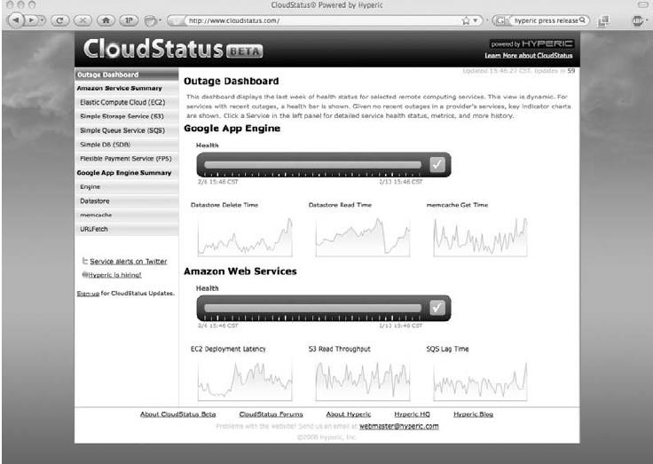



CloudStatus uses App Engine–specific management plug-ins to collect measurements that provide administrators and developers with unprecedented insight into the health of the App Engine platform.

To ensure reliability and more completely understand and trust cloud service stability, customers need transparency into real performance and availability. A free, third-party hosted service, CloudStatus provides a comprehensive measure of service availability, latency, and throughput for cloud-based infrastructure and application services.

#### CollabNet CUBiT 2.0

CollabNet’s CUBiT 2.0 strives to eliminate the time-intensive process of configuring servers for build and test by managing those configurations as “profiles” across the application life cycle. Applying the cloud computing model to distributed development, CollabNet CUBiT

2.0 enables teams to access on-demand servers from private corporate datacenters or public clouds, to significantly reduce development cycles and hardware expenses.

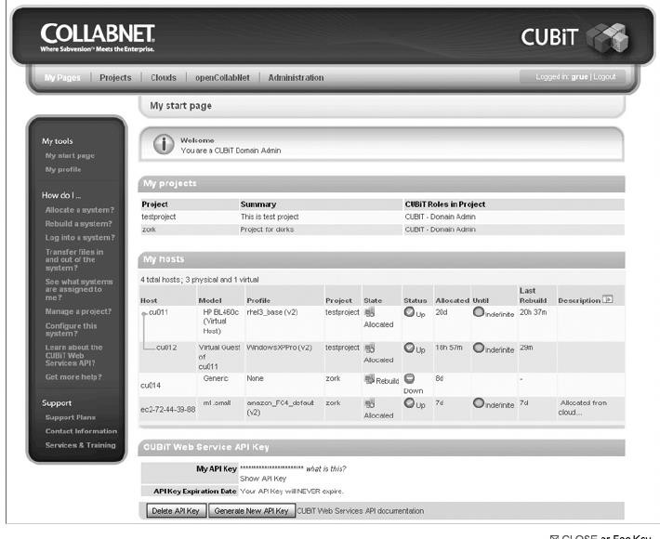

Developers spend a great deal of time configuring servers and aligning the software stacks throughout the application life cycle—an arduous task for server-intensive methodologies such as agile, scrum, and continuous integration. CUBiT eases these pain points by enabling code, build, and test teams to accelerate development cycles, eliminate build and test errors, and gain flexibility in utilizing machines. It provides a secure way to reuse build and test profiles, reducing the likelihood of configuration errors that can delay software projects by months. In addition, CUBiT’s self-service dynamic provisioning capabilities automate labor-intensive server provisioning and configuration that can take weeks. A financial services customer has decreased their time to build by 400 percent—from months to days.

CUBiT 2.0 allows teams to group and manage their computing resources as clouds. Clouds in CUBiT are groups of server pools from a corporate datacenter or from public clouds like Amazon EC2. Other new features in CUBiT 2.0 include support for LDAP/Active Directory, and advanced accounting and chargeback capabilities tied to role-based access control for allocating costs per server and profile type.

#### Cassatt

Cassatt Corporation offers several products to help internal cloud computing—an IT approach that delivers the benefits of cloud computing using the resources that organizations already have inside their datacenters.The Cassatt offerings help customers implement cloud-style computing environments using their existing systems, inside the firewalls of their datacenters without having to modify their current hardware or software. The resulting “internal cloud” can provide the same operational efficiency, fault tolerance, and energy

savings promised by external clouds, but without the worries over security, compliance, lack of control, or the need or delay required to change or replace their current applications.

#### Benefits

The Cassatt software and services provide organizations with initial steps toward realizing the benefits of cloud computing. The Cassatt Active Profiling Service gives companies a head start on establishing internal clouds by tackling a major problem facing corporate IT—a lack of information and understanding about the assets, interrelationships, and dynamic, real- time usage patterns within datacenters.

Through the control capabilities of Cassatt Active Response 5.2, Cassatt can help customers improve energy efficiency, application availability, and enable the best use of computing resources—across the diverse hardware, software, and virtualization. Cassatt experts analyze the data to help companies make the best decisions on ways to improve datacenter efficiency and operations technologies already running in a datacenter.

**Active Response** Cassatt Active Response enables datacenter managers to use policies to control and optimize the multiple diverse components of their IT infrastructure. Cassatt Active Response can monitor and automatically provision or decommission physical and virtual server, software, and network resources as appropriate to meet the application demand.

Cassatt Active Response 5.2 provides

* Platform support for Linux, Sun Solaris, Microsoft Windows, and IBM AIX.
* Support for virtualization from VMware, Citrix (Xen), with Parallels Virtuozzo Containers coming in the first quarter of 2009. Microsoft Hyper-V will be supported as customer demand warrants.
* Networking support for equipment from Cisco, Dell, Extreme Networks, Nortel Networks, F5, and Force10 Networks.

#### Best Practices

When you plan to move to a cloud solution, there are good ways to go about making the change to ensure an optimal experience while paying less than a colossal price. It starts with your analysis and selection of a vendor, and continues with your day-to-day usage of that service.

#### Finding the Right Vendor

Does the provider support me the way I need support?

* Are they easy to work with?
* Will they charge me a crippling amount of money?
* What is their support like?
* What is their track record for uptime?
* Can they give me some references?

#### Read the Fine Print

Make sure you don’t just sign a contract without understanding it. Check the fine print to see if there is a user limit cap on your software. Sometime vendors will allow a low number of users. Then, as your business grows, you get hit with awful penalty charges—even if your software needs haven’t changed.

#### Performance

A key thing to consider is assessing the maturity of the cloud service and what is acceptable—to you—from a service delivery standpoint. Since you and your organization will be affected by any outages, it’s important to get a service level agreement (SLA) in place, but also to check on past performance.

#### Spread Your Services

To be truly redundant and downtime-proof, you shouldn’t have your services on just one cloud. You could have one server on Amazon and another on Azure, for instance.

#### Data

Make sure your vendor(s) provide customizable data views and reporting. This allows you to get to the data you need quickly. Also, make sure you can get your data back from the vendor.

#### Data Flow

Automating your processes comes from workflow rules that control where and how data flows through your organization.

#### Phased-in vs. Flash-cut Approaches

IT administrators tend to be control freaks, and the thought of giving control of their systems to someone else is difficult. One of the mental hurdles to overcome is being willing to give up physical control of some of your systems.

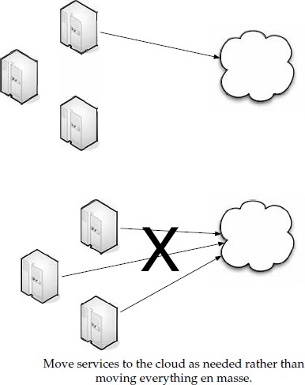

#### How Cloud Computing Might Evolve

Cloud computing takes its knocks from opponents who see it as an overused phrase with no real meaning. On the other side of the coin, there are plenty of professionals who see the cloud as not only a useful thing, but also an evolving beast. We are on the verge of Cloud 2.0.

#### Salesforce.com and Customer Service

Cloud evolution will not just take place in a technical realm. Also affecting how cloud services will change is how customers interact with the cloud. Salesforce.com is addressing customer service needs with its Service Cloud program.

Built on the Force.com platform, the Service Cloud transforms customer service through the power of cloud computing, and brings together industry-leading cloud computing platforms like Google, Facebook, and Amazon.com to capture every conversation and leverage every community expert in the cloud. By capturing these conversations, the Service Cloud empowers companies to deliver the expertise of the community to customers, agents, and partners regardless of location or device—ensuring that the quality of customer service is consistent across every channel. The Service Cloud represents the future of customer service, where more than two-thirds of all service conversations will take place in the cloud.

The Service Cloud is made up of six main components around the knowledge base to gather, distill, and disseminate the expert knowledge found in the cloud to customers agents, and partners:

* **Community** Developing an online customer community is an integral part of the Service Cloud. The Service Cloud represents a fundamental shift in how companies approach their online presence—it’s not just a place to post information, but a community where customers can interact with each other and have conversations

with the company at large. Companies can easily set up and maintain an interactive cloud community for their customers by leveraging new Salesforce.com technologies such as Salesforce CRM Ideas and Force.com Sites as building blocks.

* **Social** The Force.com platform enables the Service Cloud to connect to leading social networking sites such as Facebook, community forums, blogs, and more. Through these connections, companies will be able to funnel this information directly into their knowledge base. The Service Cloud ensures that the company’s knowledge base has the most up-to-date support information sourced from community experts.
* **Search** More times than not, customers begin with a Google search to find answers to their questions. By creating an active online community with the Service

Cloud, companies can ensure that their site is one of the top results returned in a customer’s search. It is through the power of Force.com Sites that the expert knowledge of the community is made available in search engine results.

* **Partners** Using the Service Cloud, companies can now share all of the information in the knowledge base quickly and easily with their partners. Cloud computing’s unique model has enabled Salesforce.com to easily and securely connect separate Salesforce CRM deployments, allowing companies to share cases, contacts, and company information, without the need for complex integration software.
* **Phone, email, and chat** The Service Cloud will give agents access to knowledge in the cloud, regardless if they use phones, email, or chat to service customers. By providing the contact center with the same knowledge found in the community, the Service Cloud ensures that the quality and cost of service across every channel is

strengthened by the expertise of the community.

* **Force.com** The Service Cloud utilizes the latest Force.com capabilities, including Force.com Sites, Force.com for Facebook, and more to uniquely join together knowledge and conversations regardless of where they take place online. The Service Cloud also taps into the power of more than 100 customer service extensions on the Force.com AppExchange for areas like chat, field service, and CTI. Additionally,

customers using the Service Cloud gain all the benefits of the proven security, reliability, and scalability of Salesforce.com’s trusted global infrastructure.